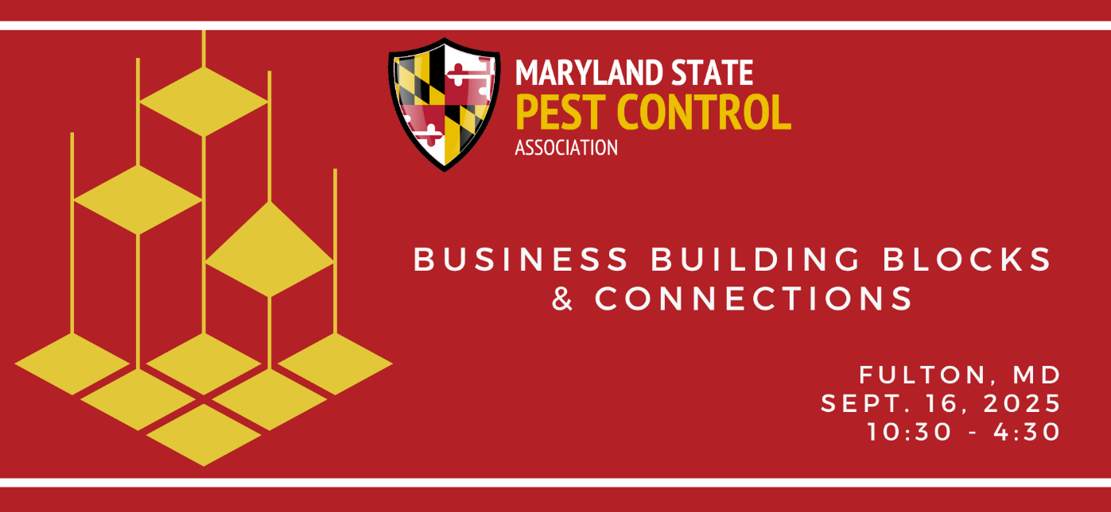

Phil Cooper, CEO, Trnz4m.com

Phil Cooper is curious. He can’t help it. He’s been that way as long as he can remember. At the age of 7, he would make weekly visits to his father’s growing pest control business, where he would help arrange the magnets - primitive spreadsheets depicting schedules and completed work. All the while, Phil would pepper his father with business questions far beyond his years. One question nagged at him more than any other: why was it that some of the technicians didn’t always do their jobs? It was a question that Phil’s Dad hated. The question prompted Phil to find a solution. Combining his 34 years at his family’s company, Cooper Pest Solutions, with his other leadership exposure, Phil and his team figured out the answer to his own question of why technicians don’t always do their jobs, because front-line service managers rarely turn their training into sustainable activities that help their teams reach their potential. Phil and his team reverse-engineered and systematized how a frontline service manager is developed, and these lessons can be transferred to any management development program. Now Phil’s team is transforming businesses both within and far beyond pest control by making service managers great so that they, their companies, and their clients experience significant impact.

