National Career Development Association
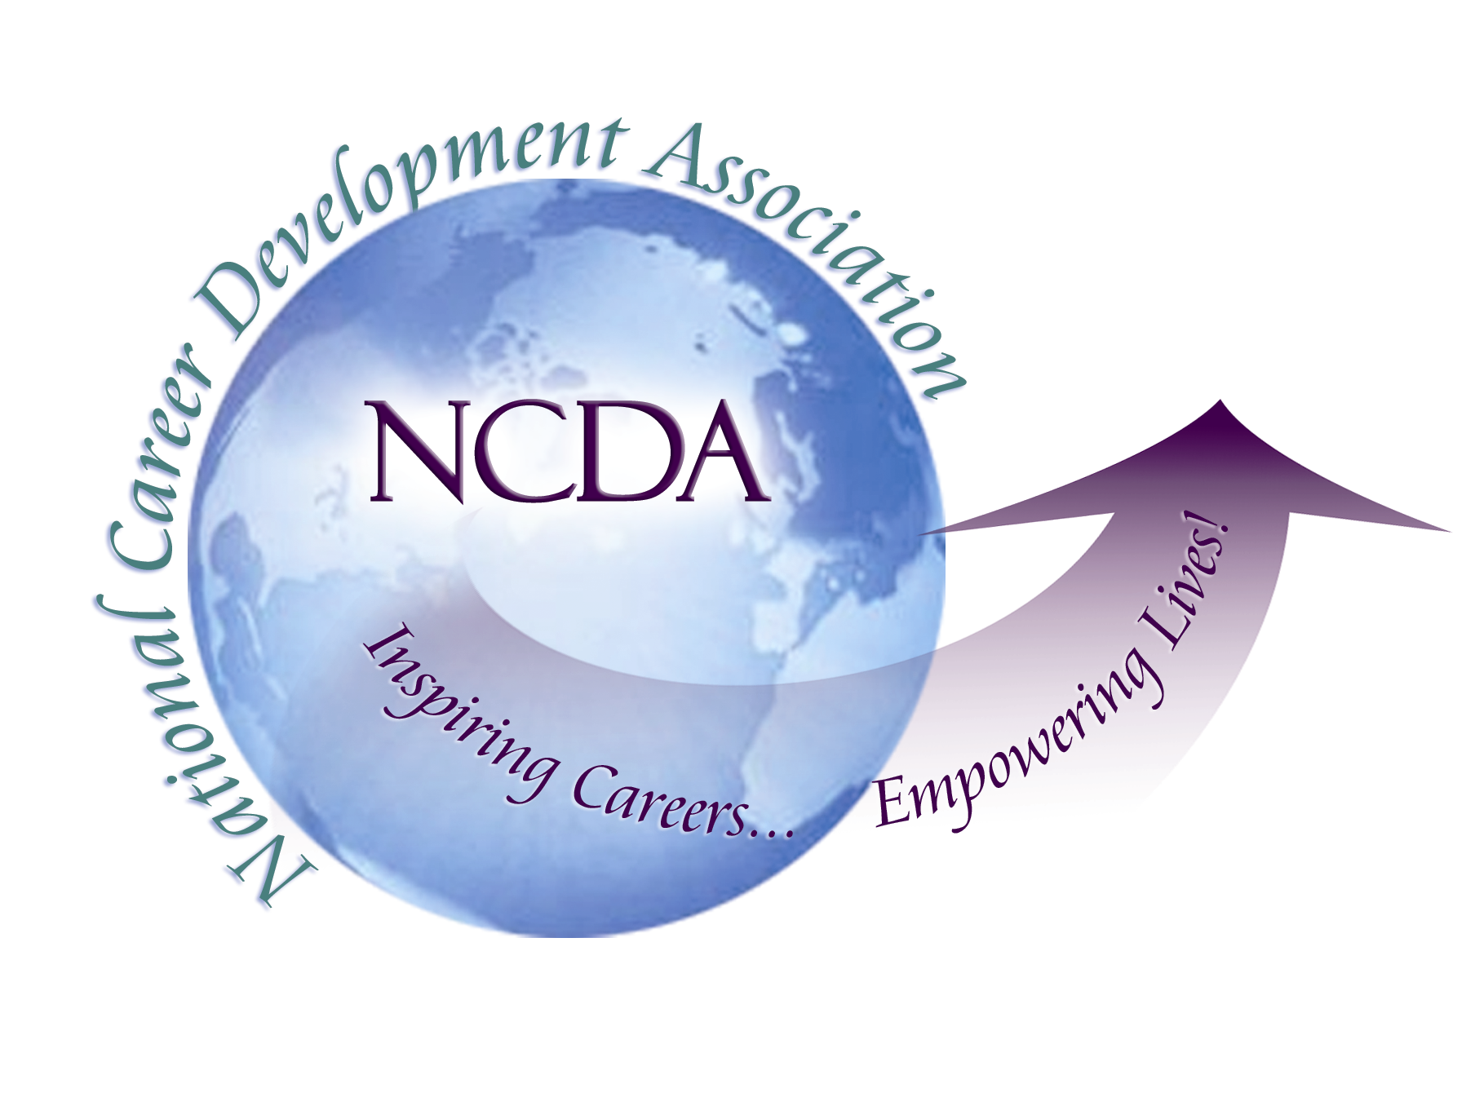
305 N. Beech Circle
Broken Arrow, OK 74012
918/663-7060
Fax: 918/663-7058
www.ncda.org

National Career Development Association
Leadership Academy
Action Learning Project Summary

Participant(s): Sungsik Ahn

Board Mentor: Hyung Joon Yoon

Leadership Academy Class: 2016

Project Title: NCDA International Affiliates: Needs Assessment and Future Directions

Project Description: Given NCDA’s long history and its international recognition, the number of International Affiliates is very small. The relationship with current International Affiliates seems to be inactive with no clear expectations, benefits, management, or support. It is imperative to understand the status quo of NCDA International Affiliates to move beyond this point.
This project aims to assess the needs of NCDA and current International Affiliates in the mutual relationships under the International Affiliations policy. The results of this project will help NCDA to identify what actions need to be taken to strengthen the relationships.

Summary/Conclusion: Two surveys were conducted to assess the needs of NCDA and International Affiliates. The 1st survey aimed to assess the needs of NCDA and sent to those of Board of Directors, Headquarter, and Global Connections Committee. The 2nd survey was intended for interviews with representatives of International Affiliates.
The results of the 1st survey indicated that
NCDA and International Affiliates have the following benefits:
- International Affiliates have been and will be beneficial to NCDA in terms of learning about international perspective and multicultural issues, NCDA’s connect with others internationally, and the expansion of NCDA’s mission globally.
- International Affiliates benefit from the relationship with NCDA in terms of bringing new idea to home countries, having access to NCDA’s resources (materials and networks), and getting credibility for their organizations.
Some challenges are:
- Current International Affiliates do not seem to be closely connected to NCDA (some are very visible and others are not).
- NCDA’s focus on international relationships seem to be weak and the service for International Affiliates is not well structured.
- The current approval process for the acceptance of International Affiliates needs to be reviewed as it is not well balanced with State CDAs and the process should include quality side of the applicants for the evaluation.
- The idea of charging International Affiliates an annual fee could be considered positively as it will make the International Affiliates more accountable and committed to NCDA. For that, benefits to International Affiliates need to be clearly defined. However, NCDA’s overall time and resource commitment needs to be carefully assessed before making such a decision.
As a resolution for those problems and challenges,
- Most of respondents agreed that Global Connections Committee (GCC) takes the role of an International Affiliates Liaison.

The results of the 2nd survey indicated that
- Before they became NCDA International Affiliates, they expected opportunities for professional development, credibility (including the promotion of their organization), and support for their organization development. After becoming NCDA International Affiliates, an actual benefit appears to be the credibility.
- Expectations from NCDA after becoming International Affiliates varied. There is no change in some organizations while one organization became to withdraw all expectation and another to expect more. The main reason of the withdrawal of expectations is that they attempted to develop a closer relationship with NCDA at an earlier time but the need was not satisfied by NCDA. They pointed out that the communication with NCDA was not effective, especially a lack of response to emails.
- Concerning the annual fee to International Affiliates, they need to see the amount of the fee and its benefits to make their decision to pay.

Results/Recommendations: The results of two surveys suggested that
- The policy and procedure of International Affiliations need to be reviewed along to the NCDA’s mission.
- It seems to be urgent to designate an entity or a person for a good communication with International Affiliates seems urgent when NCDA should expand its role and/or change the rules with them.
- Charging International Affiliates an annual fee needs more careful consideration with the changes of policy: it is not recommended to charge them with current service.
- The balance between State Organizations and International Affiliates needs to be considered.
- Reaching out other associations or organizations that are representative in home countries needs to be considered for international cooperation in the future.
- Effort to engage International Affiliates in different NCDA initiatives such as professional development and publication needs to be made.
As a follow up to the results of this project,
- After a discussion with NCDA Board members and it is decided to delegate the task to the Global Connections Committee (GCC).
- After a discussion within the GCC, a sub-committee was created and general directions for the policies and procedures of managing the relationship with NCDA International Affiliates was generated.
- The GCC sub-committee will recommend updated policies and procedures to NCDA Board.

