NCDA Speaker's Bureau

P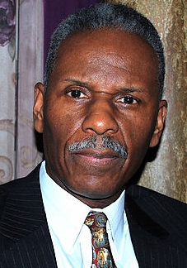hoto

Complete Contact info:
Ruben Britt, Jr.
P.O. BOX 131
Gibbsboro, NJ 08026-0131
856.256.4254

Brief Bio:
Author, lecturer, career coach, educator, and talk show host, Ruben Britt, Jr. has empowered thousands of people by providing powerful and life-changing professional motivational keynotes and seminar presentations to various organizations nationwide. Ruben cultivated his coaching expertise from over 39 years of experience in education as a career counselor and teacher. He has conducted presentations on self-empowerment, leadership, career development, Black History, organizational communication and the Black social conscious. Ruben always engages, entertains, challenges and creates a memorable experience that inspires crowds.

Presentation Titles:

Blueprint for Success: Realizing Your Career Goals and Dreams
- Success 101: A Career Development Model for Student Empowerment
- Omitted Text: Black History In America
- Winter In America: The Social and Moral Decline of A Great Nation
- The Ten Commandments of Leadership
- Outside The Lines: A Career Planning Guide For Student Athletes

Fee: $1,000, plus travel expenses

Format: Standard speech or seminar presentation

Length of Session: 40 – 45 minutes

Availability: Year round

Follow-up: It depends on the presentation format. If the presentation is given in a seminar format and needs follow-up, I will provide the necessary materials and resources.

