National Career Development Association
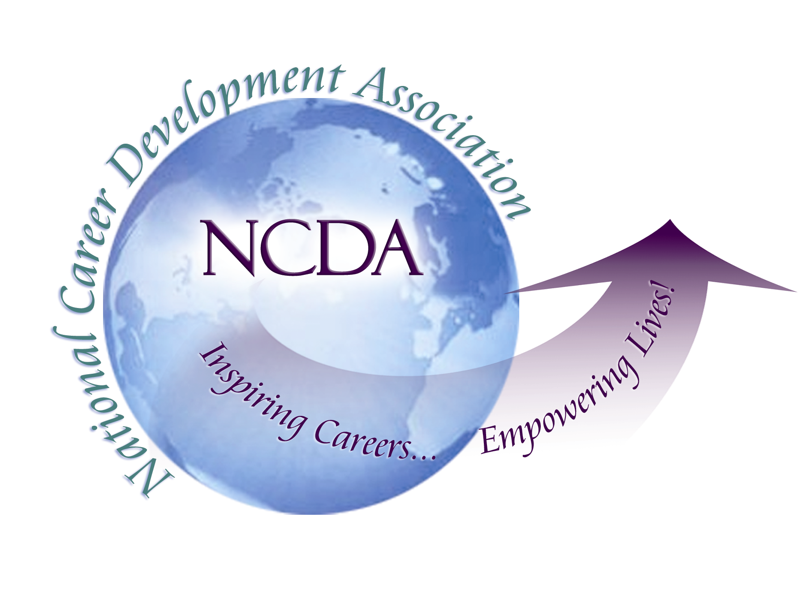
305 N. Beech Circle
Broken Arrow, OK 74012
918/663-7060
Fax: 918/663-7058
www.ncda.org

National Career Development Association
Leadership Academy
Action Learning Project Summary

Participant(s): Mary Buzzetta, M.S., LPC

Board Mentor: Marilyn Maze, Ph.D.

Leadership Academy Class: LA Class IX, 2014-2015

Project Title: Enhancing Graduate Student Involvement within NCDA

Project Description:
As of July 2014, NCDA had a total of 472 graduate student members. There is a need to increase graduate student participation and involvement within NCDA. Becoming involved with NCDA as a graduate student has implications for individuals retaining their membership as they transition into professional positions. In addition, there are a variety of opportunities for graduate students to become more involved within the organization (i.e., joining NCDA committees, publishing an article in Career Convergence or Career Developments magazines, and presenting at the NCDA Global Conference), however, these opportunities may not be fully utilized by graduate student members. This project sought to 1) develop an online needs survey and distribute it to current NCDA graduate student members, 2) gain an understanding of ways in which NCDA can better engage graduate students within the organization, and 3) assess for ways in which graduate students can become more involved within the organization.

Summary/Conclusion:
A total of 131 individuals completed the survey. The majority of graduate students who completed the survey were pursuing a Master’s degree (67 individuals; 69.8%). 48% of respondents had been a member of NCDA for under one year (n = 50). Results of the survey indicated the following:
- Participants were asked to select their top two reasons for joining NCDA:
  - 60.8% indicated that they decided to join NCDA as an indication of their commitment to the profession, and 50% indicated that they were interested in the professional development opportunities available to them
- A large majority of graduate students (74%, n = 77) indicated that they were not members of a state career development association, and a large majority of graduate students (71.2% n = 74) have not attended an NCDA conference before.
- Only a small portion of graduate students (2.9%, n = 3) indicated current membership/involvement in an NCDA committee.
- When asked about their current involvement with NCDA within the past year, participants indicated the following:
  - 10.9% (n = 11) indicated that they had submitted a proposal to present at the annual conference
  - 6.9% (n = 7) indicated that they had delivered a presentation at NCDA's annual global conference (this included a roundtable presentation and/or 70-minute presentation)
  - 79.2% (n = 80) had not been involved in any of the activities listed
- Of all the options listed for ways graduate students can be involved in NCDA, 46.1% of participants (n = 47) indicated that they were “not at all aware” of the ways in which graduate students can become more involved within NCDA.
  - 35.3% of graduate students indicated that they were “somewhat aware.”
- The majority of respondents (74%) indicated an interest in becoming more involved within NCDA.
- When participants were asked to select items they would be interested in learning more about, almost all of the items listed had high response rates.
  - 64.2% (n = 61) indicated an interest in a graduate student mentoring program in which graduate students have the opportunity to be mentored by a professional member within the organization
  - 52.6% (n = 50) indicated an interest in learning more about the publication/writing opportunities for NCDA graduate student members
  - 43.2% (n = 41) indicated an interest in becoming more involved at the annual NCDA conference
  - 43.2% (n = 41) indicated an interest in learning more about NCDA research awards for graduate students
- Participants were asked to list any suggestions they had for ways in which NCDA can further involve graduate students within the organization. A total of 16 individuals responded to this open-ended question. Overall suggestions included the following:
  - Specific opportunities for graduate students to submit proposals for the annual conference (one participant indicated that he/she made two attempts to present his graduate research and was rejected twice, in 2013 and 2015).
  - Provide free webinars and/or ongoing training opportunities that are easily accessible in order to further develop graduate students’ abilities to navigate client career concerns.
  - Encourage professional members to reach out to and partner with graduate students in both the preparation for and presentation of conference sessions.
  - Offer opportunities to collaborate with NCDA leaders on research and publications.
- Participants were asked for suggestions in which NCDA can recruit and retain graduate student members. A total of 21 individuals responded to this open-ended question. Overall suggestions included the following:
  - One overarching theme included costs for membership, as well as attending the annual conference, particularly for graduate students who do not receive funding outside of student loans. Participants recommended offering additional scholarships (or other sources of funding) to support conference costs for graduate students and extending student membership pricing after graduation.
  - Another theme included ways to involve graduate students at the annual conference. Suggestions included offering a graduate student poster session and events at NCDA annual conferences.
  - Another theme consisted of receiving encouragement and support from career professionals and faculty within NCDA.
    - Providing mentorship in a more structured way for graduate students who often struggle with making informed choices about post-graduation careers.
  - Other suggestions included posting and offering specific opportunities geared directly towards graduate students including the following:
    - Offering publication opportunities specifically geared toward graduate student projects and research.
    - Posting opportunities for graduate students to work on a committee and/or publication opportunities
    - Graduate student members may be sent emails about specific opportunities that relate to them besides regular NCDA newsletters.
  - Reach out to graduate counseling programs for mental health/clinical counseling programs and promote career development as an important aspect of overall mental health counseling.
  - Encourage NCDA professionals to identify universities in their respective regions with NCDA related graduate degree program concentrations (e.g. Higher Education Administration, Student Personnel Administration, School Psychology, School Counseling) and connect with those department chairs/deans to promote NCDA membership benefits among their students.
- A total of 32 individuals provided their email addresses and expressed an interest in receiving additional information regarding opportunities for graduate students to become more involved within NCDA.

Results/Recommendations:
As a result of the needs assessment survey, the following outcomes have occurred:
- An “NCDA Graduate Students and New Professionals” Facebook page was created as a forum for individuals to post and share relevant graduate student updates, job postings, and opportunities to become more involved within the organization. The page currently has 259 “likes.” To view this website, please visit https://www.facebook.com/NCDAGraduateStudent
- A total of 32 individuals provided their email addresses in the online needs survey and expressed an interest in receiving additional information regarding opportunities for graduate students to become more involved within NCDA. As a result, a sample artifact will be created and disseminated to these individuals and will include suggestions for ways in which they can become more involved within the organization.
- Lastly, another goal of this project is to publish an artifact in one of NCDA’s writing outlets (i.e., Career Developments magazine or Career Convergence web-magazine). This artifact will be similar to the artifact emailed to graduate students who completed the needs survey and will likely be published in summer or fall 2015.

The following recommendations are being provided to NCDA:
- Create a graduate student mentoring program in which graduate students have the opportunity to be mentored by a professional member within the organization.
- Establish specific opportunities for graduate students to submit proposals for the annual conference (e.g., graduate student poster presentations and/or roundtable sessions).
- If possible, offer additional scholarships (or other sources of funding) to support conference costs for graduate students and/or extend student membership pricing after graduation.
- Produce a special issue of Career Convergence, Career Developments, and/or the Career Development Quarterly (CDQ) which specifically has graduate students as the primary author on all publications.

