National Career Development Association
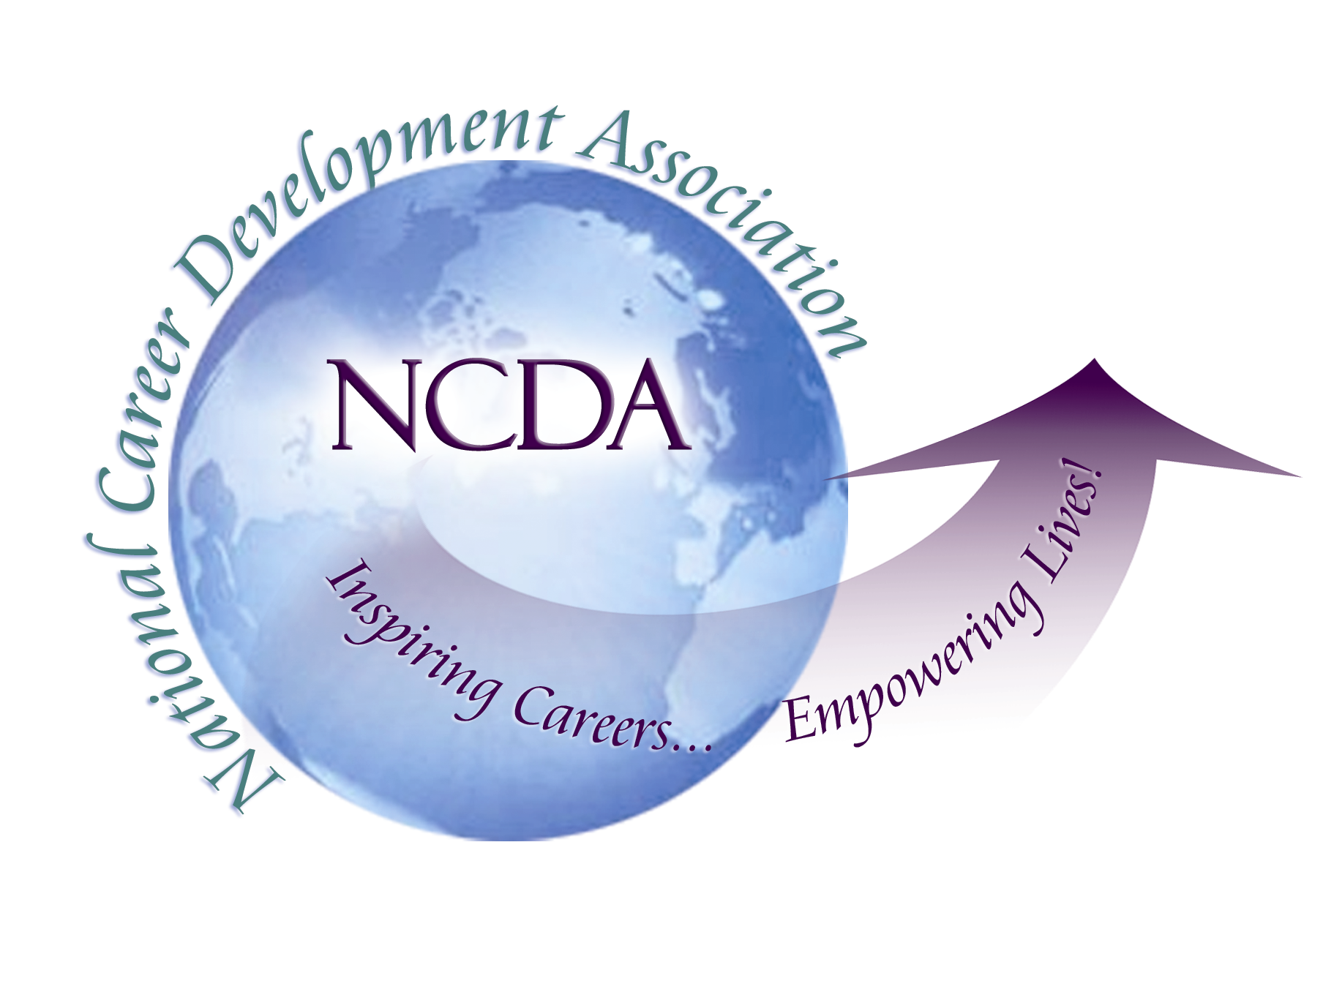
305 N. Beech Circle
Broken Arrow, OK 74012
918/663-7060
Fax: 918/663-7058
www.ncda.org

National Career Development Association
Leadership Academy
Action Learning Project Summary

Participant(s): Dawn Williams

Board Mentor: Wendy LaBenne

Leadership Academy Class: 2017

Project Title: Increasing interest in State Association Board Involvement

Project Description:
Currently, there are limited resources to help state CDAs with professional development for Board members. Recruitment is an issue and state leaders can become burned out because too few are involved. Often, the same people will hold a Board function for longer than the prescribed term due to lack of new volunteers for Board membership.

Increased involvement in state chapters’ leadership roles will make the state chapters stronger. The purpose of this project is to determine best practices for attracting new Board members and providing training and support for those who take on a leadership role.

The intent of this project is to help put together a framework of online training resources (outlines for web modules) to help strengthen the skills of state board members, and increase the involvement of members in their state board by providing training and support in taking on leadership roles.

Summary/Conclusion:
Initially, leaders of several organizations were asked about the level of interest in board involvement within their associations. All indicated that interest was low and many board members served multiple terms. A survey was sent out to learn about best practices from other organizations. No state or regional association surveyed indicated a best practice that was effective in recruiting new board members, beyond a personal invitation from a current board member. Even that is not always successful.

Results/Recommendations:
Because of the lack of existing best practices at the state and regional levels, it was determined that the best option was to draw from other areas of best practices related to promoting interest, ensuring a positive return on investment, leadership development and developing engagement within the community. The topics for the online training resources are:

- Implementing a State Association Mentoring Program
The Leadership Academy is an effective program for helping to develop leaders for the national association. It would be very beneficial to create a program that would be sustainable on a local level. A short-term mentoring program where board members or experienced state CDA members could volunteer to mentor other CDA members would be a valuable service. In our roles within Career Development, clients are often encouraged to seek out mentors; this program would encourage career development professionals to follow their own advice. This webinar includes information on setting up a mentoring program, recruiting mentors, a sample mentoring agreement and ways to utilize the mentoring program to increase interest in board involvement

- Tips for recruiting and on-boarding new Board Members

- Why you should join your State Association Board (a promotional video with personal testimonials about the benefits of board membership) – this can be utilized by State Associations to encourage their members to apply for a Board position.

- Advance your professional goals through State Board involvement.

