National Career Development Association
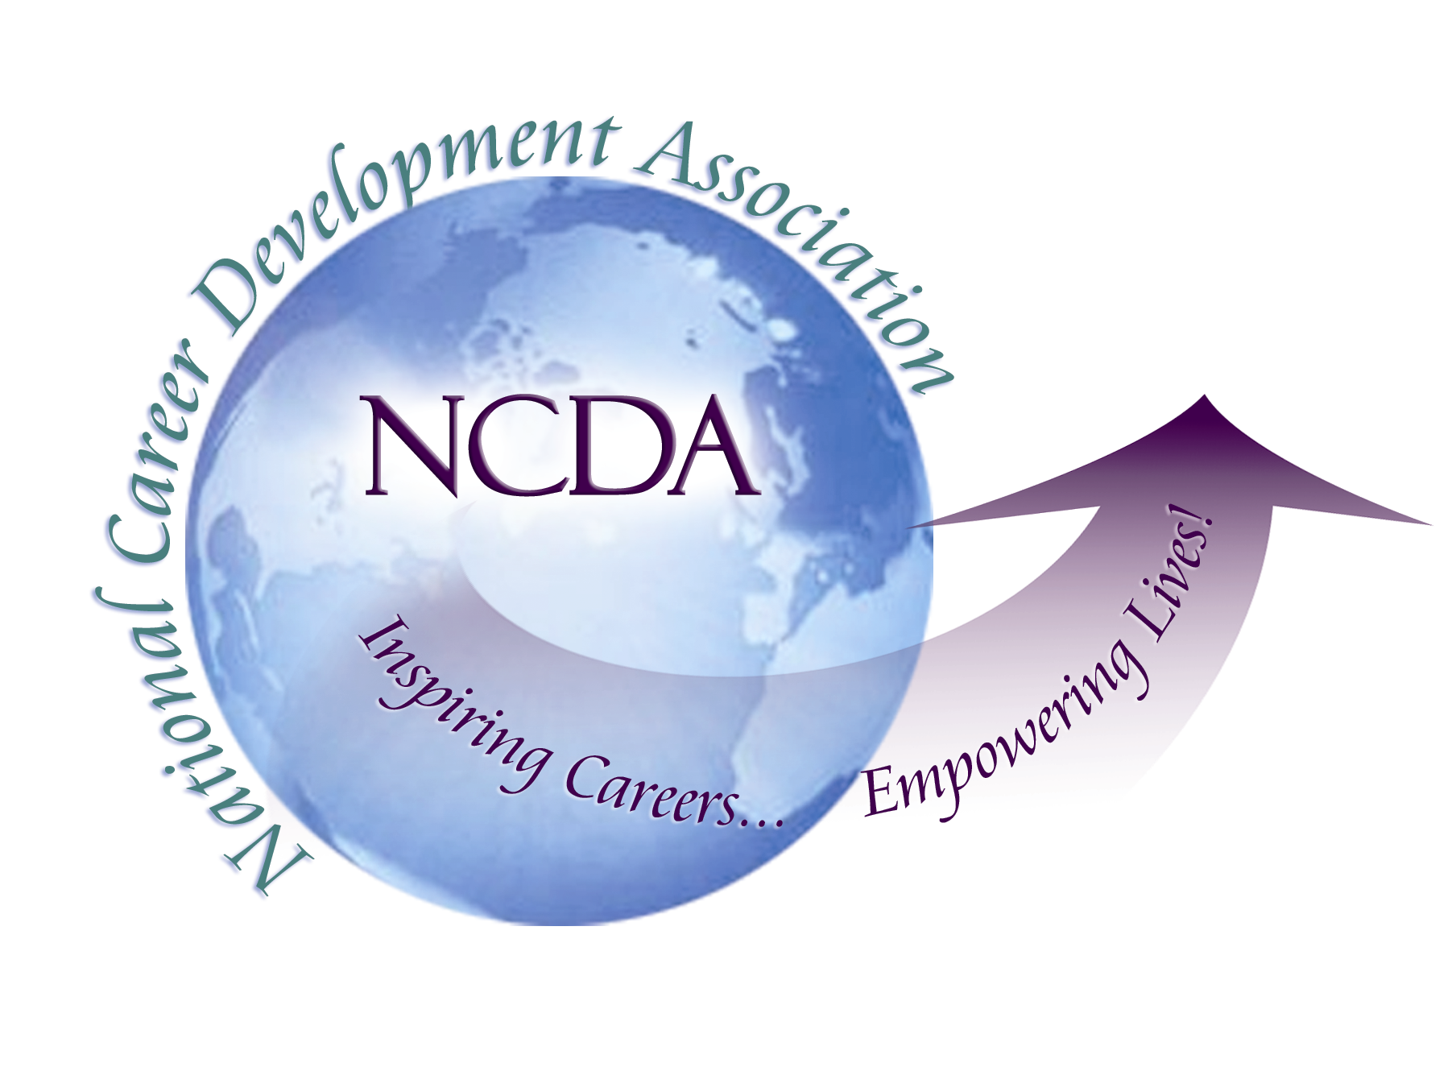
305 N. Beech Circle
Broken Arrow, OK 74012
918/663-7060
Fax: 918/663-7058
www.ncda.org

National Career Development Association
Leadership Academy
Action Learning Project Summary

Participant(s): Linda Whited

Board Mentor: Wendy LaBenne, Trustee of State Division

Leadership Academy Class: 2017

Project Title: Helping State CDAs to be engaged divisions of NCDA

Project Description: I consulted with Wendy LaBenne, Trustee of State Divisions, to discuss how to help a state CDA thrive and how best it can relate back to NCDA. She shared some of the best practices that states engage in which help her to know they are doing well. She also shared some of the challenges she encountered when working with chartered states – challenges because we don’t know too much about what’s going on or reasons for their struggles. We identified 12 states that are not engaging as well as others. This information was accounted for in the design of 2 surveys – one for the leaders (2017 presidents) of the identified states and one for NCDA members of those states. Those surveys were distributed via NCDA administration with Survey Monkey. From the survey results and consultation with Wendy, further clarification of an engaged division and an disengaged one was outlined and can be found in the summary below.

Summary/Conclusion:
Creating a definition of an engaged state CDA: Rather than focusing on deficits or challenges that some states may be encountering, it was decided to create a definition of an engaged state. The hope of this project is that this definition could be used as a measure to help state CDAs and NCDA have shared expectations and create stronger state chapters with the knowledge and resources they need to thrive.

An engaged state CDA annually submits a report to NCDA on the status of its membership and activities it’s participated in for the previous year. These reports are due upon election of new officers or September 1 each year. In addition, it participates in a minimum of 2 (but all are encouraged) of the following activities each year:
    - Hold some professional development program/event annually
    - Consistently communicate with members
    - Apply for grant funding from NCDA;
    - Submit a nomination for any award NCDA offers;
    - Submit information on state’s upcoming events for promotion on the NCDA website;
    - Request promotional materials or resources from NCDA for state held events/programs
Data Collection – Survey of leaders in disengaged states: Five leaders of the disengaged states responded to the survey (42%). The survey was given via email with reminders over a period of several weeks. Some follow up was done via LinkedIn messaging and email but with minimal additional response. The leaders were asked about which activities they participated in based on the definition of an engaged state above. Three leaders have done the annual report and few had done anything else. None of them had submitted nominations for any awards or requested resources. It is unknown whether they didn’t know these opportunities existed or if they had other reasons for not engaging. With regard to how NCDA could help – the majority mentioned helping recruit new members/raising awareness of the organization. This included creating marketing materials for state membership and event planning assistance. In addition 2 respondents requested additional information on services/support provided by NCDA. One gave a tangible suggestion of conference calls with state leaders periodically for stronger communication between NCDA and the state leaders.

Data Collection – Survey of NCDA members in disengaged states: The percentage of NCDA members who responded from these disengaged states was relatively low (2-9%); 48/1296 responses total (4% response rate). Respondents varied in their experience levels in career development. Half had 10+ years of work experience; a quarter had less than 5 years and another quarter had 5-10 years of work experience. Below are a few of the notable results.
  - Of respondents, only 54% knew their state had a CDA
  - Of those, 30% are not or have not ever been members of their state CDA. Some of the stated reasons for this choice include:
    - “I didn't know there was one and I don't know how to join it”
    - “I used to be (a member) in the past but did not find it worth paying for both memberships”
    - “I’m a member of several other organizations”
  - Only 27% of respondents felt that their state CDA helped them feel connected to NCDA
  - 81% of respondents know who their state leaders are (or how to find out who they are) and they are aware of their state CDAs website (more so than a state CDA’s use of social media which was only known at 35%)
  - When asked about the purpose of a state CDA, networking and local opportunities for CEUs were at the top of the list. Other purposes include:
      - Providing more affordable events/programs than a national conference
      - Serving as a state-wide advocate on policies for career development and workforce recruitment
      - Supporting the initiatives of NCDA on the state level
- Suggestions from NCDA members with regard to their state CDA include:
- More collaborations with other organizations that have similar foci
- Alternatives to in-person events such as webinars or regional events, especially for larger states
- Opportunity to join without being part of the state counseling association
- More communication from leaders to ensure awareness of any professional development

Results/Recommendations:
Leaders surveyed expressed their desire for support with event planning and recruitment. To address this here are a few recommendations:
- Update the NCDA Information section of the State Division Leader’s Handbook to provide more ways that NCDA can help state leaders address these issues. This area can also include the definition of an engaged state. Perhaps even make this part an appendix that can be distributed annually when new state leaders are elected. States who have had a charter for a while may not think to read the whole notebook given that they aren’t trying to establish themselves as a chartered state.
- Equip leaders with marketing materials that can be customized for each state. These can be marketing for leadership roles on the executive board and marketing for members to both NCDA and the local chapter. These should be customizable for use in print brochures as well as graphics on websites and ads on social media outlets so that state leaders can quickly distribute information.
- NCDA administration can have a series of quarterly email templates to send specifically to state leaders that outline the activities of engaged states with links to participate more easily, reminders of upcoming deadlines (poetry and poster contest; annual state report; national conference deadlines, note from the Trustee, etc.)
- An annual training webinar that is offered by the Trustee (recorded and posted online for future use) for state leaders that covers sharing information, educating on state best practices, and being available for questions.

Members want local, inexpensive professional development opportunities and leaders lack the time, skills or budget to provide these, particularly if recruitment is already an issue. To address this, NCDA could use the training webinar suggested above to bring in state leaders who can share best practices in a more dynamic way than the State Best Practices List (updated in 2009) from the website. Perhaps there could also be volunteers skilled in areas of event management, recruitment, and conferences who can be available (similar to a speakers bureau) for state leaders to discuss their struggles and get ideas.

Since only about half of the NCDA members who responded to the survey knew their state had a CDA division and only 27% felt that their state division contributed to feeling connected to NCDA increase the visibility of NCDA activities (i.e. poetry and poster contest; applying to Leadership Academy) in the states via targeted emails to state division leaders. State leaders and the state’s CDA website were the two most known elements of a state CDA and can be leveraged to increase the connection of NCDA to its state divisions.

Recommendations for future projects
- Examine the potential implications of a state CDA being connected with their state counseling association. A few comments from the survey indicated this as a potential reason they were only members of NCDA and not their state association.
- Connect with state leaders to get rosters of their members to determine how much overlap there is in membership of NCDA and the state division – do people join both? Why or why not? What are the benefits or drawbacks to being part of both or just one?

