NCDA Speaker's Bureau

Dr. Ricky C. Godbolt
US Department of Labor
200 Constitution Avenue NW
Room C5311
Washington, DC 20210

Work: (202) 693-3815
Godbolt.Ricky.C@dol.gov

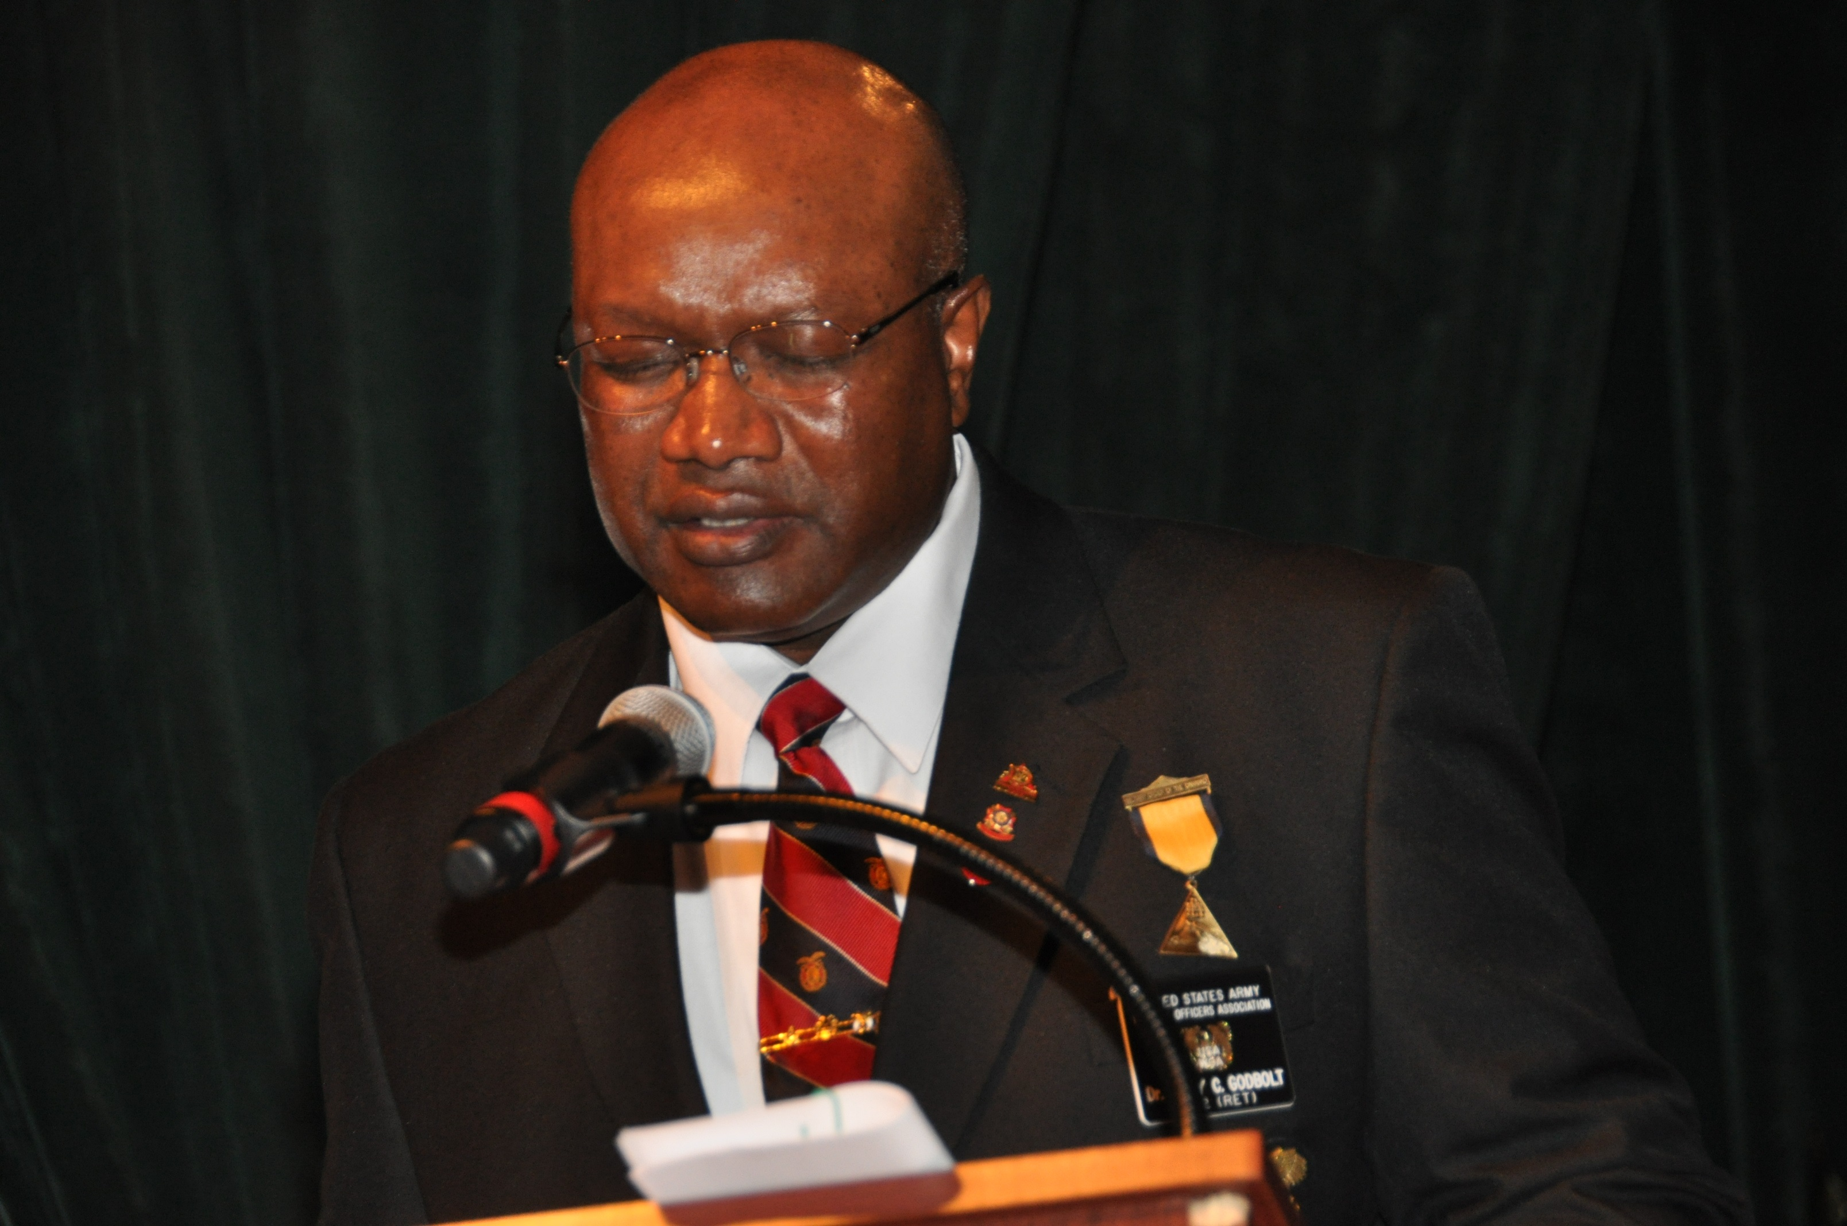Photo

Brief Bio: Dr. Ricky C. Godbolt is an Apprenticeship and Training Representative with the United States Department of Labor. He is certified by the Board of Certified Safety Professionals as a Safety Trained Supervisor – Construction; the Federal Acquisition Institute (FAI) as a Contracting Officer’s Representative; International Association of Workforce Professionals (IAWP) as a Certified Workforce Specialist (CWS); and International Association of Workforce Professionals (IAWP) as a Workforce Development Professional Master. Dr. Godbolt is a member of the following honor societies: The National Society of Collegiate Scholars (NSCS); Sigma Lambda Chi, International Honor Society for Construction; Iota Lambda Sigma, professional Honor Society in Workforce Development; Epsilon Pi Tau, International Honor Society for Professions in Technology; Pi Lambda Theta, International Honor Society and Professional Association in Education (Life Member); and the National Society for Leadership and Success (Sigma Alpha Pi).

Presentation Titles: Apprenticeship 101; ApprenticeshipUSA

Fee: N/A

Format: Lecture

Length of Session: 1-2 Hours

Availability: Based of funding from the US Government

Follow-up: Godbolt.Ricky.C@dol.gov

