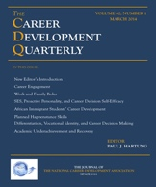
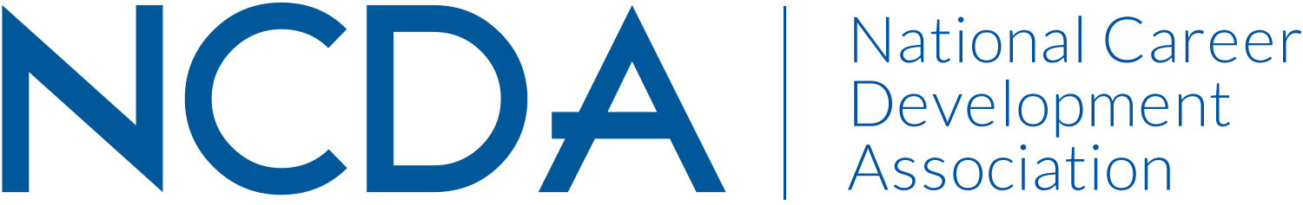

Mid-Year Report 2018-19
THE CAREER DEVELOPMENT QUARTERLY
March 8, 2019
EDITOR:
Paul J. Hartung
Department of Family and Community Medicine
Northeast Ohio Medical University
4209 S. R. 44
Rootstown, OH 44272-0095
330-325-6112
phartung@neomed.edu

EDITORIAL BOARD:

Patrick Akos, University of North Carolina at Chapel Hill (2020)
Saba Rasheed Ali, University of Iowa (2020)
Susan R. Barclay, University of Central Arkansas (2020)
Lynette Bikos, Seattle Pacific University (2020)
Hande Sensoy Briddick, South Dakota State University (2019)
W. Chris Briddick, South Dakota State University (2019)
Steven D. Brown, Loyola University Chicago (2020)
Angela Byars-Winston, University of Wisconsin – Madison (2020)
Rachel Gali Cinamon, Tel Aviv University (2020)
Eric D. Deemer, Purdue University (2019)
Bryan J. Dik, Colorado State University (2019)
Ryan D. Duffy, University of Florida (2020)
David K. Duys, University of Iowa (2019)
Ronald C. Feldt, Mount Mercy University (2019)
Michael E. Hall, Independent Practice (2019)
Tracy Lara Hilton, Kent State University (2019)
Andreas Hirschi, University of Bern, Switzerland (2019)
Brian Hutchison, New Jersey City University (2019)
Nathaniel N. Ivers, Wake Forest University (2019)
Neeta Kantamneni, University of Nebraska-Lincoln (2019)
Kevin R. Kelly, University of Dayton (2020)
Janet G. Lenz, Florida State University (2020)
J. G. (Kobus) Maree, University of Pretoria, South Africa (2019)
Peter McIlveen, University of Southern Queensland (2020)
Mary McMahon, The University of Queensland, Australia (2019)
Debra S. Osborn, Florida State University (2019)
Delila Owens, University of Akron (2019)
Jennie Park-Taylor, Fordham University (2019)
Jeffrey P. Prince, University of California, Berkeley (2019)
David M. Reile, Career Development Alliance (2020)
Patrick J. Rottinghaus, University of Missouri-Columbia (2019)
Varunee Faii Sangganjanavanich, University of Akron (2020)
Christopher D. Schmidt, Villanova University (2019)
Sandro M. Sodano, University at Buffalo-SUNY (2019)
William R. Sterner, Marymount University (2019)
Mindi N. Thompson, University of Wisconsin-Madison (2019)
Hsiu-Lan Shelley Tien, National Taiwan Normal University (2019)
Barbara H. Suddarth, Career Development Alliance (2020)
Darrick Tovar-Murray, DePaul University (2019)
Sherri L. Turner, University of Minnesota (2020)
Beverly J. Vandiver, Western Michigan University (2019)
W. Bruce Walsh, The Ohio State University (2020)
Ingrid K. Weigold, University of Akron (2020)
Chris Wood, University of Nevada Las Vegas (2019)

Activities to Date
- March 2019 issue submitted to production August 6, 2018.
- June 2019 issue submitted November 14, 2018.
- September 2019 issue submitted February 11, 2019.
- Responded to numerous inquiries about CDQ policy, NCDA resources, manuscripts, publication guidelines, journal ratings, acceptance rates, and the like.
- Journal statistics for the 12-month period prior to March 7, 2019:

- 112 manuscripts received; accept ratio = 23%
- average days to assign reviewer = 1.9
- average reviewer turnaround days = 27.6
- average days submission to first decision = 16.6
- average days from submission to final decision = 24.6

- Impact Factor = 1.5 (2-year), 1.6 (5-year).

- Projected Plan through fiscal year end (September 30, 2019)
- Submit December 2019 issue by June 1, 2019.
- Submit Editorial Board Member nominations for 2019-20 to NCDA Board for review and approval by June 15, 2019
- Submit March 2020 issue by September 1, 2019

