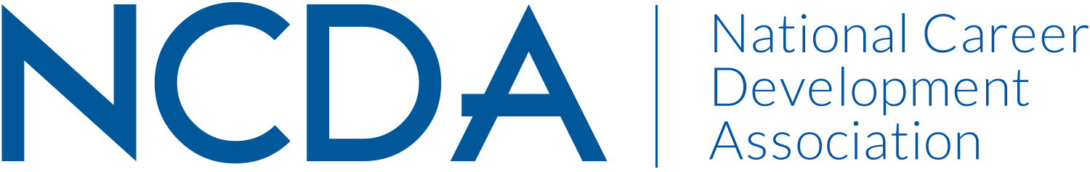

Mid-Year Report

Please prepare your report and submit electronically to dpenn@ncda.org by March 15, 2019 with a copy sent your Board Liaison. These reports will be posted on the NCDA Website.

INTERNATIONAL STUDENT SERVICES COMMITTEE
Date of Report: March 11th 2019

List the Chair and Co-Chair with full contact information and e-mail addresses
- Co-Chair: Nicole Anderson, nicole.anderson@tufts.edu
- Co-Chair: Vanessa Lee, vanessa.lee@ucr.edu

List Committee Members (no contact information required)
- Satomi Chudasama
- Elif Balin (Co-Lead of Research & Writing Subcommittee)
- Un Yeong Park (Co-Lead of Resource Subcommittee)
- Caroline Ray
- Leigh Mason
- Breanna Gallagher
- Kelly Woods
- Arame Mboji
- Sonia Liang
- Ellen Goldman
- Vera Chapman
- Kendra Nothington
- Kwan Segal
- Lauren Ptrie
- Lindsey Baltz
- Yangyang Liu
- Tekeia Howard
- Terah Davis
- Jeff Davis (left in Feb 2019 due to change in position)
Activities to Date

- 2 Annual Conference Presentations for Houston 2019
  - #611 Advocating for International Students' Career Success through Strategic Campus Partnerships
“In this presentation, we will discuss strategies for career services to collaborate with international student services and other student services units to create institutional support and advocacy for international students. Participants will take away specific resources and best practice ideas from panelists from various types of higher education institutions.”
  - 2-8 Building Connections on a Global Scale: Networking Interventions for International Students
“In this session, we will provide sample resources to attendees and facilitate an engaged discussion on networking skills and strategies for international students across and beyond the U.S. market.”
- Critical review of and redrafting and finalizing our existing LinkedIn group policies
- Hosting a webinar in May 2019 (tentative date: May 21 2019) via NCDA on topic of working with 3rd party vendors who provide services to international students and universities (using examples from ISSC’s Resource Guide)
- Participated NCDA Awards selection process with Awards Committee; made nomination for an NCDA award
- In discussion with committee members to explore publication of work in Career Convergence Magazine
- Co-Chair Nicole Anderson collaborating with committees (Government Relations, Global Connections, Diversity and Inclusion, NCDA Leadership) in conceptualizing a system for NCDA’s advocacy statements
- Co-Chair Nicole Anderson and member Yangyang Liu participated in conference proposal review process
- Research team will resume activities started last fiscal year including revising a survey for career practitioners who work with international students
- Identify and onboard one new co-chair; Vanessa Lee will continue to serve and Nicole Anderson will step down after two years; they will identify a 2nd new co-chair in early 2020

Projected Plan through fiscal year end (September 30th)

- Host webinar mentioned above in May 2019
- Finalize and publish updated LinkedIn group policies
- Research team will resume activities started last fiscal year including revising a survey for career practitioners who work with international students

If you received funding for your work, what specific outcome(s) benefited NCDA?
No

