National Career Development Association
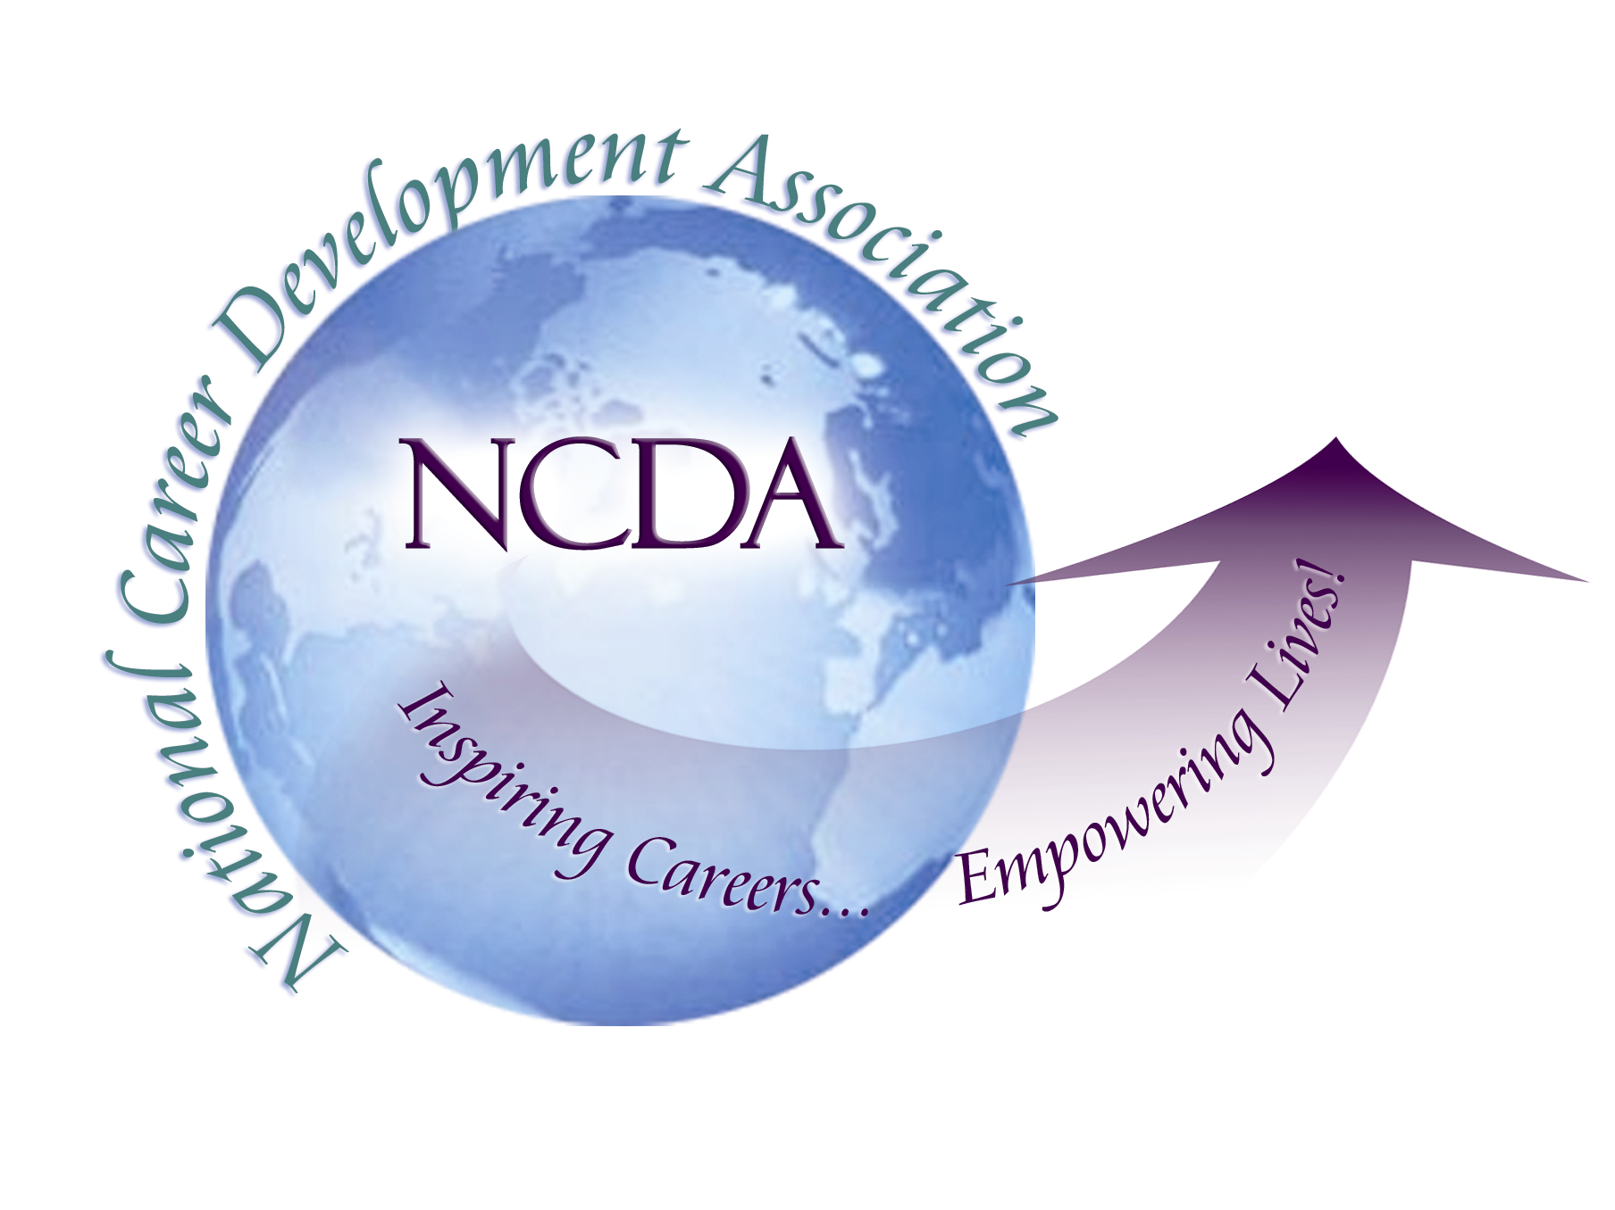
305 N. Beech Circle
Broken Arrow, OK 74012
918/663-7060
Fax: 918/663-7058
www.ncda.org

National Career Development Association
Leadership Academy
Project Summary

Participant(s): Julie Salzman

Board Mentor: Michelle Beese

Leadership Academy Class: LA V, 2010-2011

Project Title: Starting a Local Chapter of CDA in the San Francisco Bay Area

Project Description:

This Leadership Academy project is about the development of a San Francisco Bay Area Chapter of CCDA. We have a nine-member council who meets monthly for plenary sessions in the San Francisco Bay Area. In the first year, we have completed both community service events and professional development round table events. We have developed a mission statement, values statements, and a website which has attracted a membership of over 70 professionals. To our membership we offer email updates of local San Francisco Bay Area career-related professional development events sponsored by NCDA, CCDA, and other local organizations, networking opportunities, and invitations to volunteer with local community service events.

Summary:

The resurrection of a San Francisco Bay Area CCDA Chapter has been embraced by the community thus far. The hope is that this chapter continues to grow and to stay viable, increase public awareness about career options, and bring more reasonably priced professional development and networking events to this area of California. With the Council members that are in place today, there is momentum. Outreach to our membership in order to keep the momentum going is the goal for coming months.

This experience has been a pleasure overall. More than anything, I have enjoyed the professional camaraderie and relationship building within this group of career professionals. One of the main reasons that I wanted to initiate a local chapter was for such interaction and that has absolutely been a success. We have brought career professionals together, face to face, to share resources, and ultimately, to build community.

Results/Recommendations:

The first challenge to restarting this local chapter of CCDA was finding someone to head the project with. As soon as there were two of us, the ball was rolling and there have been very few bumps in the road. Then, once we had the commitment of the other Council members and developed a productive relationship with the California CDA we gained even more momentum and have been rolling along relatively smoothly.

An important result of this organization is the interaction of the Council itself. The 9-10 of us who attend and participate on the plenary council have also started a few other professional groups for our individual professional development and for networking. Before, or after, each monthly meeting, different members connect for dinner, socializing, networking and professional discourse. A few Council members also meet for bi-monthly case conferencing. We have developed a local community network of career professionals who share a common vision: the necessity of advocacy and public awareness in order for this profession to continue to be viable.

However, there are always parts that could run better. Some recommendations for potential future chapters are as follows.

First, it can be helpful to work closely with the CDA at both the State and National levels, especially when it comes to policy. Our California CDA Board has recently updated their bylaws and policy regarding local chapters which has been helpful. Although, one ongoing issue is the way in which the local chapters are expected to manage their finances. This system could be revised for better service to the local chapters.

Second, it is important listen to your predecessors, but also to consider the needs and desires of incoming members. Former CCDA presidents and also former Bay Area CCDA Council members were always willing to share information with us in order to continue the forward movement of career professionals at a local level. At the same time, it is important to hear what professionals need presently. By formally and informally surveying the local CDA members and students, delivery of services to members has been adjusted accordingly. For this reason, the Bay Area CCDA has meetings and events in the East Bay as well as in San Francisco.

Next, we would like to increase the diversity of our Council. At present, we are all women and we have a White majority. Ideally, we would have more cultures represented and always work to this end.

Further, because of the number of people on our Council and also the commute to the meetings, 100% attendance at council meetings is not required, but updates are requested via email prior to the meetings as necessary.

Finally, we recommend creating a mission/vision, values statements and a financial plan which can help the organization to be sustainable over time. When starting with this type of structure, the members and the Council know what to expect from the organization. There is a clear focus and the events are in line with the mission/values statements, which also support the CCDA/NCDA, and members can see immediately how they will benefit from joining this organization as well as opt out if they decide this is not what they want. In this way we are able to get a better fit within the membership. Additionally, event logistics often work more smoothly with a financial plan, especially considering the common lack of seed money available to new chapters, and the cost of event space (and parking) in an area such as the San Francisco Bay Area.

