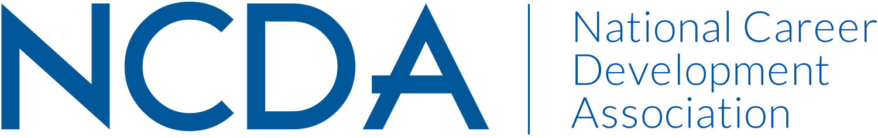

Annual Report

GOVERNMENT RELATIONS
SEPT.17, 2019

Current Co-Chairpersons: Diana M. Bailey dibailey@comcast.net
Mike Marlow- retires Sept. 30, 2019
Seeking new co-chairperson asap -October 1st
List Committee Members (no contact information required)
Rebecca Dedmond, Niel Carey, Lisa Severy, Natalie Kauffman, Raza Abbas, Rahsaan Bartet, Jason Ortega, Rae Ann Stout, Cynthia McDuffie

Activities to Date
- Successfully secured agreement from the Department of Labor’s Employment and Training Administration office to speak at the 2019 NCDA Conference. Unfortunately, personnel changes negatively impacted those plans.
- The Committee subsequently followed up with DOL to plan a November Webinar session with ETA and NCDA membership
- Re-engaged with the American Counseling Association at the most senior leadership level, including ACA’s President and new head of Government Relations. Currently, building a new partnership in the GR space that builds on history of the two associations and personal relationships.
- Maintaining relationship with the House Veteran Affairs Committee and key staffers interested in continuing to improve the services offered to service members and those transitioning to civilian life. Working closely with the NCDA Veterans Committee on long-term goal to provide veteran specialized training.
- Creating increased awareness on the hill of both NCDA and the value of the credentials that the Association has invested in developing. Including bringing Mr. Leson to DC for Hill meetings, engaging with the leading champions of workforce development and senior higher education staffers to highlight the value of NCDA credentialed career practitioners to legislator’s goals of increasing workforce participation and higher education outcomes.
- Positioning the Association to better take advantage of the intense focus on increasing investment in workforce development
- Nominated Sen. Kaine for the Government Relations Award. He was approved. DB has the plaque and will present to the Senator in his office or his staff in the coming months.
- Jason and DB attended many group sessions during the 2019 conference. Feedback was very positive.
- Coordinated with 3 NCDA Committees, Diversity Initiative & Cultural Inclusion, Global Connections and International Student Services, and President Elect, Kathy Evans, to craft an advocacy process that was approved by the NCDA Board which allows any NCDA member to submit an advocacy issue directly to a board-appointed Advocacy Contact. (This past year it was Spencer Niles.)
- Mike Marlow established the first meeting with DOL/ETA staff. As a result, NCDA will host a webinar on Nov. 3, 2019. Extensive planning has occurred over the last several months. Alicia has provided solid staff support to get the resources needed and prep for the session.
- DOL and Apprenticeship resources have been updated on the NCDA website.
- Continue to attempt to more closely link with state CDA’s to get more engagement for state GR contacts. Many states do not yet have state GR contacts. DB has contacted Carolyn Jones for planning for next year.
- DOL was selected to provide a designed session at the Conference. For multiple reasons, no DOL staff was available to attend the 2019 conference. There is interest at DOL to try to provide a session at the 2020. DB will continue to plan with DOL contacts at ETA, Apprenticeship and CareerOneStop.
- Jason and the GR committee provided feedback re the Credential White Paper that will be shared soon with legislators, agencies, etc.
- During the conference, DB and several GR members discussed briefly with Cheri Butler re IF there would be a value to convene a type of coordinating council of organizations promoting career development services and counselor supports.

Projected Plan through fiscal year end (September 30th)
- HILL Day: Jason is currently planning for Aaron and the GR committee members- Sept. 26th. Appointments with legislators are in process.
- Secure a co-chair asap
- Continue to plan with DOL for the webinar and resources to the website.
- Confirm, through our NCDA Board Liaison at the October Board Meeting, whether or not this Advocacy Contact will remain the same for the 2019-2020 year.
- Followed the recently crafted advocacy process to bring to question a possible response to an issue brought by our Global Connections Committee co-chair, Soonhoon Ahn, regarding our Hong Kong members.
If you received funding for your work, what specific outcome(s) benefited NCDA?
- LobbyIT is paid for Tier One level of services. See also Jason’s monthly report that are also posted on the website and shared with other partners. No other funding is currently provided. $12,000 annually

