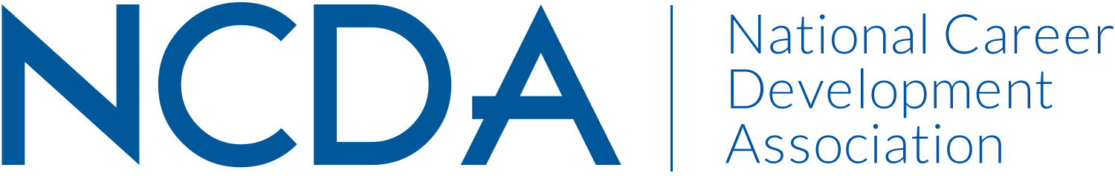

Annual Report Template

Please prepare your report and submit electronically to dpenn@ncda.org by September 10, 2019 with a copy sent your Board Liaison. These reports will be posted on the NCDA Website.

VETERANS COMMITTEE
August 21, 2019

Co Chairperson’s Names Emily Sawyer Kegerreis, Charles Lehman
Preferred Mailing Address E 732 Idlewyld Dr Middletown, DE 19709
C 4419 4th NW Albuquerque, NM 87107

New Chairperson: Rachel Coleman
*Committee Member List Attached Separately

Activities to Date:
- Supported development and completion of a needed veterans career counseling curriculum as a joint Leadership Academy project by two committee members.
• Completed participation on a congressional taskforce to revise the military separation program (TAPS) by providing career counseling recommendations.
• Held committee meeting at 2019 NCDA Annual Conference.
• Met with member on work eligibility issue for military spouses at overseas military base.
• Continued monthly committee communications and recruitment activities.
• Attended the 2019 USDOL/National Association of State Workforce Agencies Veterans Conference for information about current and new veterans public and private employment programs and initiatives.
• Recruited new co-chair and introduced at national conference (Rachel Coleman)
• Coordinated activities with Government Relations as appropriate
- Quarterly communication with Jason Ortega/Lobbyit to discuss relevant veteran-specific legislation

Projected Plan through fiscal year end (September 30th)
- Continue to work with Leadership Academy team to develop a veterans career counseling PDI for the 2020 annual conference.

If you received funding for your work, what specific outcome(s) benefited NCDA?

- Attendance at the NASWA Veterans Conference provided report information to committee members on career counseling and job search practices and provided contacts to solicit for Annual Conference attendance and exhibiting.

