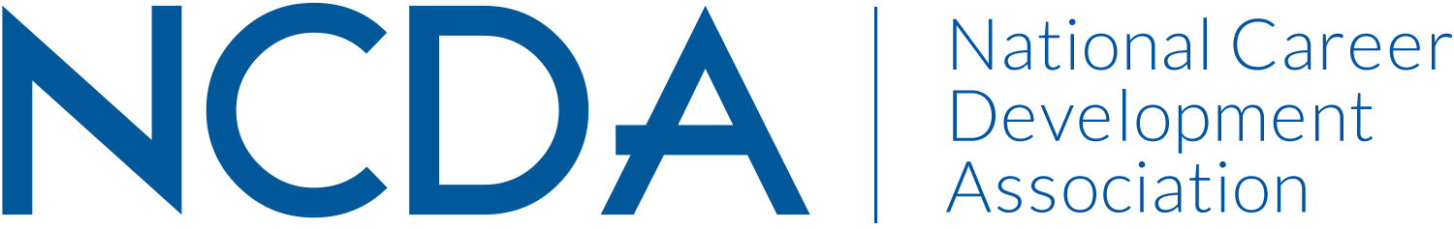

Mid-Year Report 2020

GOVERNMENTAL RELATIONS ACTION COMMIITTEE
March 18, 2020 (Revised following State/Fed updates)

- Work Group Name- Government Relations Action Committee
- Chair Name and E-Mail Address: Diana M. Bailey dibailey@comcast.net 443-996-1788
- Co-Chair Name and E-Mail Address –VACANT (NEED HELP WITH REPLACEMENT AND SUPPORT)
- Jason Ortega, LOBBYIT jortega@lobbyit.com

Committee Members: Rebecca Edmond, Niel Carey, Natalie Kauffman, Rahsaan Bartet, Steve Myers, Rae Stout, Amy Policastro Schroeder, Cheri Butler, Charles Lehman (BD Liaison) Additionally, we have 31 Government Relations/Legislative contacts across 25 states & Pakistan for 2019-20.

Activities to Date
- Worked with NCDA HQ to update Government Relations/Legislative Contacts across NCDA’s chartered and active states for 2019-20 which resulted in 31 Government Relations/Legislative contacts across 25 states & Pakistan.
- Created a Roster of 5 NCDA GR committee members to act as NCDA Government Relations Committee State Coordinators.
- Kept the 31 Government Relations/Legislative Contacts updated monthly.
- Hosted a NCDA webinar with DOL/ ETA office staff. Over 75 NCDA members attended in Nov. 2019 and earned CEUs.
- The end of 2019 was focused on impacting the Langevin/Thompson reintroduction of the Counseling for Career Choice Act. This bill is unique in that it places the emphasis on the need for well-trained career counselors in schools who are equipped with the information necessary to direct students into career paths that fit them and their region. We were able to make an impactful difference through placing the focus on career counseling throughout the bill and inserting language that empowers states to implement credentialing programs provided by national organizations, like NCDA.
- The beginning of 2020 has been focused on engaging with stakeholders and NCDA membership, while seeking to build support for the bill. Jason Ortega attended the CCD Summit, presented during a webinar for the membership, and presented at the ACCA conference on February 28th. The ACCA opportunity was presented to Jason Ortega by the ACA government relationship team as a result of the stronger relationship that we’ve been building since last year with that part of the ACA. ACA also assisted in getting the word out regarding the Counseling for Career Choice Act.
- Recently, Jason was able to engage CompTIA, a large information technology trade association regarding the bill and they’ve indicated that they intend to put their resources behind supporting the bill.
- Our overarching strategy is to engage on issues that are active on the Hill and educate Members and staff on NCDA’s viewpoint that not only is career development an important component in building a qualified and satisfied workforce, but also that those providing career advising should be properly trained in order to maximize efficacy. We have additional opportunities with the new apprenticeship bill in the House and the upcoming reauthorization of WIOA.

Projected Plan through fiscal year end (September 30th)
- Identify a Government Relations Action Committee co-chair.
- During the conference, Jason Ortega, Lobby IT will meet with the BD members, First Timers, GR Sessions; state CDA leadership and co facilitate during one of the concurrent sessions to describe our legislative agenda and next steps.
- If possible, within the budget, please increase the level of services from LobbyIT. We have made some solid efforts, but with more time, additional outcomes can be achieved.
- Continue to expand the relationship with DOL. During the conference, GR team members will interact and also discuss what next steps would be good for the remainder of 2020. The US Dept. of Labor has an approved designated session to be held during the conference. Additionally, Career One Stop is an annual vendor as well sharing DOL COS resources and linkages.
- Continue to provide information and resources to members and our 31 state Government Relations/Legislative Contacts.
- Work with NCDA HQ in the fall to again update our state Government Relations/Legislative Contacts utilizing new NCDA STATE DIVISION LEADERSHIP REPORT data.
- The GR chair and Jason Ortega will attempt to present the 2019 GR Award to Sen. Tim Kaine during the Career Pathways Summit where Sharon Givens will also be in attendance.
***** Given the virus pandemic, this conference has since been postponed. GR members will continue to seek ways to connect wish the Senator to finally present the plague for 2019.
- Chair and Jason will identify key staff member in the Congressional offices to inform them of the Congressional awards from NCDA GR 2020 and invite them to the conference if possible.

