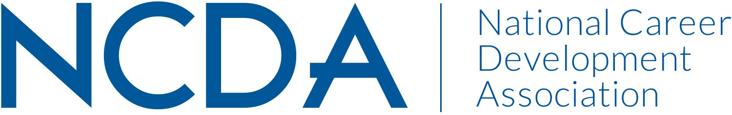

NCDA 2020 Election

Member Voting July 20, 2020 – August 31, 2020

Candidates Biographies

Inspiring Careers – Empowering Lives

305 N. Beech Circle, Broken Arrow, OK 74012
www.ncda.org

SLATE OF CANDIDATES

President-Elect-Elect

Brian Hutchison
Lakeisha Mathews

Secretary

Julia Makela
Jacqueline Peila-Shuster

Trustee for Higher Education Career Counselors and Specialists

Catherine Voss Plaxton
Diandra Prescod

Trustee for School Career Counselors and Specialists

Celeste Hall
Sherry Williams

Brian Hutchison, PhD, LPC, CCCE
Candidate for President-Elect-Elect

Brian Hutchison is a counselor educator at Walden University and career coach/counselor/consultant through his personal brand Global Career Guy. As a counselor educator, Brian has demonstrated effective leadership as a Department Chair for a program of 200 students focusing on Clinical Mental Health and School Counseling. He primarily focuses on clinical and career courses in the program. As Global Career Guy, Brian partners with clients, practitioners, and educators from more than 40 countries around the globe.


Brian has a long history of service to NCDA and its affiliate organizations. Currently, Brian is the Founding Editor of the Asia Pacific Career Development Journal, a Board Member of the Asia Pacific Career Development Association (a previous NCDA affiliate), Editorial Board member of the Career Development Quarterly, and a member of the organizing committee for the New Jersey Career Development Association. He is the immediate past Treasurer of NCDA, a past President of the Asia Pacific Career Development Association and the Missouri Career Development Association, past Chair of the NCDA Global Connections Committee, and graduate from early cohorts of both NCDA’s Leadership Academy and Counselor Education Academy, where he continues to present each year.

Brian earned a Master’s and Ph.D. degree from the Pennsylvania State University in Counseling (with a Career Emphasis). He has more than 30 publications including the book International Practices of Career Services, Credentials, and Training Monograph which was published by NCDA. He was the 2015 recipient of the Humanistic Advocate & Social Justice Award from the Association for Humanistic Counseling.

Goal Statement:
NCDA is at an important moment. Our organization is working to understand and adapt to issues around globalization, technology, and diversity and inclusion. Doing this, we must stay true to our core mission and values while also expanding our audience so that our tools and expertise remain relevant in a changing landscape. I have been fortunate to work in these areas both as a scholar and leader within NCDA. I will continue work to improve and advance current initiatives including the Credentialing Commission, social media and marketing, engaging coaches and career practitioners, diversity & inclusion, online engagement, and promoting State CDA’s. Engagement is the one talent that I think will be most evident to membership if I am elected. I have a long history of engaging diverse constituent groups, creating meaningful online relationships, sticking with difficult work processes, and demonstrating care for young and new members of NCDA.

Lakeisha Mathews, CCSP, GCDF, CPRW
Candidate for President-Elect-Elect


Lakeisha Mathews is a dedicated career services practitioner with a passion for helping professionals build their brand and achieve their dreams. She currently serves as the Director of the Career & Internship Center at the University of Baltimore and is also the Owner and Primary Career Coach for her company, Right Resumes and Career Coaching, LLC. Lakeisha holds a B.A. in Communication from the University of Maryland at College Park, a M.S. in Human Resources from Towson University, and is currently pursuing her Ed. D in Higher Education Leadership from Wilmington University. Lakeisha serves on the NCDA Board as Trustee-at-Large and previously served as the Trustee for Higher Education Career Counselors and Specialists.

Lakeisha also holds several industry certifications including the Certified Career Services Provider, Global Career Development Facilitator, and Certified Professional Resume Writer and Career Coach. Lakeisha co-authored the book Find Your Fit: A Practical Guide to Landing a Job You’ll Love published by ATD and has been featured in several online publications.

Lakeisha served as the President of the Maryland Career Development Association (MCDA) from 2011 – 2012. Under her direction MCDA was honored with the 2012 NCDA Southern Region Award and launched its first Tech Café as part of their 2012 state conference. Prior to her presidency, Lakeisha served as the National Career Development Month Chair for MCDA and launched the chapter’s first annual Poetry/Poster contest which produced national contest winners. She received the 2012 MCDA President’s Award for her work with the contest. She is also an alum of the NCDA Leadership Academy, Class of 2012 and was chair of the NCDA Career Development Month Committee in 2016.

Future Contributions & Personal Statement:
As a seasoned career development professional and long-term member of NCDA, I aim to help NCDA define, operationalize, and achieve our strategic priorities. This includes continuing to grow competency-based credentials, developing a culture of planning and outcomes assessment, working to enhance and expand in-person and virtual professional development opportunities, ensuring the needs of all membership constituency groups are heard, and broadening international outreach to increase membership. I will bring a spirit of innovation, creativity and collaboration to merge the past with the future and ensure that all members are equally valued and have a voice. My focus will also be on social justice and equity within our organization and among the populations that we serve. Finally, I will be a future thinking leader, helping to secure NCDA’s future as the premier career development organization globally.

Julia Makela, PhD
Candidate for Secretary

Julia Makela is the Associate Director for Assessment and Research of The Career Center at the University of Illinois at Urbana-Champaign. With more than 20 years of experience in career development, Julia’s work focuses on helping career practitioners bring out the best in their programs and services. In 2019, Julia was recognized as a NCDA Fellow, acknowledging her scholarship, leadership, and contributions to NCDA.

Julia specializes in facilitating practitioner-engaged program assessments that gather evidence to inform and continually enhance career development practice. She develops resources and builds communities to communicate the value of career services. Julia is the lead author of NCDA’s program assessment monograph, Learning outcomes assessment step-by-step: Enhancing evidence-based practice in career services, as well as various assessment-related journal and professional association publications. She also established and maintains the Assessment and Research in Career Services (ARCS) Network, which facilitates conversation and collaboration among career services professionals nationwide who are engaged in assessment and research within practice environments.

For NCDA, Julia serves as a member of the Ethics Committee (2005-present; Chair 2009–2012). She assisted with two revisions of the NCDA Code of Ethics (2007, 2015), led the conceptualization and development of the Ethics in a Nutshell column in the Career Developments Magazine (contributing 11 articles in 10 years), wrote two NCDA ethics case study monographs (2009, 2017), and more. Julia is also a member of NCDA’s Publications Development Council (2012-present), helping to identify, review, and share resources to enhance practice across our field.

Julia earned a Ph.D. in higher education from University of Illinois, a M.S. in counseling from Florida State University, and a B.S. in computer science from Cornell University. She was a member of the inaugural 2006-2007 NCDA Leadership Academy.

Goal Statement:
I have dedicated my career to exploring and communicating the value of career services. As a member of the NCDA Board, I look forward to additional opportunities to highlight evidence of the value of career services on a national scale, as well as to share efforts to improve the quality of the work that we do. To accomplish this, I would continue to embrace a collaborative leadership style in liaison work supporting association committees and task forces. I would actively participate in Board discussions and listen to membership needs, recording input in ways that provide high-quality information for decision-making. I most look forward to communicating the good work and future directions of our association in order to bolster our foundations and contribute to the continuing vitality of the career development field.
Jacqueline Peila-Shuster, PhD, LPC, NCC
Candidate for Secretary
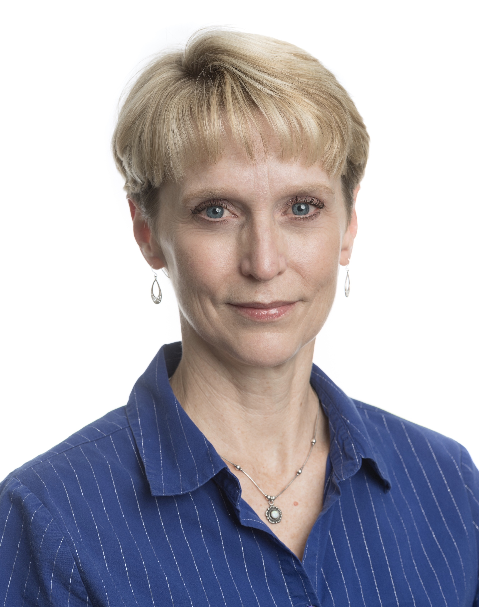
Jacqueline (Jackie) Peila-Shuster is an Assistant Professor in the Counseling and Career Development graduate program at Colorado State University in Fort Collins, Colorado. She teaches four courses in career development, supervises counseling internship and practicum, and serves as the Program Coordinator and coordinator of the Career Counseling specialization. She was a member of the 2017 NCDA Counselor Educator Academy, has over 15 refereed publications focused on career development and counseling, contributions to NCDA publications, and has regularly presented at NCDA over the years. Furthermore, she is honored to be faculty with the Career Construction Network as well as a humble recipient of the Colorado Career Development Association’s Rich Feller Leadership Award.

Jackie received her Ph.D. in Education and Human Resource Studies with a focus on Counselor Education and Career Counseling. She also has a master’s degree specializing in Counseling and Career Development and a B.S. in Occupational Therapy.

Goal Statement:
My goal in serving NCDA is to help us construct a positive future that connects to the richness of our past. Much like career construction, I want to help us tell and hear our stories in ways that can connect our past to our present and will give us meaning and direction as we construct our future. Furthermore, we must find ways not only to hear ALL voices, but also to understand whose voices have not been considered but MUST be. That is the only way we can connect our past roots in social justice to our future possibilities in a manner that will propel us forward into a world that demands NCDA be a leader in advocating for inclusive excellence and justice.

I have earned the reputation of being a dedicated and collaborative leader who is diligent and willing to go above and beyond in everything I do. I am also people-focused, authentic, and compassionate as I draw others out to gain new perspectives, consider all voices, and make collaborative decisions. I have long been truly touched by the people in NCDA who care so much for each other and for the work we do. NCDA has proven to be my professional home and family with the power to refresh and renew my commitment to walk alongside individuals as they design their careers and lives. Thus, it is with deep humbleness and gratitude that I seek the nomination for the NCDA Board position of Secretary.

Catherine Voss Plaxton, EdD, PPSC
Candidate for Trustee for Higher Education Career Counselors and Specialists
As San José State University's Interim Associate VP for Student Services and Career Center Director, I lead five functional areas that foster academic and career success for all students. I am proud to serve the Silicon Valley’s only public university, an urban campus that’s among the nation’s most ethnically and socioeconomically diverse. As Career Center Director, I’ve aimed to resolve the discrepancy between student intention to leverage a college degree for career opportunity and relatively low student engagement in career-preparation activities. I’ve led my team to reshape career-education delivery, emphasizing broad access, convenience, and campus partnerships. I’ve trained counselors to integrate learning sciences, behavioral sciences, and eLearning techniques. Because SJSU is on the front line of efforts to increase diversity in tech companies, I’ve invested in underserved students’ social capital through tailored career-development programs, including the campus’ first large-scale, professional-mentoring program tapping Silicon Valley alumni connections.

In previous roles, I led global talent-development and information-technology functions in diverse corporate and non-profit organizations. From these experiences, I’ve developed a mix of human- and organization-development strategies to foster learning and behavior change in large populations. I earned an MA in Counselor Education and EdD in Educational Leadership from San José State University. I also received an MA in Human Resources and Organization Development from University of San Francisco. My doctoral research, which explored the impact of behavioral-design incentives on student engagement in professional development, was selected for presentation at the American Educational Research Association’s 2020 Annual Meeting. I would like to serve NCDA membership by focusing association efforts on three, interconnected goals:
- NCDA must advocate for broad access to career opportunity. At SJSU, I have had a close view of the dynamics driving socioeconomic disparity. I have developed programs to address that disparity. I would like to help generate national strategies that grow career opportunity for all.
- NCDA must inspire career-development approaches that acknowledge trends in environmental degradation and artificial intelligence. My professional experiences include consulting on sustainable business practices and speaking on the future of work. I believe NCDA must lead in illuminating and legitimizing career pathways that preserve the environment and human agency.
- NCDA must foster new competencies in career counselors. The recruiting process is increasingly digital, skills-focused, and emergent. I and my team have collaborated with LinkedIn, Business Roundtable, and Education Design Lab to explore how competency-based assessment and learning can foster broad student career readiness. I’d like to help career counselors apply learning sciences, behavioral sciences, and eLearning to adapt to this reality.
Diandra Prescod, PhD, LPC, NCC, CCSP
Candidate for Trustee for Higher Education Career Counselors and Specialists

Diandra J. Prescod is an Associate Professor of Counselor Education and Program Coordinator of School Counseling at the University of Connecticut. She served as Program Coordinator for Penn State University’s career counseling program from 2015-2020. From 2019-20, Diandra served as Secretary and is a Charter Member for the Pennsylvania Career Development Association (PACDA) organizing committee. She is a Facilitating Career Development Instructor and has been teaching career planning, counseling, and development courses for the past 9 years.
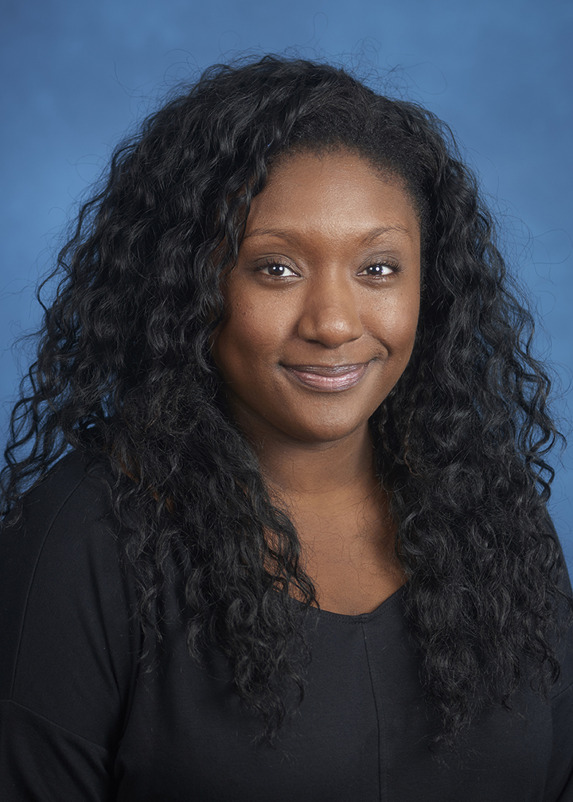

Diandra’s research focuses on career development interventions for STEM students and women/students of color in higher education. She has delivered over 50 national/international presentations focusing on career development theory and practice. Her work has been published in many national journals including the Career Development Quarterly, Journal of School Counseling, and Journal of Employment Counseling.

Diandra received her master’s degree in mental health counseling from Monmouth University and her doctorate from the University of Central Florida. She was awarded with the New Professional of the Year Award from the North Atlantic Region Association for Counselor Education and Supervision (NARACES) in 2018. In 2016 and 2017, Diandra was selected to be an Emerging Leaders Fellow for both the regional (North Atlantic) and national chapters of the Association for Counselor Education and Supervision.

Goal Statement:

NCDA stands on a firm foundation and although the nation is facing unprecedented times, this is a moment for us to continue our mission and truly have an impact. As a Trustee, I will show others my passion for career development, and hopefully excite others about NCDA and the wonderful sense of community it offers. Having a vision allows us to think ahead and have something to work towards. NCDA is an organization that individuals should remain excited about and inspired by; we remain on the cutting edge of innovation in career development. I would like to add to the vision of the organization and think about how this constituency group can collaborate with other groups, and incorporate ideas of diversity, inclusion, social justice and advocacy.

Celeste J. Hall, MEd, CCSP, GCDF, SCDA
Candidate for Trustee for School Career Counselors and Specialists

Celeste Hall is a Facilitating Career Development and School Career Development Advisor Training Instructor, working with the Virginia Community College System providing training and support to a state-wide career coaching program for students in high schools and community colleges. Her education career includes teaching and roles as a school counselor and career counselor in high schools and a technical center. She served on the Advisory Council for FCD training representing K-12 and was a major contributor to the chapter focusing on K-12 in the most current SCDA curriculum. Through the years in addition to NCDA, Celeste has been involved in the Virginia Career Development Association (VCDA), the Virginia Counselors Association and the Virginia School Counseling Association. She has served as president of VCDA and currently is the Treasurer.
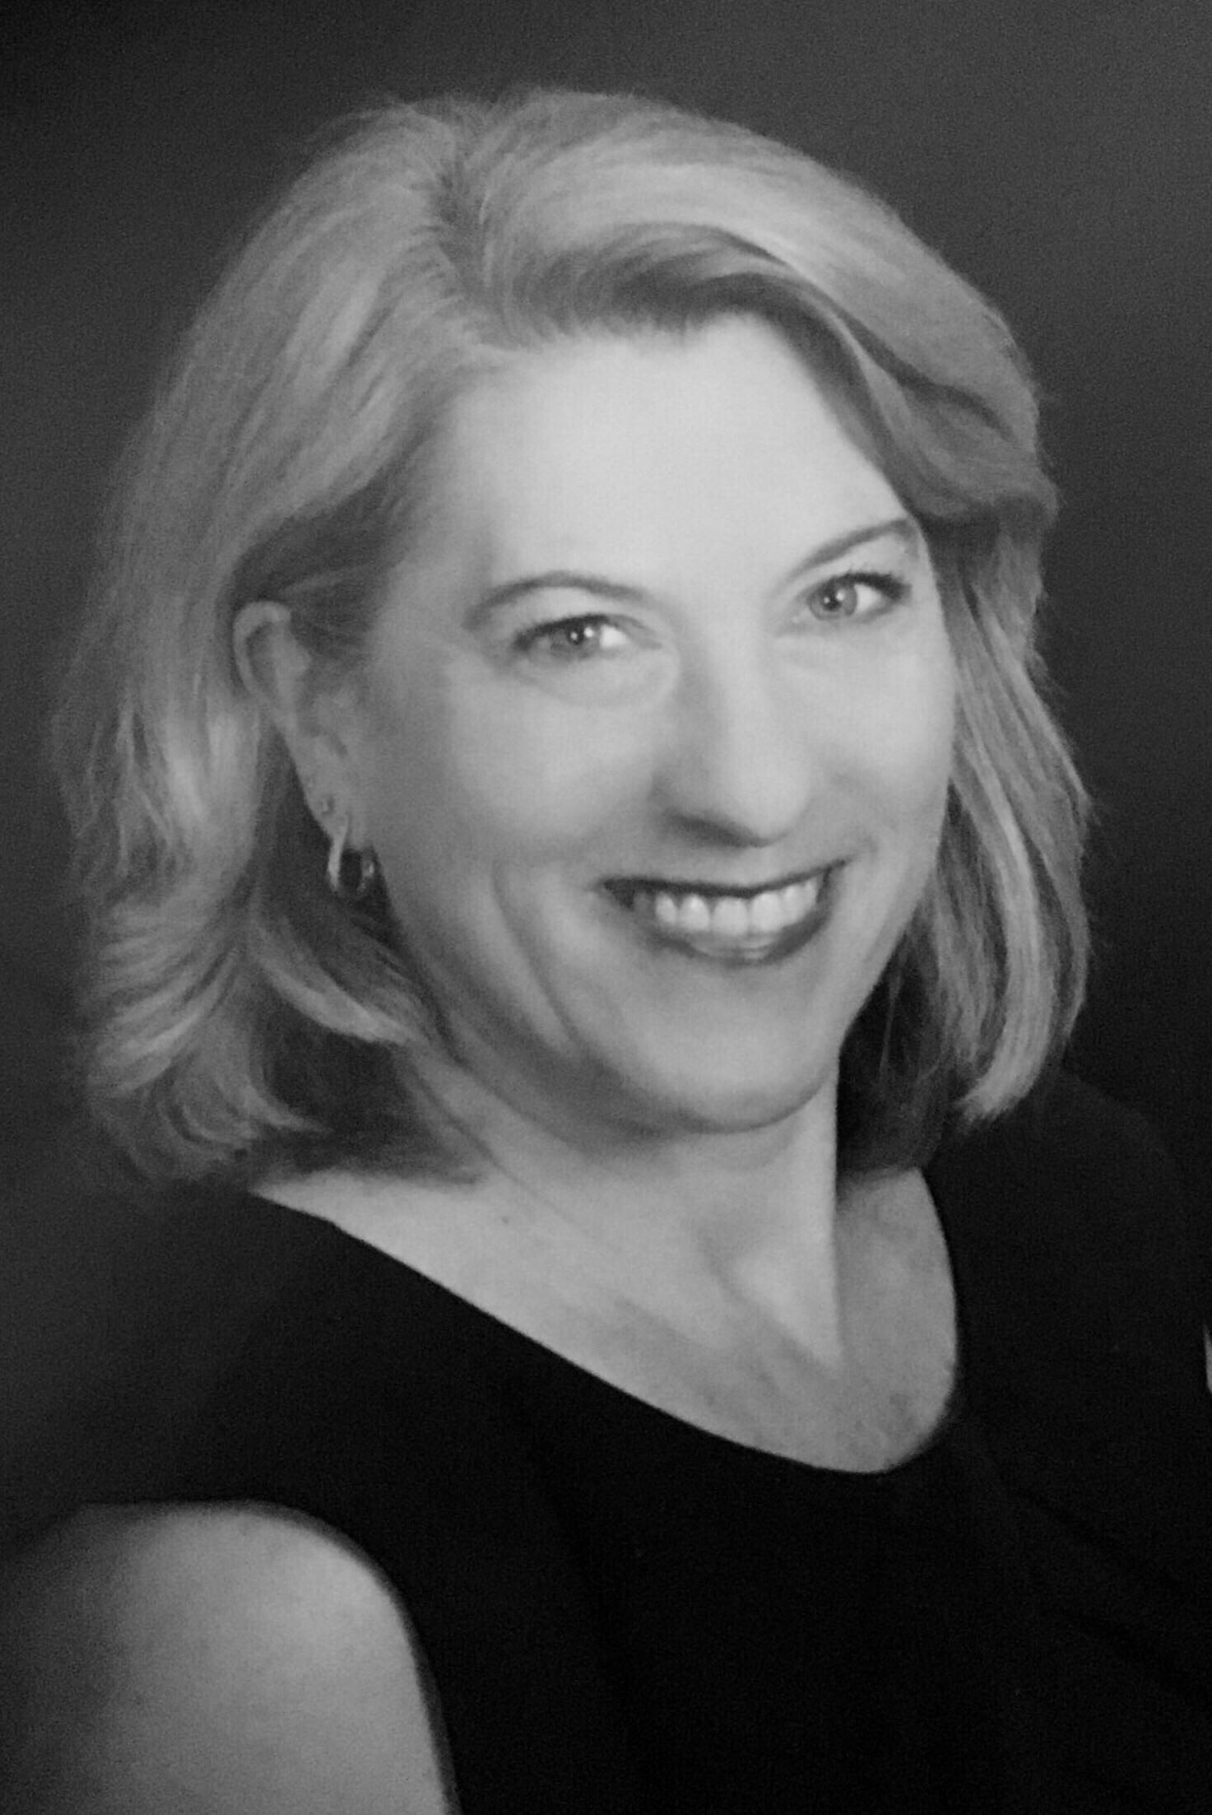

Celeste earned her undergraduate degree in History from The College of William and Mary. She currently holds teacher licensure in Virginia in School Counseling. Her master’s degree in school counseling is from Virginia Commonwealth University where she taught the master’s level course on career development as an adjunct. She was a National Board-Certified Teacher in the school counseling area from 2006 until 2016 and was the recipient of the Secondary School Counselor of the Year award from the Virginia School Counselors Association in 2000.

Goal Statement:

The SCCS constituency makes up roughly 10% of NCDA’s membership. It is my belief, that this statistic does not adequately represent the importance of the contributions made by those who provide career development services in K-12 schools. A focus on K-12 is essential for our organization to address issues related to the Future of Work and preparing the next generation to thrive in their work and life. We must inform more career practitioners who work in K-12 about the ways that NCDA will benefit their work and enrich their lives. In recent years on the Board, I have worked with the Training and Education Council and the Credentialing Commission to ensure that instructors with K-12 experience were trained to deliver the new SCDA curriculum and to provide the opportunity for those working in K-12 to earn a credential that demonstrates their competency. I have followed the work of the Coalition for Career Development to advocate for School Career Development Advisors in every middle and high school. The recent Counseling for Career Choice Act with bipartisan support is another indicator of the current focus on the need for more career development in K-12. My goals include continued support for professional development opportunities that meet the needs of our constituency, expanded support for the Poetry/Art Contest, which is one of our signature initiatives and continuing to equip those who work in schools to be change agents working to infuse much-needed career development programming. I pledge to continue to listen to your ideas and concerns and to always keep the needs of our members in the center of every thought and vote that I cast as a Trustee of the NCDA Board of Directors.
Sherry Williams, MEd, LBSW, GCDFI, MBTI Step 1 & 2,
CMCS, CSCDA
Candidate for Trustee for School Career Counselors and Specialists

Sherry has provided targeted direct services to students and adults for more than 35 years working in state government, the private sector, K-12 education, and higher education. Jobs within her career have included social worker for people with developmental disabilities at Babcock Center (1985 - 1991); abuse investigator for vulnerable adults and Director of Social Work and Community Relations for the SC Department of Disabilities and Special Needs (1991 - 2000); a career counselor at Piedmont Technical College (2001-2005); career specialist in Lexington School District Two (2005 - 2007); Career Specialist Liaison with the SC Department of Education (2007 - 2014); she joined Lexington School District One as a career specialist in 2014 and in 2015 was promoted to Coordinator of Leadership Curriculum and Work-Based Learning where she supervises the career specialists who ensure that 27,000 students receive career awareness, exploration and guidance services and are career and college ready. She is a subject matter expert of the Education and Economic Development Act of 2005 which propelled career development in the state of South Carolina, placing career specialists in all public middle and high schools, and is an instructor of the CCE GCDF curriculum and the NCDA FCD and SCDA curriculums. A member of SCCDA, the 2019 NCDA Emerging CDA of the Year, Sherry is the current President and on May 1, 2020, will transition to Past President.
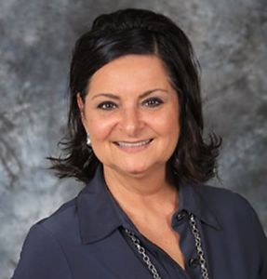

Goal Statement:

My goal in the position of NCDA Board Representative for the K12 constituency is to provide opportunities to collaborate and share resources. The only thing constant is change. The changing landscape of careers keeps the career services provider busy with industry and generational changes as we teach our clients cultural elasticity and the agility to reinvent themselves. With so many factors affecting a career choice, the career service provider has to be a lifelong learner in order to share relevant resources with their clients. Leadership experts such as John Maxwell, Brene Brown, Kouzes & Posner, and others, remind us that leadership requires a vision, the ability to lead-up, and willingness to make mistakes. I look forward to implementing my vision of collaborative e-meetings with our NCDA membership where career development professionals will learn and use their leadership skills. Constituents will be empowered to share best practices with each other to promote career awareness at the elementary level, career exploration in the middle level, and career guidance at the high school level.

