National Career Development Association
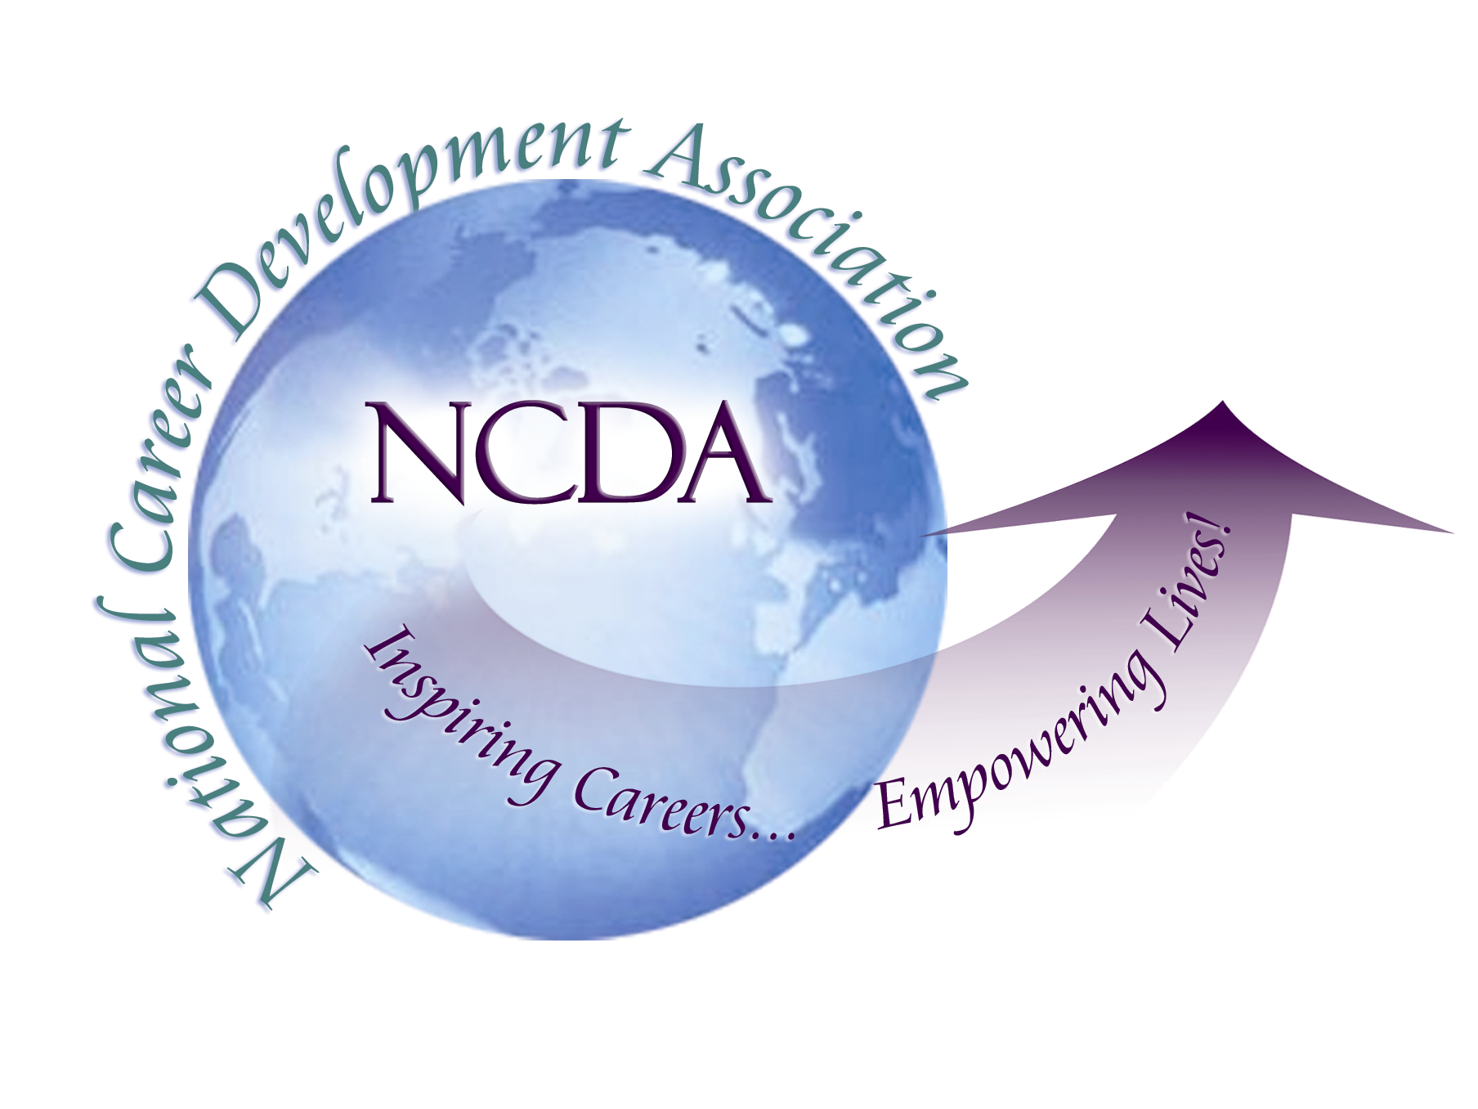
305 N. Beech Circle
Broken Arrow, OK 74012
918/663-7060
Fax: 918/663-7058
www.ncda.org

National Career Development Association
Leadership Academy
Project Summary

Participant(s): Imants Jaunarajs, Oula Majzoub, and Jane Gay

Board Mentor:

Leadership Academy Class: LA II, 2007-2008

Project Title: International Member Needs, Perceptions and Advice for the National Career Development Association

Project Description:
Optimizing NCDA Relationships with Local, State, and Regional Associations. As the world changes in regards to globalization and the nature of “world of work” NCDA is actively seeking to expand its international member base. International members bring expert career knowledge to NCDA programs and professional development activities. As the top career development association in the country NCDA must collaborate with career experts across the globe to effectively serve our local and international clientele. Inclusiveness across our borders is not just important, but necessary for truly effective career development professionals. The current Leadership Academy group decided to expand the international agenda from the Seattle 2007 conference and investigate what international members enjoy, need, and appreciate from being a member of NCDA. A survey was constructed and sent to approximately 600 current and past international NCDA members. Fifty international members completed the survey.

Summary/Conclusion:

1. The majority of completed surveys came from Canadian (nationality/country of residence) members.
2. 43 of 50 members indicated they were between the ages of 36-65.
3. The majority of international members indicated they were either career counselors, professors, or worked in a career services office at a university/college.
4. Most international members indicated they worked in higher education or private practice.
5. 94% of members indicated they have been a NCDA member for less than 5 years.
6. Only 4% of members indicated they were active in NCDA leadership (committees, board, etc.).
7. International members learned about NCDA through ACA, internet searching during graduate studies, and from colleagues.

