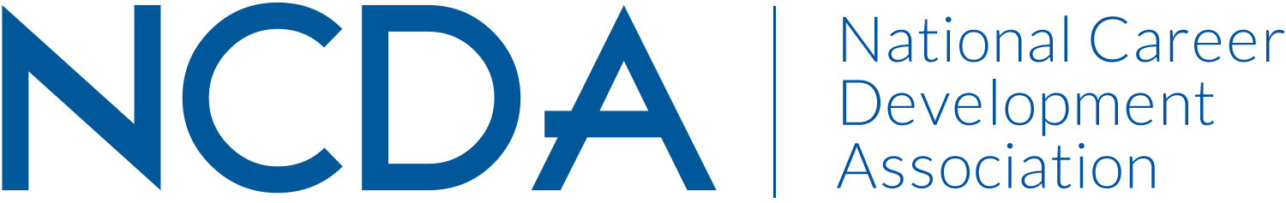

ANNUAL REPORT 2020-2021
PREPARED FOR THE NCDA RESEARCH COMMITEE
September 3, 2021

Chair: Lia Falco ldf@arizona.edu Co-Chair: Sheri Young Sheri.Young@jwu.edu
Board Liaison: Patrick Akos pakos@email.unc.edu
Committee Members:
Brian Calhoun
Nami Bang
Seo Gaeun
Lynette Hepburn
Debra Osborn
Mauli Patel
Chris Pisarik
Andrea Rydel
Mark Scholl
Scott Solberg
Kevin Stoltz
Melissa Wheeler

Activities to Date

- Committee meeting on January 8, 2021.
- Research Award recipients selected and notified on March 2, 2021. The board approved an additional $500, and two proposals were awarded.
- Graduate Research Award 2021 nominations (3) reviewed and winner selected.
- 6 requests to include NCDA members as research participants were received and 5 were approved
- CDQ Article of the year was selected: “From Role Conflict to Job Burnout: A Mediation Model Moderated by Mindfulness” by Park and Nam.

Projected Plan through fiscal year end (September 30th)

- Second committee meeting was planned for May but postponed to September in order to allow for increased member participation. Agenda will include upcoming conference and institutes, recruitment plan, and future vision for committee including outreach to other constituency groups.

