National Career Development Association
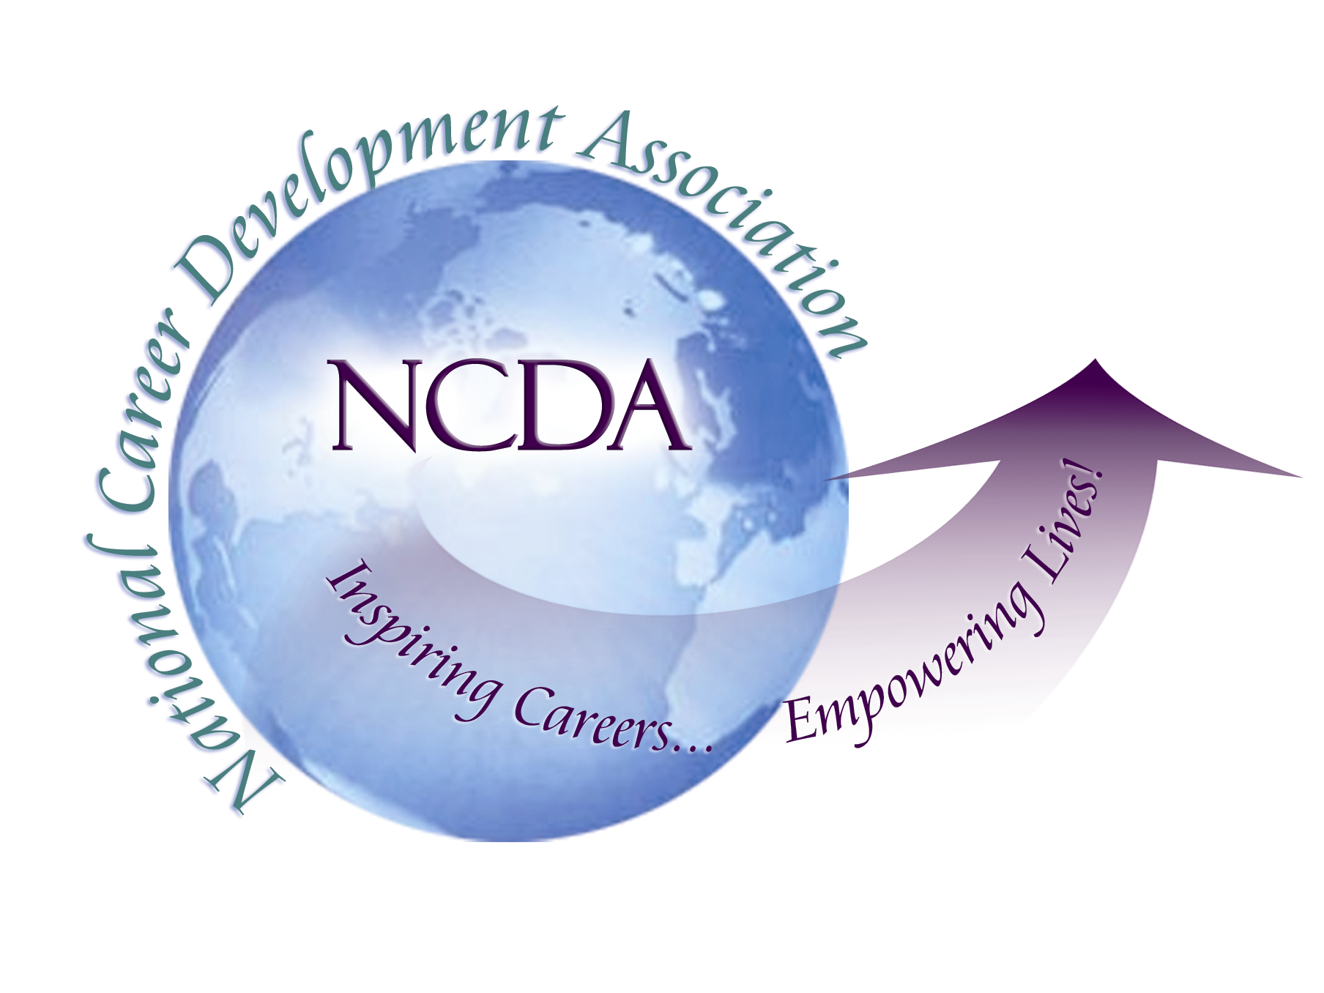
305 N. Beech Circle
Broken Arrow, OK 74012
918/663-7060
Fax: 918/663-7058
www.ncda.org

NCDA MAILING LIST PURCHASE APPLICATION
305 N. Beech Circle
Broken Arrow, OK 74012
(866) 367-6232 ** 918-663-7058 fax

Purchasing Organization
Contact Person
Billing Address
Phone |  |  | Fax
E-mail Address
Purpose for which labels will be used:
Payment Method: Check or MasterCard or VISA # Expiration Date: Authorization Name that appears on Card: Security Code: _______

Procedure:
- Purchaser is required to submit a copy of the material to be distributed to NCDA members along with this form.

- Identify if you want the full NCDA membership or only a portion. Lists may be sorted by:
By state(s): list the states you want
By membership category: (you can eliminate any category; they include professional, regular,
student, new professional, retired)
Do you want international addresses?
Ideally, how many names/addresses are you seeking? (full list is 5400; pricing is based on
1000 per list

- The NCDA Staff evaluates the information for consistency with NCDA Board-established guidelines.

- After approval, the mail list will be provided to you in an ASCII comma delimited format which can be easily merged for mailing labels.

- Mail, fax, or e-mail request and supporting materials to Alicia Kirkpatrick at the above address or akirkpatrick@ncda.org.

- Buyer will be promptly notified regarding the status of his/her request.

- Price: $100/1000 names – (minimum cost $100; number rounded up to nearest 1000)

