National Career Development Association
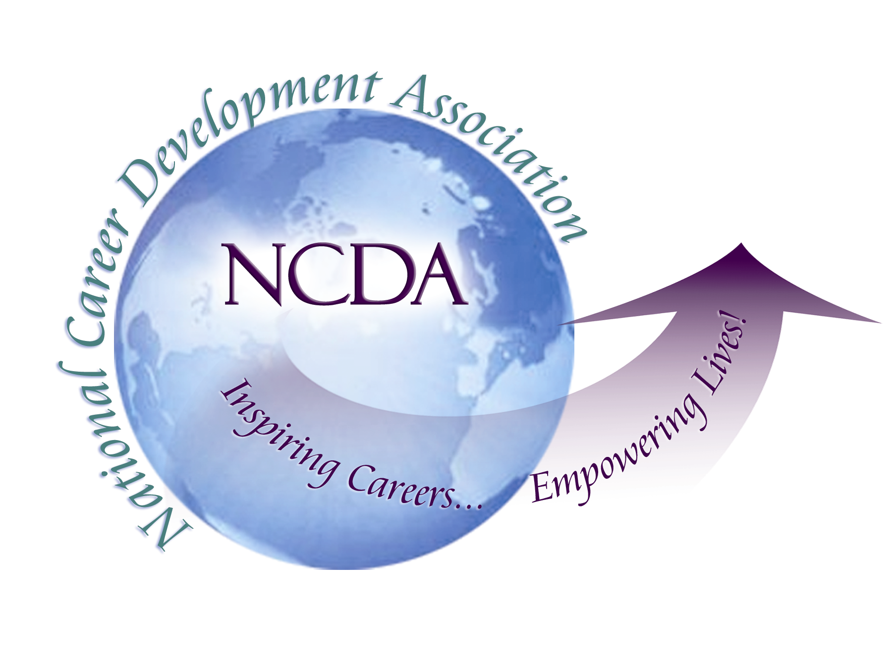
305 N. Beech Circle
Broken Arrow, OK 74012
918/663-7060
Fax: 918/663-7058
www.ncda.org

National Career Development Association
Leadership Academy
Project Summary

Participant(s): Wendy LaBenne

Board Mentor: Rebecca Dedmond

Leadership Academy Class: LA VII, 2012-2013

Project Title: State Association Leadership Handbook

Project Description:
The purpose of the State Association Leadership Handbook project is to update the existing document in order to provide an updated and comprehensive tool for state leaders. Sources utilized to produce the end product included the current NCDA Leadership Handbook; documents and information from the Missouri Career Development Association and one other association; best practices contributed by NCDA Regional Trustee, Paul Timmins; and thoughtful contributions by the NCDA Executive Board. Information from this project will be shared at the State Leadership Training during the NCDA Conference.

Summary/Conclusion:
The impetus for this project was based on the experience of being President of the Missouri Career Development Association (MoCDA) in its second year.

Results/Recommendations:
Serve as:
- a resource guide for those starting new Career Development Associations (CDA)
- a comprehensive resource guide for incoming CDA Presidents
- a checklist for those reviewing and updating their CDAs

