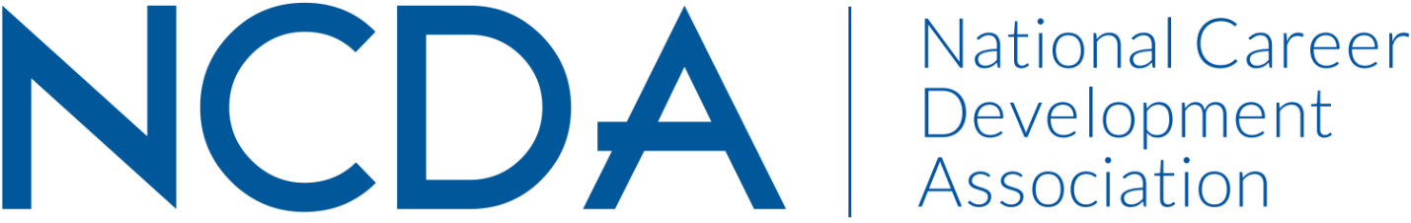
Annual Report 2021-22

CAREER CONVERGENCE, WEB MAGAZINE
August 24, 2022
Melanie Reinersman, Editor, webeditor@ncda.org
Associate Editors: Marty Apodaca, Natasha Barnes, David Dietrich, Linda Evans, Melissa Fickling, Francine Fabricant, Amy Pierce-Danders, Vonya Hodrick, Elyse Pipitone, Billie Streufert, Michelle Tullier, Melissa Venable
Field Editors: Mason Murphy, Janine Rowe, Willa Smith

Activities to Date
- Published new issues on the first of each month (except Jan 1 and July 1), bringing the total issues up to 202 (since 2003); Began conversations about the 20th Anniversary of Career Convergence
- Published 7 new articles, plus one Tech Tip, each month. Electronic distribution to over to 22,000 emails on the first of the month
- Social justice topics are regularly covered and diversity of articles and authors is evident throughout each issue via title, topic, and author bio. Diversity also found in the editorial volunteers
- Presented the web magazine at the 2022 NCDA Virtual Global Conference via a live and recorded presentation on the NCDA website tour, as well as requested presentations
- Recorded 30 day hit rate for each issue’s articles
- Held a zoom call for all editors on Dec 1, 2021 and July 11, 2022; small subset of the editorial team met at the live conference
- Fulfilled 7 author requests for CEs
- Tweeted each month, with links to the issue and each article; new NCDA social media coordinator also shares web magazine
- Selected (by editors’ votes) the annual “Career Convergence Recognition Award” winner who was recognized during the annual NCDA Global Conference.
- Changes in volunteers: Tullier ended her term with the Independent dept and Fabricant stepped down; Evans started; Venable ended time with Features and Pierce-Danders started

Projected Plan/Work Completed through September 30.
- Continue to publish monthly web magazine; encourage diversity in topic and authors and connection to 2023 conference theme.
- Consider co-associate editor needs for two depts.
- Consider a new social media volunteer role
- Follow up work on the content analysis of the web magazine.

