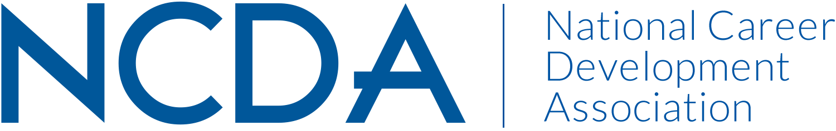

NCDA TECHNOLOGY COMMITTEE
March 15, 2023

Committee Chairs

Jaana Kettunen, jaana.h.kettunen@jyu.fi, Professor, Finnish Institute for Educational Research, University of Jyväskylä, Finland. (Co-chair)

Katherine (Kathyy) Battee-Freeman, kathyy@uis.edu, Director, University of Illinois – Springfield, (Co-chair)

Committee Members
Barbara Thomson
Darrin Carr
Dawna Reeves
Debra Ruddell
Dirk Matthews
Ellen Weaver Paquette
Jaana Kettunen
Janet Wall
Jennifer Villalobos
Julia Panke Makela
Katherine (Kathyy) Battee-Freeman
Leigh Farrar-Freeman
Lisa Raufman
Luke Gormann
Lynne Orr
Tom Dubbels

Committee Activities to Date

- Developed a short video which was included as an “on demand” session during NCD Month Virtual Event the live virtual event
- Continued quarterly reviews of new resources for internet sites
- Submitted monthly Tech Tips
- Revising NCDA Tech Survey

Projected Plan/Work Completed through September 30.

- Recruit a new co-chair
- Finalize the revision of the NCDA Technology Survey.
- Utilize survey results to generate a white paper on technology in career development
- Several members will present at the NCDA Conference this June
- Committee meeting will be held at the NCDA Conference in this June
- Continue with quarterly reviews of new resources for the Internet Sites page
- Continue generating monthly Tech Tips
- Write 1-2 column/articles about technology and career development to the NCDA Online Career Convergence Magazine

