NCDA COMMITTEE REPORT FORMAT

COUNSELOR EDUCATOR ACADEMY - CEA (in CAPS)
8/29/2023

Leadership Information
2022-2023:
- Melinda Gibbons, Chair
Department of Educational Psychology and Counseling
University of Tennessee, Knoxville
450 Claxton Complex
Knoxville, TN 37996
Mgibbon2@utk.edu
- Arden Szepe, Co-Chair
Master of Arts in Counseling Program
Doane University, Lincoln Campus
303 N. 52nd Street
Lincoln, NE 68504
Arden.szepe@doane.edu
- Committee Members
  - Melissa Fickling
  - Jackie Peila-Shuster
  - Tiffany Brooks
  - Elif Balin
  - Carrie Sanders
  - Suzy Wise
2023-2024:
- Arden Szepe, Chair
Master of Arts in Counseling Program
Doane University, Lincoln Campus
303 N. 52nd Street
Lincoln, NE 68504
Arden.szepe@doane.edu
- Jackie Peila-Shuster, Co-Chair
Counseling and Career Development Program
Colorado State University
Education 227
Fort Collins, CO 80523
jackie.peila-shuster@colostate.edu
- Committee Members
  - Melissa Fickling
  - Melinda Gibbons
  - Tiffany Brooks
  - Elif Balin
  - Carrie Sanders
  - Suzy Wise

Committee Activities to Date

- Solicited CEA 2023 applications: received 40 applications
- Committee sub-group reviewed and selected CEA 2023 cohort – 12 cohort members
- Notified 12 cohort members and confirmed attendance and notified NCDA as well
- Submitted a best practices in teaching career counseling panel to ACES – panel consisting of five CEA committee members; presentation accepted
- Planned and facilitated CEA in June 2023
  - 11 participants
  - Co-facilitators: Melinda Gibbons and Arden Szepe
  - Multiple guest speakers
  - Support from CEA committee: Tiffany Brooks, Suzy Wise, Jackie Peila-Shuster, Elif Balin
  - Amazing feedback from cohort members (see below)
- Identified new chair (Arden Szepe) and co-chair (Jackie Peila-Shuster)

Projected Plan/Work Completed through September 30

- Follow-up with CEA 2023 cohort to ensure that they are working on their post-CEA projects

NCDA CEA 2023 Evaluation
11 Participants
Primary Facilitators: Melinda Gibbons and Arden Szepe
Guest Facilitators: Tiffany Brooks, Suzy Wise, Jackie Peila-Shuster, Elif Balin
Guest Speakers: Deandra Prescod, Melanie Reinersman, Lakeisha Matthews, David Ford

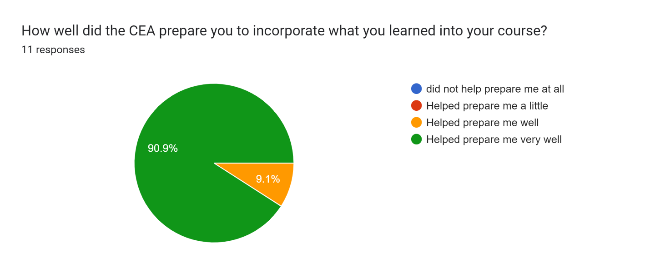
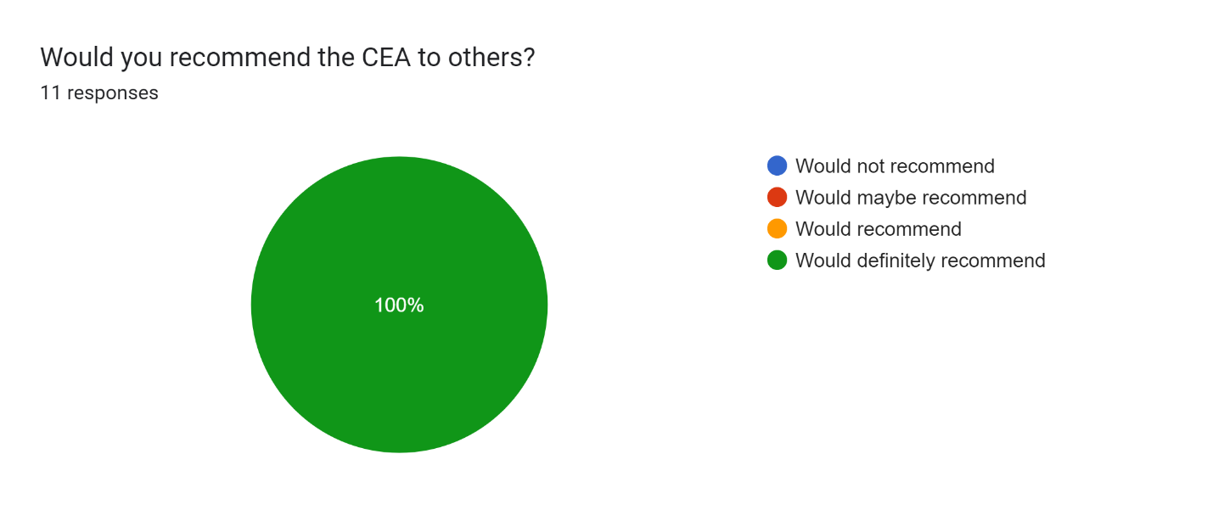

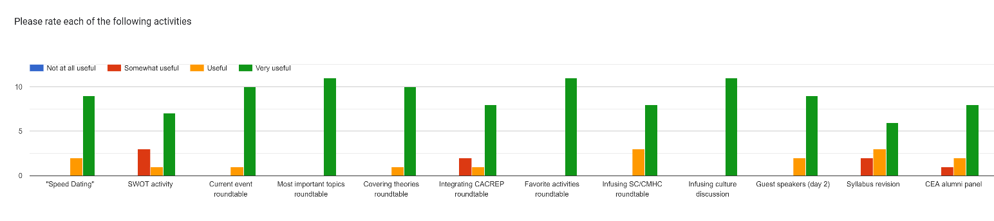

How was your experience with the CEA facilitators?
Absolutely incredible experience!
It was very enriching and validating! They provided wealth of knowledge. Simply amazing!
They were amazing! Very helpful, engaging, knowledgeable and supportive. They fostered true community in this space.
Excellent! Such wonderful, kind, creative, resourceful people!
They were wonderful!
Very very positive
They were so helpful in facilitating the CEA meetings and being accessible and open about sharing how to enhance my work as a career counselor educator.
Excellent. Knowledgeable, responsive to group concerns that emerged: genuine
Very passionate and knowledgeable about teaching career development; very kind and created a sense of community for the CEA members
Fantastic
Great! They were both energetic and made the course engaging. They were also understand of circumstances.

What was your favorite part of the CEA and why?
Everything was my favorite! It was awesome!
My favorite part was the round table series.
Forming community with career counselor educator colleagues. Sharing ideas and resources. Roundtables.
Collaboration
The roundtables were great- good mix of discussion and idea sharing
Connecting and discussing at round tables (and other parts) naturally
The roundtables; I appreciated the opportunity to connect with CEA alumni and facilitators, along with learning from members of the CEA cohort.
Roundtables
The roundtables were really helpful to hear my peers' ideas and also have Jamboard stickers to refer back to.
Discussion and connection with peers. Learning information and materials that I can use in my class.
I liked the round tables because I got to connect more with my cohort.

What would you change about the CEA and why?
Nothing!
Nothing
More time on syllabus revision and sharing out.
NA
Perhaps a slightly longer buffer (an hour) between the end of the CEA and start of the conference
Perhaps some example syllabi to review?
Adding some workshop time for the yearlong projects.
I missed first day due to travel challenges. Wish there was some kind of record of introductions to access for that reason and future reviw
I think Jamboard is doing this a little already, but I'm hoping there could be a collective google doc/spreadsheet of all the wonderful resources that people used (e.g., sometimes, people might mention a specific film/video clip that has been working really well for their class, and I would love to have access to them, too!)
Probably organize a resource list all were mentioned during CEA
I don’t think there’s much you can do about the timing, but it would be nice to have started a little later on the second day.

Save the document, titling it: (Committee Name) Annual Year Report 2022-23 and submit electronically as an attachment to dpenn@ncda.org with a copy to your board liaison by September 1, 2023.

