National Career Development Association
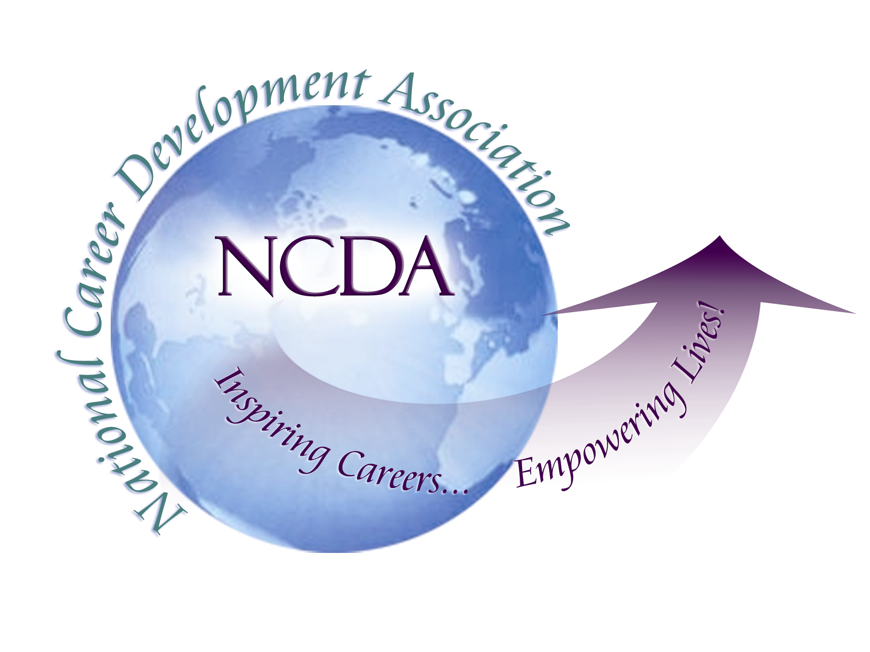
305 N. Beech Circle
Broken Arrow, OK 74012
918/663-7060
Fax: 918/663-7058
www.ncda.org

National Career Development Association
Leadership Academy
Project Summary

Participant(s): Marsha Boettger and Stacie Stormer

Board Mentor: Pat Schwallie-Giddis, Chair, Department of Counseling/Human and
Organizational Studies, Graduate School of Education,
George Washington University

Leadership Academy Class: LA III, 2008-2009

Project Title: Bringing the Voice of the Employer into NCDA

Project Description:
Proposal:
To design, develop and deliver a “voice of the employer” experience to career development practitioners attending the NCDA Conferences resulting in an ongoing systematic and active role for the employer community in every annual NCDA Conference. The “voice of the employer” would be brought into the Conferences through presentations, panel discussions, roundtables, Professional Development Institutes and, if feasible, through a unique and dedicated employer program track.

The “voice of the employer” experience and the resulting employer participation would be aimed at ensuring career development practitioners have a thorough knowledge and understanding of labor market processes, practices and trends and are capable of delivering comprehensive, relevant and accurate career information, services and programs on topics such as:
- Candidate qualifications and requirements – education, experience, competencies, skills, abilities and attributes
- Hiring practices and tools – candidate sourcing (internal vs. external and the use of job posting systems, job boards, advertisements, recruiters, placement agencies), resumes/vitas, portfolios, testing and assessment, background checks, interviewing processes
- Employment projections – local, national and global
- Forecasted job obsolescence and creation
- Career management – lifelong career planning, professional growth and development, networking, mentoring, performance coaching, retention, professional affiliations, volunteer activities, civic and community service
- Tips and techniques for competing successfully in a global labor market

Implementation Steps:
- Gain the support of Judy Hoppin, 2009 NCDA President, for our LAIII Project Proposal and for initiating implementation in the 2009 Conference
- Gain the support of Jane Goodman, 2009 NCDA Conference Program Chair, for our LAIII Project Proposal and for initiating implementation in the 2009 Conference
- Gain the support of Jane Goodman for serving as “official” Program Proposal Reviewers and Evaluators for employer-related program submissions
- Gain the support of Pat Schwallie-Giddis, 2009 NCDA President-Elect, for our LAIII Project Proposal and for serving as our LAIII Board Member Mentor
- Provide Pat Schwallie-Giddis additional information and research supporting the importance of including a “voice of the employer” experience in future NCDA Conferences
- Gain the support of Pat Schwallie-Giddis for including a “voice of the employer” experience in the 2010 Conference
- Provide Pat Schwallie-Giddis with information on potential employer-related Keynote speakers for the 2010 Conference
- Gain the support of Rich Feller to serve as our employer-related Professional Development Institute Leader/Developer/Presenter
- Personally contact potential presenters and solicit employer-related Program Proposals with a very tight program submission timeline and due date
- Develop and submit our own employer-related Program Proposals
  - Employer Panel Discussion
  - Designing Career Development Systems
- Assist Rich Feller in developing a Professional Development Institute consistent with our “voice of the employer” vision
- Establish an employer-related Program Proposal evaluation subcommittee, approved by Jane Goodman
- Review and evaluate employer-related Program Proposal submissions individually
- Meet with the employer-related Program Proposal evaluation subcommittee, review and discuss individual ratings and come to consensus on ratings
- Document and provide Program Proposal evaluation ratings and comments to Jane Goodman and Headquarters staff
- Develop Employer Panel Discussion format, process and questions
- Identify potential Employer Panel Discussion participants from various industries and from various size organizations
- Contact potential Employer Panel Discussion participants to review our vision, the process and our expected outcomes with each individual
- Select final Employer Panel Discussion participants
- Develop Designing Career Development Systems program including PowerPoint presentation, handouts and activities
- Review and critique Designing Career Development Systems program and make final revisions
- Assist Rich Feller with the actual implementation of his employer-related Professional Development Institute
- Assist selected presenters with their employer-related Program sessions as they occur throughout the Conference
- Implement our Employer Panel Discussion
- Implement our Designing Career Development Systems session
- Attend as many employer-related sessions as possible
- Network and solicit feedback from attendees in employer-related sessions
- Review attendee evaluations and feedback from employer-related sessions
- Develop recommendations for the “voice of the employer” experience in the 2010 Conference and other future NCDA activities and events
- Provide written recommendations to Judy Hoppin, Pat Schwallie-Giddis, the NCDA Board and Headquarters staff regarding the “voice of the employer” in the 2010 Conference and other future NCDA activities and events

Summary/Conclusion:
The primary goal of our project is to bring the “voice of the employer” into NCDA through Conference programming beginning with the 2009 Conference in St. Louis. We achieved this objective with the inclusion of the unique Professional Development Institute “Super Session” on Tuesday, June 30, 2009, with Rich Feller, titled “STEM Careers and the New Economy: Tips, Resources and Practitioner Update” and with the inclusion of the following 14 employer-related content sessions for which we recruited, evaluated and selected most of the presenters/programs.
- #101 Organizational Career Counseling in a Diversified and Nationwide Union Environment - Darlene Martin and Michele DeRosa, Elsdon, Inc.
- #102 The Brave New World of Work: Are Practitioners and Researchers Ready? - Fred Dorn, University of Mississippi
- #201 Engagement, Supports & Barriers: Career Development in STEM - Marie Forcier and Mary Deacon, University of Virginia
- #202 Helping Employees Attend to Career Establishment and Work Adjustment - Kevin Glavin, Kent State University
- #210 Piloting a Career Development Center at Cessna Aircraft Company - Daniel Weyant, Jim Mercer, and Dawn Clark, Cessna Aircraft Company
- #307 Occupations in Demand and the Skills They Demand - Implications for Career Counseling - Linda Kobylarz, Linda Kobylarz & Associates
- #405 Creating a Culture of Ownership: Two Case Studies - Angelika Reiss, The University of Arizona, and Katherine Maloney, Blue Cross Blue Shield of Massachusetts
- #503 Linking Individual Career Development to Business Performance: A Case Study, Blue Cross Blue Shield of MA - Katherine Maloney, Blue Cross Blue Shield of Massachusetts
- #507 New and Emerging Occupations: Technology, Law, Demographics, and Business are Changing Future Jobs - Janet Wall, Sage Solutions
- #604 Learning Contracts: An Organizational Tool for Engaging and Retaining Talent - Nisha Khare and Christy Ciezki, Health Canada
- #705 Development in Place: Bloom Where You Are Planted - Maggie McCormick, State Farm Insurance Co.
- #801 The Changing Culture of the Workplace of America - Ines Beilke, Fullerton College
- #806 Enriching Our Client Services with the Employers' Perspective: A Panel Discussion - Stacie Stormer, The Ohio State University, and Marsha Boettger, Chrysler Retired, Private Practice
- #909 Creating an Inspired Workforce: Designing Career Development Systems that Work - Marsha Boettger, Chrysler Retired, Private Practice

We believe all of this programming fits well with the theme of the 2009 Conference “Inspiring Career Development Practitioners” by providing practical insights, information and techniques regarding employers, employability requirements and the nature of today’s global workplace. In addition, we are so committed to bringing the “voice of the employer” into NCDA that we have expressed our sincere interest to Pat Schwallie-Giddis to volunteer to extend our project and time commitment into the 2010 conference. We are passionate about the need for career development practitioners to hear the “voice of the employer” and to prepare and assist their clients consistent with this voice.

Results/Recommendations:
Given the crisis on Wall Street, the loss of over 2 million jobs in 2008, the projections for the loss of an additional 2-3 million jobs in 2009 and the dismal state of the national and global economies this is the “perfect storm” for the career development profession. If career development professionals seize this unique opportunity to reach out to the employer community to communicate, collaborate and develop closer working relationships all of us can do a better job of:
- helping our clients prepare for and find employment and pursue career goals by developing a better understanding of employer hiring processes, wants, needs and requirements
- helping employers match candidate/employee strengths and attributes with open positions and the requirements of the work that needs to be done and continuously develop these employees for future requirements

This potential collaboration represents a win-win-win situation whereby:
- our clients are more likely to achieve employment, their career aspirations and potential, and ultimately career satisfaction and success
- employers can enhance bottom-line business performance and results through the increased engagement, productivity, creativity and performance of their employees
- the career development profession can enhance and prove its value to our clients, the business community and the government as improved business performance contributes to the nations economic recovery, health and prosperity

We realize NCDA has many priorities but we believe for the long-term health, viability and growth of both the organization and the profession the “voice of the employer” must be heard in every annual Conference and in other NCDA sponsored activities, events and publications. We are willing to facilitate this process at least through the 2010 Conference and are prepared to help others (perhaps the Board and the Headquarters staff) do so beyond that time. This is a highly critical priority for the future viability and success of the career development profession, the NCDA organization and the NCDA membership.

