National Career Development Association
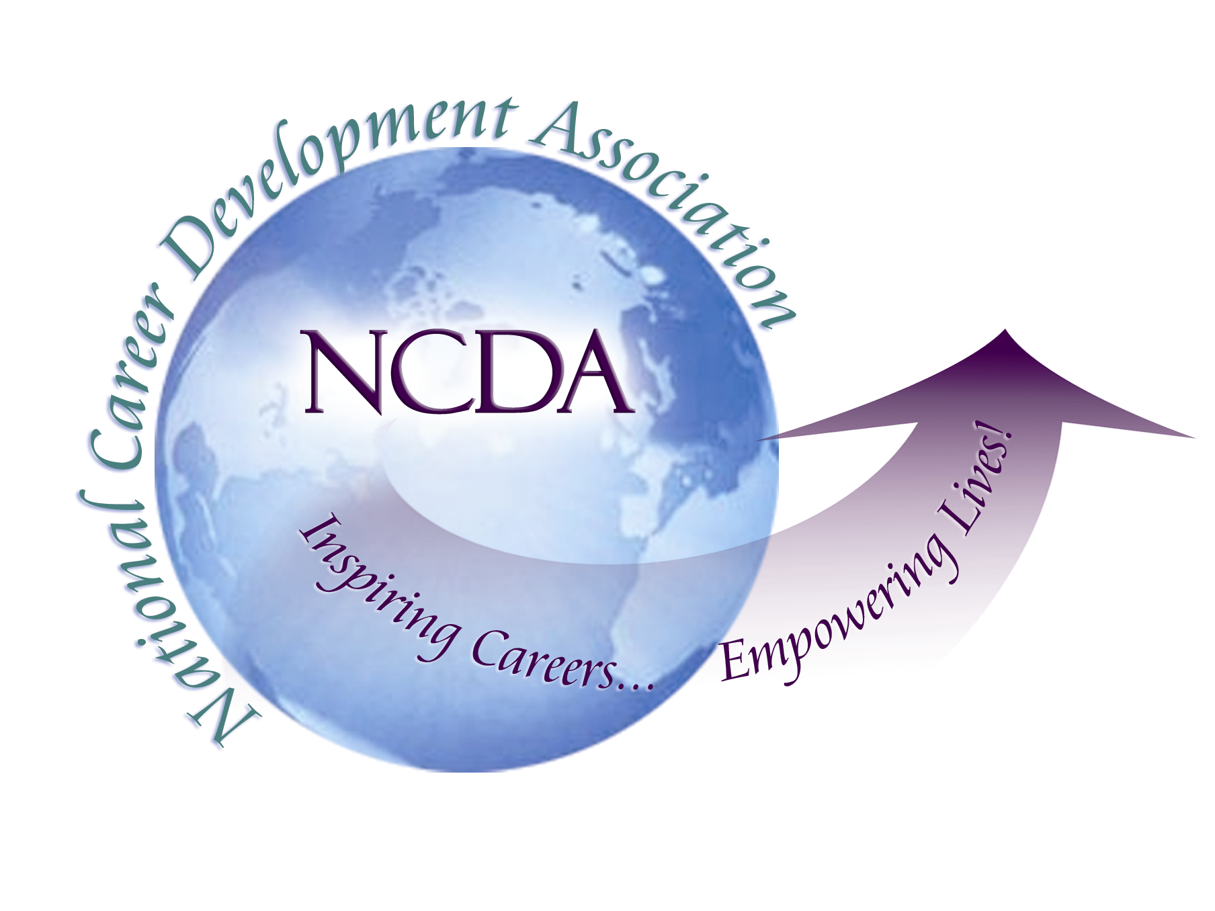

305 N. Beech Circle
Broken Arrow, OK 74012
918/663-7060
Fax: 918/663-7058
www.ncda.org

National Career Development Association
Leadership Academy
Project Summary

Participants: Tina Anctil and Paulette Schenck, Ph.D.
Board Mentor: Carol Dahir
Leadership Academy Class: LA III, 2008-2009

Project Title: School Counselors’ Roles and Perceptions of Career Development
2009 National Career Development Association Conference

This study
- focuses on career development perspectives of school counselors who may not be members of NCDA
- by polling members of the American School Counselor Association
- to describe current career development practice in K-12 schools
- to determine who is delivering career development curriculum
- to suggest strategies for NCDA School Counseling Interest Network
- to recommend organizational outreach strategies to NCDA board

ULTIMATE PURPOSE: reduce gap between career development guidelines and practice in schools

Current American School Counselor Association (ASCA) National Model domains: academic development, career development, personal and social development (ASCA, 2003)

Study’s career development provider profile (N = 1016): female (85.2%), Caucasian (81%), masters (87%), certified school counselor (88.4%), <10 yrs in school counseling (60%), ASCA member <5 yrs (68.5%), state association member (82.7%), attends 2+ professional development trainings per year (82.9%). 7.2% - NCDA member

School profile: public (92.6%), high school (44.3%), suburban setting (36.3%), community economic status (middle to upper income – 53%; low to below poverty line – 47%), 1/3 at least half of students qualify for free/reduced lunch.

Career Development Providers (who is delivering career guidance): school counselors (58% -- 95% masters); career specialists (23% -- 53% masters, 35% bachelors); teachers (9% - 49% masters, 50% bachelors)

Students receiving services:
 | Least time | Most time
High achievers | 30.8% | 38.6%
Moderate achievers | 7.6% | 23.6%
Low achievers | 6.1% | 19.9%
Underachievers | 48.0% | 21.2%

Priority on career development:
 | Percent
Very high | 6.9%
High | 18.7%
Moderate | 41.6%
Low | 30.3%
None at all | 2.6%

Time spent in counseling domains:
 | Academic | Career | Person/Social
< 20% | 15.6% | 45.4% | 15.0%
21 - 40% | 33.4% | 34.3% | 31.4%
41 - 60% | 28.4% | 8.8% | 25.4%
61 – 80% | 14.4% | 5.2% | 17.6%
81 – 100% | 7.9% | 5.1% | 10.0%
None at all | 0.2% | 1.2% | 0.5%

Frustration areas when working with student’s career development needs:
 | Not Frustrated | Very Frustrated
Understanding career theories | 47.5% | 3.1%
Lack of career guidance resources | 18.3% | 20.3%
Lack of time devoted to career guidance | 6.5% | 54.9%
Lack of recognition that career guidance is important to students | 11.3% | 34.1%

Lack of time: (1) too many other responsibilities and (2) access to students (No Child Left Behind has made teachers more defensive about instructional time to do classroom presentations)

Assistance in meeting students’ career development needs:
 | Least Helpful | Most Helpful
Consulting with other school counselors | 5.6% | 50.0%
Reading article | 18.5% | 9.4%
Reading book | 39.2% | 4.0%
Attending workshop | 3.3% | 43.0%
Attending conference sessions | 4.9% | 40.6%
Internet searches | 6.4% | 38.4%

Helpful topics in newsletters:
- Classroom activities (62.5%)
- Assessments/Inventories: career (43.6%), values (42.5%), interests (52.7%)
- Web-based career information (47.3%)
- Strategies working with students: underachievers (37.4%), dropout prevention (47.1%)
- Transitions: post-secondary career planning (33.1%), linking school choices to future career options (42.1%)

RECOMMENDATIONS:
- Encourage link between state career development associations to provide career development sessions at state school counselor association conferences.
- Expand school counseling sessions at state and national career development association conferences.
- Make materials available and support research establishing positive link between career development and academic achievement, dropout prevention, and success with underachieving students.
- Share this information not only with school counselors but also educational leaders (articles in professional journals and professional development opportunities).
- Identify and expand web-based materials that can be immediately applicable to career guidance classroom activities.
- Identify and expand the variety of web-based career assessments applicable to K-12 students.
- Expand career development resources applicable to elementary-aged students.

CONTACT INFORMATION:
Tina Anctil, PhD, Assistant Professor of Counseling, Department of Counselor Education, Portland State University, 204 School of Education Building, 615 S.W. Harrison , Portland, OR 97201 (anctil@pdx.edu or 503-725-9886)
Paulette M. Schenck, Assistant Professor of Counseling, Educational Leadership, Counseling & Special Education, Augusta State University, 2500 Walton Way, Augusta, GA 30904-2200 (pschenck@aug.edu or 706-729-2444)
Carol Dahir (Project Mentor), PhD, Associate Professor of School Counselor Education, New York Institute of Technology, Northern Boulevard, Old Westbury, NY 11568-8000 (cdahir@nyit.edu or 212-261-7616)

