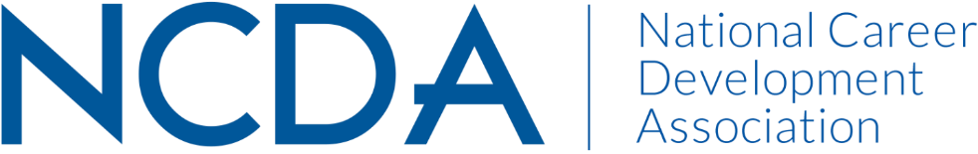

ETHICS COMMITTEE MID-YEAR REPORT
March 15, 2024

Co-Chairs:
Conquaya James, MS & EdS  ConquayaJames@hotmail.com  478.241.0466 | David Reile, PhD  David@reile.com

Committee Members

Amanda Chenkin
Amy Policastro Schroeder
Angie Smith
Azra Siwiec
Becca McCarthy
Billie Streufert
Chris LaFever
Dan Greenwood
Diane Farrell
Duke Wallin
Gillian Johnston
Jaana Kettunen
James Westhoff
Keith Okrosy
Keley Smith-Keler
Lisa Sweet
Manpreet Kaur
Marie Nicks
Mary Guirovich
Michi Mizuno
Ron Cathey
Sarah Patterson Mills
Sharon Anderson
Shundrika Morris
Stacy VanHorn
Tanisha Stokes
VL Muanpuii

Committee Activities to Date

- Responded to two ethical inquiries
- Submitted Ethics in a Nutshell articles for the Career Developments magazine
- Submitted a draft of revisions for the Code of Ethics
- Working to diversify membership, working to understand the interests/skills of committee members, and develop subcommittees

Projected Plan/Work Completed through September 30.

- Respond to ethical inquiries
- Submit Ethics in a Nutshell articles
- Resubmit an updated draft of the Code of Ethics to include information regarding Artificial Intelligence (AI)
- Work to diversify membership, work to understand the interests/skills of committee members, and develop subcommittees
  - Sent a survey to members to gage committee interests and their plans for continuing with the committee
  - Reach out to members who have yet to respond to the survey
  - Use our survey to remain cognizant of the types of skills we need to complete our tasks when looking to recruit new members
  - Determine how to recruit new members and begin prior to October 1
- The NCDA President Elect, Marty Apodaca, plans to form a cross-committee AI Task Force. We are awaiting more guidance on his vision for this.

Budget Requests: N/A

