RESOURCES FOR ASPIRING AUTHORS

Provided in the context of NCDA’s Career Practitioner Conversations Podcast
Season 4: Episode 17 with Sujata Ives and Paula Brand

BOOKS that aim to inspire aspiring authors

1) The Artist’s Way by Julia Cameron
This is a classic book and shares two now famous activities of “morning pages” and “artist’s date”.
https://juliacameronlive.com/

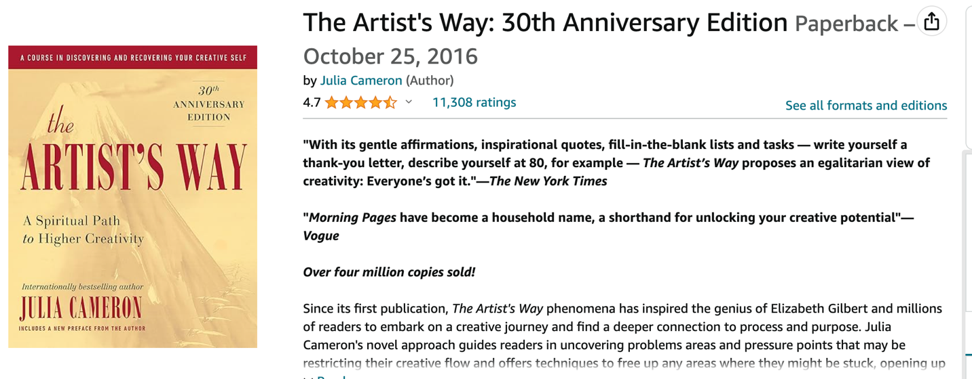

2) The War of Art by Steven Pressfield
The title plays off the classic book, The Art of War, and discusses the difficulties of creating.
https://stevenpressfield.com/books/the-war-of-art/

3) So You Want to Write by Frankie Collins – This new release challenges you to begin writing and offers prompts to get you started.

Order here:
https://bookshop.org/p/books/do-you-feel-like-writing-a-creative-guide-to-artistic-confidence-frankie-rollins/20241190?ean=9798988193708

The author offers courses to help you to start writing and share your voice.
Find out more about Frankie here: https://www.frankierollins.com/

SUPPORT AND COMMUNITY
Writing Groups
Joining a writing group can help you in many ways. They can provide structure and support among other authors. Ask around in your area or search online to find groups near you.

https://robbiesamuels.com/hub/ - He has a free monthly networking event for writers and such – no membership needed to join them

Find out more about Frankie Rollins’s Fifth Collective which offers resources for writers: https://www.fifthbraincollective.com/

International Women’s writing Guild
Membership Cost 75$ annual
https://iwwg.org/history
They hold an annual conference

https://archives.awpwriter.org/
The AWP Conference & Bookfair is the annual destination for writers, teachers, students, editors, and publishers of contemporary creative writing. It includes thousands of attendees, hundreds of events and bookfair exhibitors, and four days of essential literary conversation and celebration.

The Association of Writers and Writing Programs (AWP) holds an annual conference and book fair. AWP’s bookfair is the nation’s largest marketplace for independent literary presses and journals, creative writing programs, writing conferences and centers, and literary arts organizations.

PODCASTS
There are a ton of podcasts about the writing process and various aspects about publishing. There are even more that are topic and genre specific.

Below is a podcast that is not focused on writing per se, but they interview a lot of authors, and this episode focused on an author speaking about writing for personal growth/writing a memoir

Psychologists Off The Clock podcast. Episode 345
https://offtheclockpsych.com/writing-for-personal-growth-with-maureen-murdock/

Costs
If you want to publish a book on your own, I would prepare to invest from $8,000 – 13,000. These costs might cover the logistics of publishing (hiring an editor, an indexer, a designer of the cover and inside pages, etc.). It might also include costs for a book launch and initial copies of the book. It does not include any costs for a publicist or paid advertising.

Marketing Strategies
There are lots of strategies you might employ when sharing your book with the world as a self-publisher. You might try to make it a best seller. Some lists are solely based on weekly book sales, and some are hard to break into unless you are famous (like the New York Times). Some best seller lists like on Amazon, depend on which categories you try for and are based on sales the first day of release. There are many tricks to achieving this status like having pre-sale books that all land on the same day.

Tim Grahl helps authors launch a book – he offers many free webinars with actionable tips along with paid services
https://booklaunch.com/

Book creation/self/publishing
Lindsey and her team at https://www.youcangetitdone.com/bookproduction can help you get your book finished and offer cover design and editing services.

