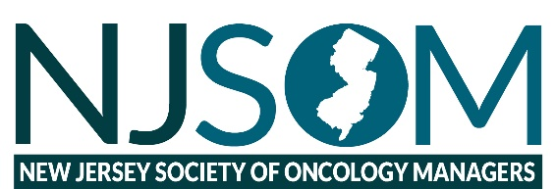
2025 NJSOM Fall Conference
Thursday, October 9, 2025
Renault Resort - Château Renault, 72 North Bremen Avenue, Egg Harbor City, NJ 08215

Registration Form
LINK: http://njsomconference.org/aws/NJSOM/pt/sp/conference_registration
or by completing the form below.
Please email info@njsom.org or fax to 973-453-8133
Company Name | Contact

Contact email | Contact Phone Number

Vendor Table (Please indicate YES or NO) | Name to appear on Vendor Table

_____ Diamond _____Gold _____Silver _____Exhibitor
6 complimentary attendees 5 complimentary attendees 3 complimentary attendees 2 Attendee Booth Only Fee ($2700)

Additional Attendees/Non-Member Fee:
All day Conference including breakfast and lunch fee. $250.00
Please indicate YES or NO for each meal
 | Attendee Name | Attendee email | Wednesday October 8th Dinner | Breakfast  October 9th | Lunch  October 9th
1
2
3
4
5
6

