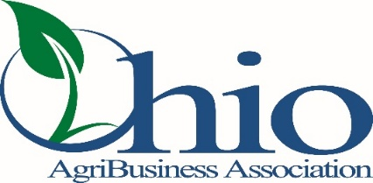
Grain Operations Training Course
Agenda
April 2026

Session One – Tuesday, April 14, 2026 -- 8:30 am – 4 pm
Cargill Sidney
2400 Industrial Drive
Sidney, OH 45365
Registration & Welcome

Fall Protection Safety and Inspections
Jed Bookman, Sunrise Cooperative

Structural Integrity, Maintenance and Repairs
Jeremy Morris, Trisco Systems, Inc.

Grain Quality
Mike Muse, Eurofins Scientific

Preventive Maintenance Best Practices
Mike Hottman, Dodge Industrial, Inc.

Aeration
Travis Banks, AirX

Tour Cargill’s Soybean Crushing & Food Grade Packaging Facility
Amanda Matheny, Cargill

Session Two – Tuesday, April 28, 2026 -- 8:30 am – 4 pm
The Andersons
1947 Briarfield Blvd
Maumee, OH 43537
Registration, Welcome & Review
Grain Operations Committee

Rail and Dump Safety
Mike Ponder, MH Equipment
Randy Digby, Legacy Farmers Cooperative

Grain Elevator Revenue Generation
Communications Between Merchandising and Operations
Chris Hager, Sunrise Cooperative
Cristen Cramer, Legacy Cooperative

Grain Market Analysis
Intro to markets, basis, futures, why does this matter to the elevator?
Kendra Dauer, Risk Management Consultant, StoneX Group Inc.

Tour The Andersons Barge Loading Facility

