Fishy Gardening

ABSTRACT
The purpose of this lesson is to utilize inquiry skills to design and solve a problem. The problem students are trying to solve is how to provide inexpensive food sources to an impoverished city in Puerto Rico that lacks clean water and fertile soil. This is accomplished by designing and maintaining an inexpensive hydroponic growing system. While completing the project, students are learning about and applying knowledge of Earth systems and cycles, such as the nitrogen cycle, the water cycle, and photosynthesis. They continuously monitor their system by performing water quality tests and making adjustments as necessary to maintain the health of the fish and plants used in their system.

Grade Level
6th - 8th grade

Resource Type
Classroom/ Laboratory

Subject
Life Science

Next Generation Science Standards (NGSS):
MS-LS2-3. Develop a model to describe the cycling of matter and flow of energy among living and nonliving parts of an ecosystem. [Clarification Statement: Emphasis is on describing the conservation of matter and flow of energy into and out of various ecosystems, and on defining the boundaries of the system.] [
Ohio’s New Learning Standards, Content:
Grade 7
Theme Order and Organization
Topic Cycles of Matter and Flow of Energy
Content Standard
In any particular biome, the number, growth and survival of organisms and populations depend on biotic and abiotic factors.
Matter is transferred continuously between one organism to another and between organisms and their physical environments.

Ohio’s New Learning Standards, Inquiry and Application:
During the years of grades 5-8, all students must use the following scientific processes, with appropriate laboratory safety techniques, to construct their knowledge and understanding in all science content areas:

- Identify questions that can be answered through scientific investigations;
- Design and conduct a scientific investigation;
- Use appropriate mathematical tools and techniques to gather data and information;
- Analyze and interpret data;
- Develop descriptions, models, explanations and predictions;
- Think critically and logically to connect evidence and explanations;
- Recognize and analyze alternative explanations and predictions; and
- Communicate scientific procedures and explanations.

Local Course of Study:
The current local course of study is aligned with the Ohio's New Learning Standards

Lesson Objectives:
Students will be able to:
- Work cooperatively in a group
- Set acceptable standards of performance and conduct for their project team
- Research methods of hydroponic growing, and appropriate fish and plant species used in hydroponic systems
- Design and build a hydroponic growing system
- Monitor the water quality of their growing systems and make adjustments as necessary
- Maintain the health of fish and plant species used in their systems
- Present the findings of their team's research at the end of the project

Activity Pre-Assessment:

The pre-test and post-test for this project are identical to provide an accurate reflection of the student's individual progress at the end of the lesson.

Lesson/Project Timelines
Materials Needed
- growth tank
- 2-3 fish (danios or tetras)
- water pump and tubing (provided by teacher)
- 2-3 plants capable of growing hydroponically
- various materials for constructing plant holders (cups, tank lids, styrofoam, duct tape, PVC pipe, etc.)
- Handouts:
  - Team code of conduct
  - Aquaculture questions
  - Nitrogen cycle article
  - Nitrogen cycle anticipation guide
  - Water Pump Inquiry
  - Design Research
  - Project Rubric

Resources
"Hunger and Poverty in the Dominican Republic" (4m27s) video:
http://www.youtube.com/watch?v=kYObMb7JXak
"A Kid's Introduction to Hydroponic Gardening" (5m9s) Video
http://www.meetmeatthecorner.org/episode/earth-day-2011-a-kids-introduction-to-hydroponics
"The Nitrogen Cycle" (5m8s) Video:
http://www.youtube.com/watch?v=pdY4I-EaqJA&feature=related
"The Green Box Video Aquaponics" (2m44s) Video:
http://www.kickstarter.com/projects/975759058/the-blue-green-box?ref=category

Appendix E: Window Gardens Video/Aquaculture Article Assessment
Name: ___________________________ Date: _____________ Period: _____

Directions: Before the video, read the extended response questions below. During the video take notes on a separate sheet of paper to help you answer the questions. When you finish watching the video, use the article to continue taking notes to help answer the questions. After watching the video and reading the article, answer the following questions. Make sure you site evidence from the video/article and use domain specific vocabulary when supporting your answer.
- Where is the Windowfarm Project located? For what reasons have they located this particular project here?

- Describe how window gardens are similar to an ecosystem. Support you response with evidence from both your prior knowledge and the video and/or article.

- Compare conventional gardening to hydroponic gardening. Using scientific, domain-specific vocabulary, describe the role of clay pebbles in window gardens.

- What quantities and qualities are used to determine the safety/efficiency when rearing aquatic animals? Cite evidence from information provided in the video and/or article.

- What are the advantages and disadvantages in hydroponic gardening? Support you response with evidence from both your prior knowledge and the video and/or article.
Appendix F: Engineering Design Challenge and Rubric

Name: ___________________________ Date: _____________ Period: _____

Engineering Design Challenge:
The mayor of Caguas, Puerto Rico and his Strategic Planning staff have developed a plan to address unemployment, food quality and production, and poverty within the city. He is searching for participants to participate in the "Sustainable Food Initiative" that will promote local food production. Your company, Agronomics, is asked to create a viable farming method consisting of a self-sustaining system that would provide both fish and vegetables for families to eat. Because there is little viable soil and water availability may be scarce, the goal is to combine a hydroponic planting method with a fresh water system that promotes a symbiotic relationship beneficial to both the plants and fish. The fish waste (nitrogen) provides nourishment to plants and the plants in turn are able to filter the water.
Your system must be created using readily-available, inexpensive materials and be able to produce nutrient-rich, safe food. You must submit a small-scale, functioning model of your idea along with a presentation to the mayor and his strategic planning staff.

Engineering Design Challenge Rubric

 | 4 | 3 | 2 | 1
Problem Identification / research | Problem is clearly defined with stated objectives and constraints. Includes an in-depth revised problem statement. | Problem is clearly defined with stated objectives and constraints. Includes a revised problem statement. | Problem is loosely defined with stated objectives and constraints. Includes a revised problem statement. | Problem is loosely defined with stated objectives and constraints. Fails to include a revised problem statement.
Design Process | Evidence of at least 2 carefully thought-out individual sketches; one scored on team decision matrix. | Evidence of at least 2 individual sketches, but only one carefully thought-out; one scored on team decision matrix. | Evidence of only 1 carefully thought-out individual sketch; scored on team decision matrix. | Evidence of only 1 quickly thought-out individual sketch; scored on team decision matrix.
Data Collection | Includes complete set of required, easily understood data displays. Tables and graphs clearly labeled. | Includes nearly complete set of required, easily understood data displays. Tables and graphs clearly labeled. | Includes incomplete set of required, easily understood data displays. Tables and graphs clearly labeled. | Includes incomplete set of required, data displays. Tables and graphs are not clearly labeled.
Constraints / Criteria | Design exceeds required criteria and meets defined constraints. | Design contains required criteria and meets defined constraints. | Design contains required criteria, but not within defined constraints. | Design does not contain all required criteria, and is not within defined constraints.

Appendix I: Research Guidelines

Name: ___________________________ Date: _____________ Period: _____

Directions: Your team is to research the following areas in order to help you create the design for your farming method. Divide these tasks among your team members. All research must be referenced.

- Research one type of fish used in aquaculture (i.e. perch, tilapia) and the type of fish you will be able to use for your model- both danios and tetras. For each fish record data on optimal temperature, amount of space and pH required for the fish to thrive or grow well. Also research the cost, the amount of waste, and any behavior the fish exhibit (feeding habits, habitats and any other miscellaneous information that may be useful).

- Research the types of plants that could be planted in the garden. Leafy vegetable and herbs are best. Select two and record the following information: common name, scientific name, sun exposure, root depth, soil pH, plant height, temperature requirements, nutrient requirements, time of seed germination, time to harvest, pest, and cost.

- Research different hydroponic systems. Provide sketches or pictures. Make sure to research the different types of rocks (growing media) used in hydroponics (i.e clay, granite, sand, river rock, and shale). Particles need to be between 8mm and 16mm and cannot have limestone or other particle that have high pH

- Research aquarium assembly. Write out step-by-step instructions on how to set up an aquarium. Include safety precautions.
All members are required to log information from each member in there journals. Your team can create a recording sheet if it chooses. All research must include references from appropriate sources. Below is a list of Internet sources that may useful. You may also use resources from the library or pet stores.

- http://www.almanac.com/plants/type/vegetable
- http://ohioline.osu.edu/lines/vegie.html
- http://www.conference.ifas.ufl.edu/aitc/presentations/Session%204/Hydroponics%20in%20the%20Classroom/Hydroponics%20in%20the%20Classroom%20PowerPoint%20Presentation.pdf
- http://www.kidsgardening.org/
- http://www.japan-aquaponics.com/growbed-media-guide.html
- http://www.petsmart.com/
- http://www.agfc.com/fishing/documents/are_classroom_aquarium_curr.pdf
- http://www.troutintheclassroom.org/setup

Appendix J: “The Nitrogen Cycle” Article: Anticipation Guide

Name: ___________________________ Date: _____________ Period: _____

Directions: Before reading the article, read each statement and mark agree or disagree in the column labeled “before.” These will serve as your predictions. After reading the article with your team, check the corresponding box on the right side of the table. In the middle underneath the question quote evidence from the article to justify why you agree or disagree.

Before |  |  | After
Agree | Disagree | Statement and Evidence | Agree | Disagree
- Nitrogen is an essential element for life on earth

Evidence:
- Nitrogen is the most abundant gas in the air and is readily usable by animals and plants

Evidence:
- Bacterial is the most important participant in the nitrogen cycle

Evidence:
- Bacteria have a symbiotic relationship with plants

Evidence:
- Using nitrogen rich fertilizer is always good.

Evidence:
- Too much nitrogen can kill fish in a water system

Evidence:

Appendix K: “The Nitrogen Cycle” Article

Source: cK-12 http://www.ck12.org/book/CK-12-Earth-Science-For-High-School/r2/section/18.2/

Name: ___________________________ Date: _____________ Period: _____

Nitrogen (N₂) is also vital for life on Earth as an essential component of organic materials, such as amino acids, nucleic acids, and chlorophyll.
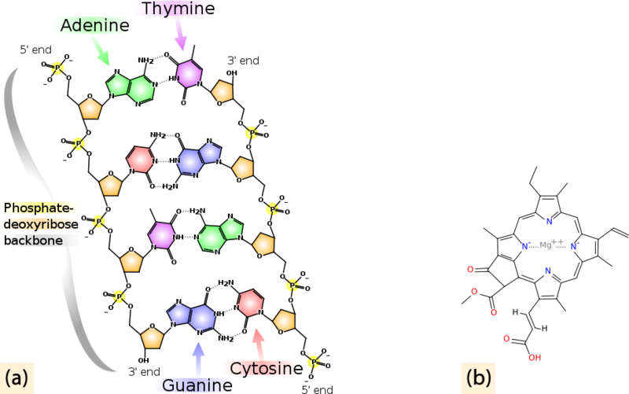

(a):
Nitrogen is found in all amino acids, proteins, and nucleic acids such as DNA and RNA.

(b):
Chlorophyll molecules, essential for photosynthesis, contain nitrogen.

Although nitrogen is the most abundant gas in the atmosphere, it is not in a form that plants can use. To be useful, nitrogen must be “fixed,” or converted into a more useful form. Although some nitrogen is fixed by lightning or blue-green algae, much is modified by bacteria in the soil. These bacteria combine the nitrogen with oxygen or hydrogen to create nitrates or ammonia. See the following Nitrogen Cycle diagram.

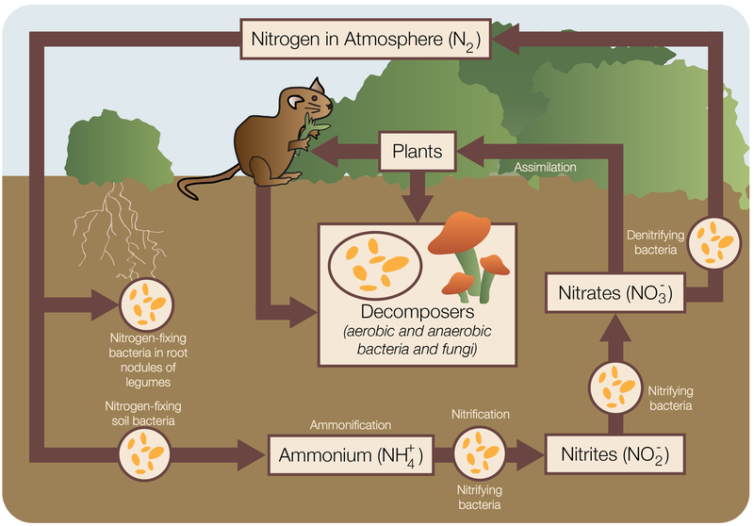

Nitrogen fixing bacteria either live free or in a symbiotic relationship with leguminous plants (peas, beans, peanuts). The symbiotic bacteria use carbohydrates from the plant to produce ammonia that is useful to the plant. Plants use this fixed nitrogen to build amino acids, nucleic acids (DNA, RNA), and chlorophyll. When these legumes die, the fixed nitrogen they contain fertilizes the soil.

Animals eat plant tissue and create animal tissue. After a plant or animal dies or an animal excretes waste, bacteria and some fungi in the soil fix the organic nitrogen and return it to the soil as ammonia. Nitrifying bacteria oxidize the ammonia to nitrites, other bacteria oxide the nitrites to nitrates, which can be used by the next generation of plants. In this way, nitrogen does not need to return to a gas. Under conditions when there is no oxygen, some bacteria can reduce nitrates to molecular nitrogen.

Usable nitrogen is sometimes the factor that limits how many organisms can grow in an ecosystem. Modern agricultural practices increase plant productivity by adding nitrogen fertilizers to the soil. This can have unintended consequences:

- Nitrogen from fertilizers may return to the atmosphere as nitrous oxide or ammonia, both of which have deleterious effects. Nitrous oxide contributes to the breakdown of the ozone layer, and ammonia contributes to smog and acid rain.

- Excess fertilizers run off the land, end up in water, and then cause nitrification of ponds, lakes, and nearshore oceanic areas. The nitrogen “fertilizes” the pond, causing bacteria to grow. When these enormous amounts of bacteria die, their decomposition uses up all the available oxygen (Figure below). Without oxygen, fish and other larger organisms die. This is called a dead zone when it happens on a large scale.
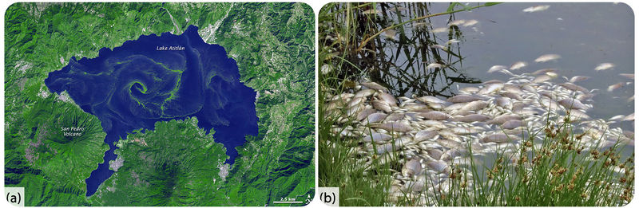

(a):
Nitrogen runoff into Lake Atitlán, Guatemala, caused an algae bloom in the normally clear blue mountain lake.

(b):
Fish killed by a lack of oxygen in the water.

