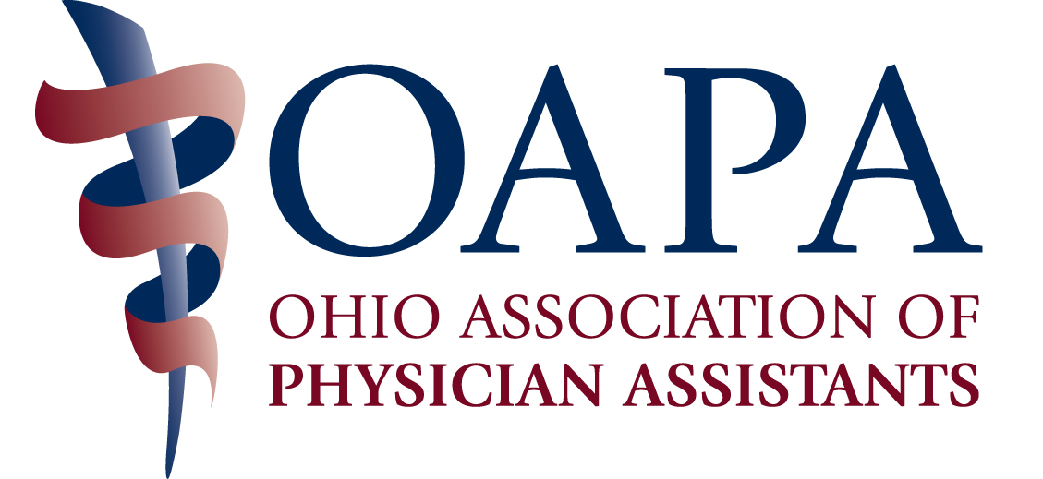

OAPA Past-Presidents Leadership Scholarship Application

A candidate for this award, given by the Past-Presidents Council, will possess the characteristics of what the Council envisions in a future leader within the profession. The winner of this scholarship must have vision and have a high degree of faith and confidence in themselves to attain these visions. They are to become the spokesperson of the profession. The successful candidate must be self-motivated and be able to communicate to their peers their expectations. Ideally they would accomplish this in a way that stimulates participation by their peers in the successful completion or adaptation of their visions. Participation in student government is taken into consideration, but not necessarily a requirement for this award. You must be a member of both OAPA and AAPA for a minimum of 3 months prior to applying.

Please complete this application and submit it OAPA at oapa@ohiopa.com (preferred) or mail to OAPA, 4700 Reed Road, Suite N, Columbus, OH 43220 or fax to 614/824-2103 by August 8, 2016.

Part 1: Personal Information

______________________________________________________________________________
First Name Middle Name Last Name

______________________________________________________________________________
Address

______________________________________________________________________________
City State Zip Daytime Phone

______________________________________________________________________________
ARC-PA Accredited PA Program Graduation Year E-Mail Address

Part 2: PA Program Director Attestation of GPA and Student Status
Must be electronically sent to the OAPA by the PA Program Director

Part 3: Academic History
Enter all Colleges attended and degrees awarded with GPAs from each

___________________________________________________________________
___________________________________________________________________
___________________________________________________________________

Part 4: Community and Volunteer Services and Leadership History

Activity | Responsibilities | Time Commitment

Part 4: Personal and Professional Statement
Discuss what you perceive to be the most important health care concern in the community today and describe how you would help resolve or approach it. (250 words or less)

Part 5: General Information
What characteristics do you possess that would make you an outstanding leader within the PA Profession? (250 words or less)

I understand that if the application is incomplete or received beyond the deadline, it will not be eligible for entry. I attest that all of the information given is true and accurate.

____________________________________________________________________
Original or Electronic signature of applicant

