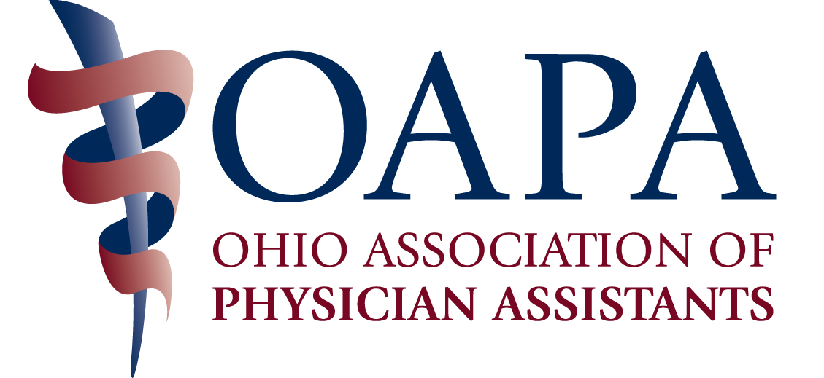

Charles L. Hudson, M.D. Award

INSTRUCTIONS
1. The purpose of this award is to recognize an individual who is deemed to be outstanding, based on deeds and actions promoting the PA profession in Ohio.
2. Complete the following form in as much detail as possible so that the Selection Committee may evaluate each nominee in a fair manner. Use additional paper as necessary. One complete nomination form must be received for a nominee to be considered. Additional letters of support may also be sent to supplement a nominee's official nomination.
3. Any person submitting nominations must be an OAPA member.
4. Submit the completed form by mail to:
Charles L. Hudson, M.D. Award Committee
C/O OAPA
4700 Reed Road, Suite N
Columbus, OH 43220
Or by email to oapa@ohiopa.com
5. Whether you tell your nominee that you are nominating them for this award or not, is your decision. The Selection Committee will release only the name of the winner.
6. Forward a copy of the nominee’s resume, if at all possible.

NAME OF NOMINEE ____________________________________________________
PHONE ______________________________________________________________
ADDRESS ____________________________________________________________
_____________________________________________________________________
PROFESSION _________________________________________________________
EMPLOYER ___________________________________________________________
LENGTH OF PROFESSIONAL SERVICE __________

On a separate sheet, explain why you feel this person should receive the award. Consider such information as human service activities, community services, professional affiliations and involvement, etc. Remember, you need to provide relevant information to the committee to facilitate selection of the winner.

NAME OF PERSON
SUBMITTING NOMINATION ______________________________________________
ADDRESS ____________________________________________________________
_____________________________________________________________________
PHONE ________________________EMAIL_________________________________

Applications must be received by August 8, 2016.

