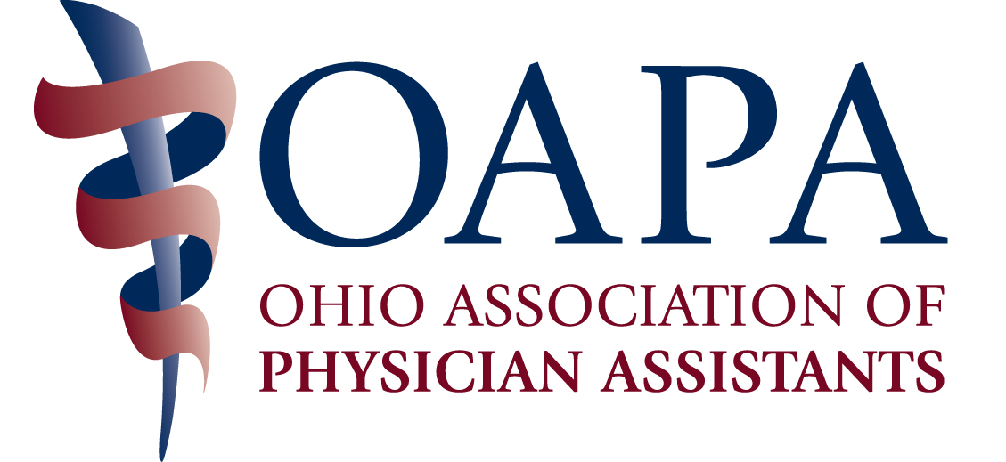

2015 PHARMACOLOGY CONFERENCE – APRIL 17-18, 2015

REGISTRATION FORM

NAME _________________________________________________________________

YOUR FIRST NAME FOR YOUR NAME BADGE_____________________________

YOUR PRACTICE SPECIALTY FOR YOUR NAME BADGE____________________

MAILING ADDRESS _____________________________________________________

CITY/STATE ____________________________________________________________

PHONE ____________________________EMAIL______________________________

SPECIAL OR DIETARY NEEDS ___________________________________________

Inclusive (Friday, Saturday) Conference Rates:
Includes all meals, breaks and materials.

Pre-Registration Postmarked after 4/12/15
Deadline 4/12/15 & On-Site Registration

OAPA Member $300 $400 $______
Non-member $475 $575 ______

Daily Rates:

Friday, April 17
OAPA Member $175 $225 $______
Non-member $275 $325 ______

Saturday, April 18

OAPA Member $125 $175 $______
Non-member $225 $275 ______

Syllabus $ 10 $______

Guests Meals (Friday Lunch) $ 35 $______

Make Checks Payable to OAPA

Mail Registration Form and Payment to:
OAPA
4700 Reed Road, Suite N
Columbus, OH 43220

You may also register with a credit card on line at the OAPA website: www.ohiopa.com.

Questions? Call OAPA at 800/292-4997

Full refund (minus $25 processing fee) available upon written request, postmarked on or before April 13, 2015. No refunds after deadline date. No refunds for no shows.

HOTEL ACCOMMODATIONS AND DIRECTIONS
(Attendees make their own hotel reservations):

Sheraton Suites, Cuyahoga Falls
Room Rates: $124.00, Reservation Deadline: 3/20/15
Call 330/929-3000 and mention OAPA.
1989 Front Street, Cuyahoga Falls
Directions: www.sheratonakron.com

Conference organizers plan to request 12 hours of AAPA Category I CME credit from the Physician Assistant Review Panel. Total number of approved credits yet to be determined.

SCHEDULE OF PHARMACOLOGY SESSIONS
Friday, April 17
Registration at 7:00 AM with sessions from 8:00 AM – 5:30 PM – includes continental breakfast, lunch and cocktail reception.
7.0 CME hours including sessions on Hyper and Hypo Calcemia, Hirsutism, Osteoporosis, Contraception, Pain Management, Skin Infections and Acute Pain.
Saturday, April 18
Registration at 7:30 AM with sessions from 8:00 AM – 1:15 PM - includes breakfast buffet and box lunch.
5.0 CME hours including sessions on Ebola and Pandemics, Acute Stroke Management, Antibiotics, Adult Vaccines and Prescribing Hormones.

