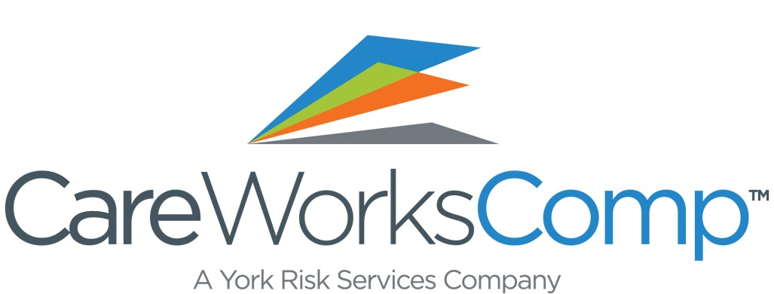

Important Information Regarding our 2017
Workers’ Compensation Group Rating Program

The 2017 CareWorksComp group rating enrollment deadline for the traditional discount group rating program is November 16, 2016 and the retro group rating enrollment deadline is January 25, 2017. It is important to apply early so that you have adequate time to evaluate your options. If you have not already applied, we ask that you take a look at your potential premium savings through our partner, CareWorksComp. Our workers’ compensation program was created to help our members maximize their workers’ compensation premium savings and to provide them with quality claims management services. Consider these points about our program:

- CareWorksComp evaluates your company for your greatest premium savings options.
- Maximum BWC projected premium and rate discounts of up to53% in our traditional group rating programs and premium rebates of up to 69% through our retrospective group programs for eligible businesses.
- Unemployment program consulting services are included in our program.
- Best-in-class full-service program includes program management, with professional account executives, hearing representatives and claim staff as well as underwriting/rate analysts providing you peace of mind.

To request a free, no-obligation analysis of your best savings options, please take a moment and contact CareWorksComp’s Program Manager, Beverly Westover toll-free at 1-800-837-3200, ext. 57169 or via email at beverly.westover@careworkscomp.com

