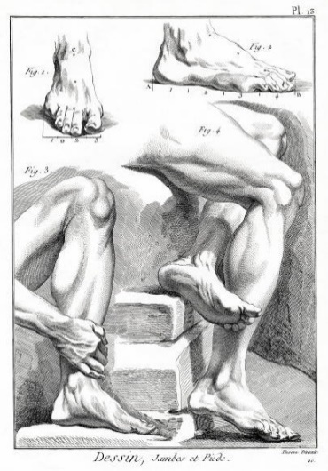  
  
  
  
  
  
  
TO: Residency Directors, Chief Podiatric Resident and OHFAMA Residents

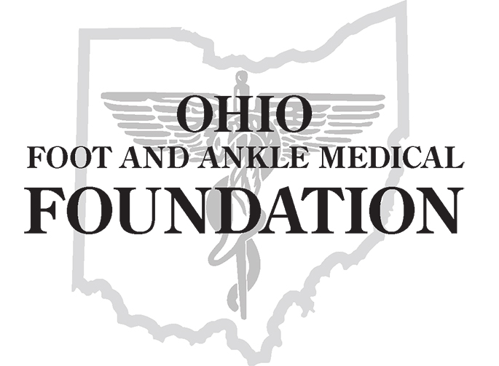

FROM: Robert Brarens, DPM – Chair of the 2021 Scientific Paper Competition

DATE: December17, 2020

SUBJECT: Dr. Gerard V. Yu Scientific Paper Competition

The 105th Annual Foot & Ankle Scientific Seminar June 10-12, 2021

The 105th Annual Foot & Ankle Scientific Seminar will hold the Annual Gerard V. Yu Scientific Paper Competition on Thursday, June 10, 2021.

Active resident members **that are currently members of the Ohio Foot and Ankle Medical Association in good standing** may submit a paper. Papers submitted by anyone who is **NOT** a member of the OHFAMA will not be accepted.

The final papers for the competition will be announced **May 18, 2021**. The papers will be judged by the following criteria:

1. Originality
2. Amount of research involved
3. Topic of interest
4. Format (Length, style, etc.)
5. Practical applications
6. Proper Grammar & Punctuation

Scientific Paper Submission:

Complete the one-page application and mail with your paper submission to the OFAMF. Please submit a copy of the paper with title pages that indicate the title ONLY. Carefully review your submission paper to make sure that any references to a residency program or director are removed. Papers must be HIPAA compliant to protect patient identity on films or pathology reports.

Mail submissions to: OFAMF, 1960 Bethel Road, Suite 140, Columbus, OH 43220.

Paper submissions will be compiled and given to Dr. Brarens as well as the selection committee. Neither the doctor nor their committee will know who wrote the paper or from which program it came.

All papers must be postmarked by Friday, March 12, 2021 and the final papers will be announced by May 18, 2021.

The finalists will present their papers at the Annual Seminar on June 10, 2021 at the Columbus Hilton at Easton. If the paper is a group effort, only one representative is allowed to present. Paper presentations are limited to 15 minutes.

If you have any questions, please call Luci Ridolfo, CAE at the OFAMF at 614-457-6269.

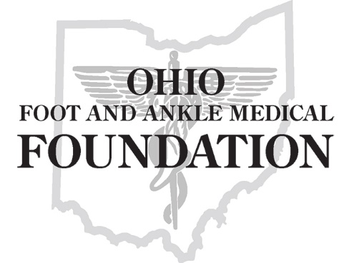

**2021 Gerard V. Yu, DPM Scientific Paper Competition   
  
Application for Participation**

Complete this application and remit with your paper by **March 12, 2021**. Send to OFAMF, Attn: Luci Ridolfo, 1960 Bethel Road, Suite 140, Columbus, Ohio 43220. *Sorry, only mailed submissions will be accepted.*

**GENERAL INFORMATION:**

Name(s) of Author(s): ___________________________________________________________________

_____________________________________________________________________________________

Name of Presenter / Group Representative: _________________________________________________

Representative Phone Number: __________________________ Email: ___________________________

Residency Program: ____________________________________________________________________

Residency Director: _____________________________________________________________________

**RESEARCH TOPIC INFORMATION:**

Research Paper Title: ___________________________________________________________________

Author or group representative sign below, verifying that (a) the research paper submitted is original work, (b) the author/authors DO NOT have a conflict of interest in submitting this paper (see “Competition Guidelines”) and (c) all patient information has been removed according to HIPAA regulations.

Author or Group Representative: ______________________________________ Date: ___________  
  
All applications must be signed by the Residency Director to verify this paper has been reviewed for content and authenticity.  
  
Residency Director Signature: _________________________________________ Date: ___________