Northeast Ohio Baseball Coaches Association

Board Members

Position | Coach | School
President | John Bakalar | Crestwood
Treasurer | Luke Smrdel | Kirtland
All-Star Game  Coordinator | Bill Gamble | Jackson
Hall of Fame/  Scholarship | Brian Sliwinski/  Bob Merritt | Retired
Area Rep. | Matt Koenig | Canfield
Area Rep. | Spike Ridgley | Washington
Area Rep. | Andrew Burnett | Warren G. Harding

Ohio High School Baseball Coaches Association

State Representatives

Position | Coach | School
Senior Rep. | John Bakalar | Crestwood
Junior Rep. | Dan Ransom | Firelands
Sophomore Rep. | Matt Weymer | Ursuline

2017 Northeast Ohio Baseball Coaches Association All-Star Game


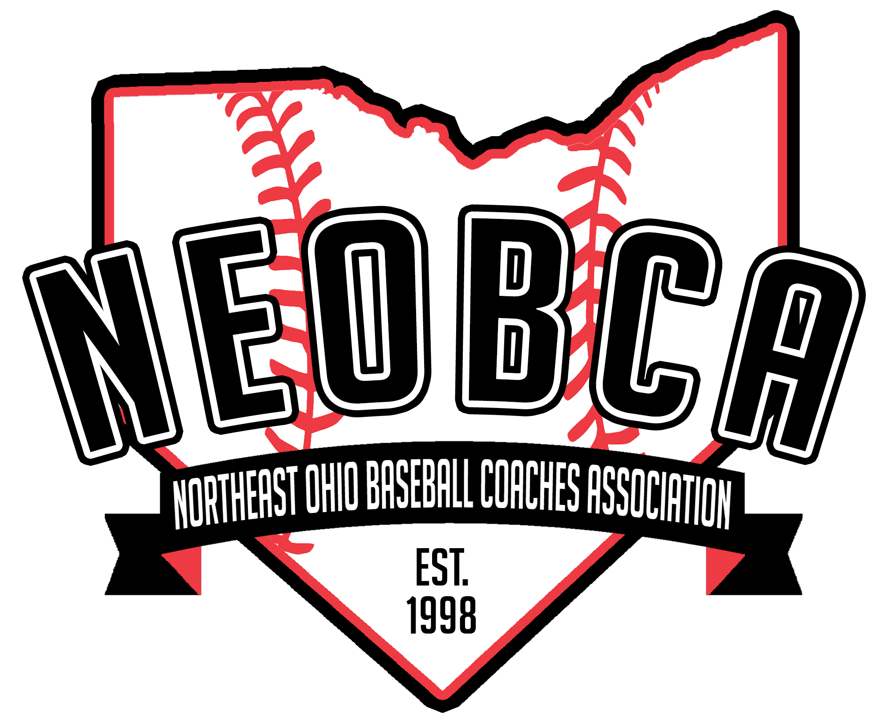

Tuesday, June 20th
Canal Park
Akron, Ohio

2017 NEOBCA All-Star Series

Game 1: 10:00
Portage/Trumbull vs
Columbiana/Mahoning

Award Ceremony: 12:30
Field of the Year
Scholarship Awards
District Players of the Year
District Coaches of the Year
NEOBCA Coaches Hall of Fame Induction

Game 2: 1:00
Lake/Geauga/Eastern Cuyahoga
vs
Cuyahoga

Game 3: 4:00
Stark/Wayne/Holmes
Vs
Ashland/Lorain

Game 4: 7:00
Summit Team #1
Vs
Summit Team #2

Website: www.ohsbca.org
Twitter: @NEOBCA

Page 2

Special Thanks To

Greater Akron Baseball Hall of Fame

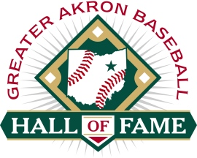

www.gabhof.com

Page 15

We Remember…

Bob Addis
Euclid High School
OHSBCA HOF ‘75
NEOBCA HOF ‘08

Ray Sharnsky
Gilmour Academy
OHSBCA HOF ‘04
NEOBCA HOF ‘08

Page 14

Award Ceremony Recognition

Field of the Year
Massillon Washington High School
Perry High School

Scholarship Recipients
Molly Barber – Jefferson Area
Caitlyn Huth - Dalton
Brett Lowther – Cuyahoga Heights
Andrew Wolff - Hillsdale

Northeast Ohio Player of the Year
Division I | Xavier Moore | Amherst Steele
Division II | Erik Wilson | Chagrin Falls
Division III | Michael Turner | Champion
Northeast Ohio Pitcher of the Year
Division I | Kyle Nicolas | Jackson
Division II | Jared Burick | Tallmadge
Division III | Andrew Abrahamowicz | Elyria Catholic
Division IV | James Kontur | Lake Center Christian
Division IV | Wyatt Larimer | Western Reserve
Northeast Ohio Coach of the Year
Division I | Doug Cicerchi | Strongsville
Division II | Kenny Linn | Tallmadge
Division III | Rick Yauger | Champion
Division III | Aaron Brandt | Hawken
Division IV | Jason DiMacchia | Lake Ridge Academy
Northeast Ohio Assistant Coach of the Year
Division I | Dan Wolff | Mentor
Division II | Keith Bowers | Field
Division IV | Jake Zatchok | Western Reserve
NEOBCA Coaches Hall of Fame Class of 2017
Dan Boarman
St. Vincent St.Mary
Dennis Dever
Woodridge

Sean Durkin
Ursuline

Robert Loeffler
Bedford

Dennis Markiewicz
Garfield Heights/Holy Name

Larry Wiles
Field/Firestone
Portage/Trumbull County Roster

# | Player | School | Position | College
1 | Jaret Rose | Aurora | P | Mount Vernon
2 | Michael Turner | Champion | C | Kent State
3 | Lucas Nasonti | Champion
4 | Jakeb Tekavec | Crestwood | C/P | OSU-Mansfield
5 | Colton Rahach | Crestwood | 2B/OF | Slippery Rock
6 | Michael Massucci | Howland | P/3B | Walsh
7 | Zachery Campbell | Howland |  | Tiffin
8 | Andy Prentice | Ravenna | P/OF | Pittsburgh-Greensburg
9 | Jared Strausser | Ravenna | SS/P | Ohio State
10 | Sam DeMars | Rootstown | 3B | Kent State
11 | Brad Trescott | Rootstown | SS/OF | Wheeling Jesuit
12 | Tommy Dailey | Southeast | 2B/SS | Hiram
13 | Alex Krauss | Southeast | P/OF
14 | Kyle Ambrecht | Streetsboro | P/1B | Capital
15 | Preston Collins | Streetstboro | P/OF
16 | Grant Williams | Warren G. Harding | 3B/1B | Youngstown State
17 | Antonio Walker | Warren G. Harding | SS/2B
18 | Ryan Lee | Warren JFK | P/OF/1B | Youngtown State
19 | Ryan Galle | Warren JFK | C | Toledo
 | Coaches:
 | Dave Clegg | Southeast | Don Lee | Warren JFK
 | Aaron Rauber | Ravenna | Rick Yauger | Champion
 | Tim Calhoun | Champion | Patrick Rhodes | Champion

Coach | School | HOF Class
John Spankal | Eastlake North | 2009
Ken Ciolek | Lakewood | 2009
Jerry Nowak | Brooklyn | 2009
Lenny May | Chagrin Falls | 2009
Bob Merritt | Crestwood | 2009
Joseph Santora | Mayfield | 2009
Chuck Schilling | Hudson | 2009
Curt Karpinski | Elyria | 2008
Mike Ryan | Perry | 2008
Doug Miller | Canton Central Catholic | 2008
Dennis Woods | Lake Catholic/Cleveland Heights/ Glenville | 2008
Ray Sharnsky | Gilmour Academy | 2008
Vince Pellegrini | McDonald | 2008
Mike Mohner | Fairport Harbor | 2008
Frank Gamble | Massillon Perry | 2008
Art Massey | Cuyahoga Heights | 2008
William Schmidt | Ashtabula Saint John | 2008
Joe Gilhousen | Massillon Washington/Glen Oak/Oakwood | 2008
Marion Delaney | Maple Heights | 2008
Paul Serra | Euclid | 2008
Tim Miller | Canton South | 2008
Bernie Hovan | Nordonia | 2008
John Anspach | Cuyahoga Falls | 2008
Luke Izer | Sandy Valley | 2008
Roy Bates | Northwestern | 2008
George Sosobee | Hudson | 2008
Dave Young | Tallmadge | 2008
Robert Smith | Riverside | 2008
Milo Ratkovich | Kenmore | 2008
Fred Brideweser | Fairless | 2008
Jim Humpal | Brush | 2008
Don Kelly | Rocky River | 2008
George Caso | Fairview | 2008
Dick Shine | Cuyahoga Falls | 2008
Augie Bossu | Benedictine | 2008
Fred Heinlen | Shaker Heights | 2008
Hank Miller | Canton McKinley | 2008
Bob Addis | Euclid | 2008
Neal Nelson | Willoughby South | 2008
Les Scarr | Barberton | 2008
Page 4

NEOBCA Coaches Hall of Fame

Page 13
NEOBCA Coaches Hall of Fame

Coach | School | HOF Class
Scott Gabelt | Marlington | 2016
Donald Jones | Twinsburg | 2016
Mel Long | Hoover | 2016
Tim Murphy | North Olmsted | 2016
John Sarver | Ellet/Hoban/Kenmore/Buchtel | 2016
Paul Verno | Cardinal | 2016
Bill Frey | Brunswick | 2015
Joe Kilburg | Cleveland Central Catholic | 2015
Ken Krepop | Westlake | 2015
Jim Rucki | Rocky River | 2015
Brian Sliwinski | Benedictine | 2015
Tim Cope | Champion/Southington | 2014
Terry Griffith | Fairless | 2014
Marty Kane | Normandy | 2014
Tom Kubinski | Elyria Catholic/Elyria West | 2014
Dennis Turkall | Euclid | 2014
Dave Wilks | Holy Name | 2014
Len Taylor | Mentor | 2013
Steve Barona | Beachwood | 2013
Dave Clegg | Southeast | 2013
Jeff Dallas | Revere/Saint Vincent-Saint Mary | 2013
Steve Grescovich | Walsh Jesuit | 2013
Jerry Gruss | Lakewood/St. Edward | 2013
Norris Smith | Amherst Steele | 2013
George Snider | Aurora/Woodridge/Chanel | 2013
Tim Tomc | Parma Senior | 2013
Lou Cangelosi | Valley Forge | 2012
Jerry Chase | Cleveland Central Catholic/Chanel | 2012
Tom Owens | West Branch | 2012
Angelo Rodriguez | Cleveland South | 2012
Frank Rozum | Strongsville | 2012
Mark Zofka | Padua/Holy Name | 2012
Jeff Gibson | Revere | 2011
Jeff Keck | Vermillion | 2011
Bill Kronik | Collinwood | 2011
Don Lee | Warren John F. Kennedy | 2011
Mike McMullen | Medina | 2011
Don Seeker | Tallmadge | 2011
Jeff Short | Westlake | 2011
Cliff Zunis | Avon Lake | 2011
Jim Clark | Notre Dame Cathedral Latin | 2010
Cliff Cook | Bay Village | 2010
Chris Kaczmar | Walsh Jesuit | 2010
Bud Longo | Shaker Heights | 2010
Richard Szalay | Olmsted Falls | 2010
Mahoning/Trumbull Roster

# | Player | School | Position | College
 | Coleman Stouffer | Boardman | C/1B/3B/P
 | Mark Wittman | Canfield | INF | Youngstown State
 | Anthony Vross | Canfield | INF | LaRoche
 | Mitch Davidson | Columbiana | CF/SS
 | Keenan Davis | Columbiana | C
 | Dylan Dickey | Crestview | P/OF | Bowling Green
 | Tyler Fitzsimmons | Crestview | OF | Youngstown State
 | Alex Guy | East Palenstine | C/3B
 | Marshall Huddleston | East Palenstine | OF/SS/P
 | Eric Ostrowski | Jackson-Milton | P/INF/OF | Mount Union
 | Noah Laster | Jackson-Milton |  | California
 | Jack Bajerski | South Range | 2B | West Virginia
 | Randy Skripac | South Range | OF | Ohio State
 | Russell Seymour | Springfield | P
 | Alex Scarrow | Wadsworth | OF
 | Luke Clinton | Wadsworth | 1B/3B/P | Rose-Hulman
 | Jeep DiCioccio | Western Reserve | P/3B | Mount Union
 | Wyatt Larimer | Western Reserve | P/SS | Youngstown State
 | Coaches:
 | Dan Hill | Crestview
 | Todd Kibby | Crestview
 | Ed Anthony | Wester Reserve

Page 5
Lake/Geauga/East Cuyahoga County Roster

Player | School | Position | College
Aaron Siegel | Beachwood | C | Arizona
Aden Stern | Beachwood | P/INF | Colorado
Aaron Pawlak | Berkshire | SS | Mercyhurst NE
Miles Chapman | Berkshire | C | Florida Gulf  Coast
Tanner Nahorniak | Fairport Harding | INF/P | Lakeland CC
Ryan Thomas | Fairport Harding | INF/C | Lake Erie
Tyler Michalski | Harvey | OF/1B
Owen Loncar | Kirtland | 1B | Ohio State
Alec Ward | Kirtland | P | Kent State
Anthony Kornokovich | Lake Catholic | C
Nick D’Angelo | Lake Catholic | P/OF | John Carroll
Vince Donato | Mayfield | 1B | Youngstown  State
Jack Hollinshead | Mayfield | C | Wittenberg
Danny Kraig | Orange | OF | Ohio State
Ryan Schwarzwalder | Riverside | OF/C | Mount Union
Christian Martinitis | Wickliffe | C | Ohio State
Lucas Thomeier | Wickliffe | OF | Defiance
Coaches:
Brian Hiscox | Berkshire
Steve Smetana | Berkshire
John “Spark” Spankal | Eastlake North
Mike Mohner | Fairport Harding

Page 6
Summit/Medina County Team #2 Roster

Player | School | Position | College
Grant Kersh | Hoban | C/INF | Kent State
Jaret Corwin | Hoban | INF | North Central College
Nate Vassalotti | Cuyahoga Falls | OF | Ohio
Kyle Borton | Cuyahoga Falls | P/1B | Kent State
Dillon Benefield | East | 3B | Marines
Tyrique Bryan | Garfield | OF
Jack Zimmerman | Green | P/OF | Kent State
David Stopp | Green | P/1B | Bowling Green
Bryce Kilfoyle | Hudson | OF | Wittenberg
Hayden Knox | Hudson | SS | Wittenberg
Dalton Earich | Manchester | P/SS | Youngstown State
Andrew McFadden | Manchester | OF | Earlham
Cade Mottice | Jackson | INF | Malone
Jake Mottice | Jackson | OF | Malone
Justice Ramirez | Mogadore | 2B/P
Austin Williams | Mogadore | C | Ashland
Jacob Margroff | Woodridge | OF | Butler
Preston Clark | Woodridge | SS/2B | Kent State
Coach:
Chuck Rusinek | East
Scott Koenig | Cuyahoga Falls

Page 11
Summit County Team #1 Roster

Player | School | Position | College
Luke Correia | Copley | C | Mercyhurst
Nicholas Mastrangelo | Copley | P | Ohio State
Steven Taylor | CVCA | SS/P | Indiana Wesleyan
Chris Fair | CVCA | OF | Indiana Wesleyan
Matt Owen | Firestone
Dustin James | Firestone | P/SS | Akron
Trace Peterson | Medina | C | Lake Erie
Brandon Bischof | SVSM | P/OF/1B | USC-Upstate
Jacob Horning | SVSM | P/2B | Bethany
Jordan Jolly | Stow | P/OF | Wittenberg
Max Stillisano | Stow | OF/SS | Kent State
Josh Taylor | Tallmadge | 3B/P | Kent State
Ryan Christy | Twinsburg | OF/P | Ohio
Jake Carinci | Twinsburg | 1B/P | Penn State
Jace Burke | Walsh Jesuit | P | Evansville
Alex Weitman | Walsh Jesuit | OF/SS/3B | St. Joseph
Coach:
Aaron DeBord | Stow

Page 10

Cuyahoga County Roster

Player | School | Position |  | College
Griffin Stevens | Brecksville | SS |  | Urbana
Brett Lowther | Cuyahoga Heights | INF/OF |  | Lake Erie
R.J.Dean | Cuyahoga Heights | P/INF |  | Mount Union
Josh Fikill | Fairview Park | SS/OF |  | Cleveland State
Liam Cunningham | Holy Name | SS/DH |  | Mercyhurst
Jack Stolar | Holy Name | P/OF |  | Toledo
Ryan Wancata | Independence | INF |  | Mount Union
Nick Loparo | Indpendence | P/OF |  | Fire Academy
Raymond Jackson | John Hay | SS/CF/P |  | Bowling Green
Dynis Frigic | North Olmsted | C/3B |  | Cuyahoga CC
Adam Ivancic | Parma | OF/P |  | Cuyahoga CC
Justin Hudecek | Parma | 3B/C/P |  | OSU-Mansfield
Wyatt Eisen | Shaker Heights | C/3B |  | Wisconsin
Nathan Hill | Shaker Heights | SS/2B |  | Wooster
Joe Bubonics | Solon | C/SS |  | Dayton
Jeremy Friedman | Solon | P/OF |  | Ohio State
Parker Shannon | Strongsville | C |  | Mercyhurst
Alex Gray | Strongsville | P |  | Ohio
Andrew Mayor | University School | 2B
Will Kilroy | University School | P/3B |  | Southern Methodist
Coaches:
Tim Hogan | John Hay
Marc Lowther | Cuyahoga Heights

Page 7

Lorain/Ashland County Roster

Player | School | Position | College
Chad Jones | Amherst Steele | 1B | Walsh
Brian D’Andrea | Amherst Steele | P | Lake Erie
Taylor Reynolds | Avon | 1B/3B | Malone
Ethan St. Claire | Avon | OF | Findlay
Tim Ackerman | Brookside | P/3B/SS | Notre Dame College
Andrai Wright | Clearview | 1B | Cuyahoga CC
Cody Schwartz | Columbia | OF | Otterbein
Jared Heidecker | Columbia | P/OF/1B
Jamaris Cook | Elyria | OF/P | Lake Erie
Jordan Reed | Elyria | 3B | Lake Erie
Jeff Spencer | Elyria Catholic | P/INF/OF | Malone
Tony LoParo | Elyria Catholic | SS | Baldwin Wallace
Trevor Damron | Firelands | P | Coastal Carolina
Nathan Kovach | Firelands | C
Cole Casdorph | Hillsdale | SS/2B | North Central State
Julian Rodriguez | Lorain | 1B
Connor Young | Loudonville | OF | Ashland
Justin Vansickle | Loudonville | 2B/P | OSU-Mansfield
Matthew Norton | Wellington | P/OF | Lorain CC
Max Carevic | Wellington | P/OF
Coach:
Bruce Lisicky | Elyria Catholic
Matt Rositano | Amherst Steele

Page 8
Stark/Wayne/Holmes County Roster

Player | School | Position | College
Anthony Thomas | Alliance | P/2B | Kent State
Cameron Ruffin | Canton Central Catholic | OF
Brady Thompson | Canton Central Catholic | OF
Andrew Wade | Canton Heritage Christian | P/OF | Malone
Andrew Martin | Canton Heritage Christian | 2B | Taylor
Mitch Clark | Dalton | OF/1B | Muskingum
Matthew Gothard | East Canton | P/1B/OF | Vanderbilt
Alex Armitez | Lake | INF | Mount Union
Zach Sturmi | Lake | OF | Walsh
Carson Davis | Louisville | P | Mount Union
Corey White | Louisville | 1B/OF | Mount Union
Vince Murray | Massillon Washington | C | Ohio
Kordell Ford | Massillon Washington | OF/P | Mount Union
Chris Barbitta | Northwest | 2B | Toledo
Greg Geiger | Northwest | P | Lourdes
Colten Burdy | Waynedale | INF/P | Akron-Wayne
Stephen Spidell | Waynedale | P/INF | Wooster
Shane Williamson | Wooster | P | Akron
Grant Bielke | Wooster | INF | Cuyahoga CC
Coaches:
Brian Warner | Louisville
Page 9

