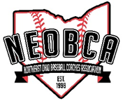
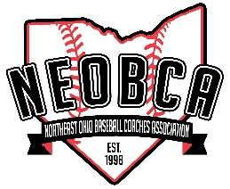
NEOBCA 2018
Hall of Fame Nomination Form

Brian Sliwinski, Co-chair slew19@aol.com
Bob Merritt, Co-chair bmerritt14@gmail.com
John Bakalar, Co-chair JBAKALAR@CrestwoodSchools.org
Dennis Markiewcz, Co-Chair dmarks104@aol.com

Nominee: |  | School(s):
Phone: |  | Email:
Nominated By: |  | School:
Phone: |  | Email:

Criteria is the following:
- Candidate must have ten years as a Head Coach in Ohio.
- Nominating coach must be a current member of NEOBCA.
- Attach a coaching resume to form if possible.

List awards/ accomplishments:

Community Involvement:

Wins: |  | Losses: |  | Total Years Coaching
Conference Championships: |  | Years:
Sectional Championships: |  | Years:
District Championships: |  | Years:
Regional Championships: |  | Years
State Championships: |  | Years:

Date of Nomination:

Mail nomination form and coaching resume to:
NEOBCA Hall of Fame
5164 Pinckneya Dr.
North Royalton, OH 44133
Deadline: December 1, 2017

