NEOBCA Scholarship Application
- Applicant must be a son or daughter of a baseball coach.
- Coach must be a member for the current year.
- Nomination signed by a school guidance counselor and administrator.
- Current senior and attending college in the fall.

Name: _________________________ School: ________________________________
Home Address: _______________________________________________________
City: ________________________ State: ________ Zip: _________________
Father Coaches at what School _______________________________
Date of Graduation: _____________________________________
Academic Information: GPA (on a 4.0 scale): ___________ Class Rank: _____ out of _____
ACT Composite Score: ________ SAT–Verbal: ________SAT-Math: _______ SAT–Combined: _________
Activities: High School, community, music, sports, art, scouts, religious, etc. Complete year, positions held and if you plan to continue the activity in college.
Activity: ________________ Activity: ________________ Activity: __________________
Years Participated: _______ Years Participated: _______ Years Participated: _________
Name of Coach: _______________________________________________
Head Coach’s Home Address: ____________________________________
City: _______________________ State: _________ Zip: _______________
Head Coach’s Home Phone Number: ________________________________
Applicant’s Signature: __________________________________________
Guidance Counselor Signature/ Date: ___________________________________________________
School Administrator Signature/ Date: __________________________________________________
This form and documentation must be received by June 1, 2019. Please return to:

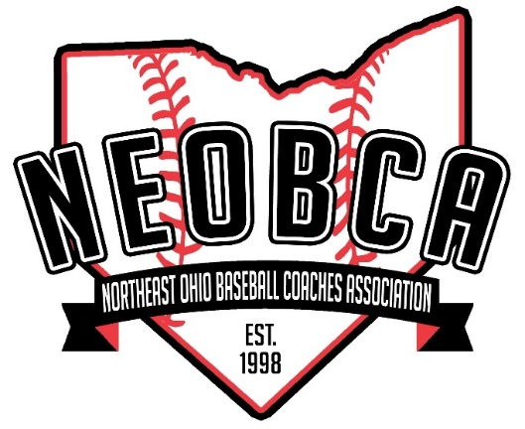
Coach Sliwinski
5164 Pinckneya Dr.
North Royalton, OH 44133

