2013 O.H.S.B.C.A. HANK MILLER
MEMORIAL SCHOLARSHIP WINNERS
Each year the Board of Directors selects several individuals to be awarded our “Hank Miller Memorial Scholarship”. An eligible applicant must be a graduating son or daughter of a coach who has been an OHSBCA member for a minimum of five consecutive years. This year 10 worthy students have been awarded a $500 scholarship. Hank Miller, Canton McKinley High School, was inducted into the OHSBCA Hall of Fame in 1975. Hank was a teacher of Industrial Arts and Vocational Carpentry for 39 years. He retired from Canton City Schools in 1989. He coached many sports including tennis, golf, basketball, but football and undoubtedly baseball were his favorites. He was a World War II veteran who served in the Marine Corps. Hank graduated from Canton Township High School (Canton South) in 1942 and earned his college degree from Ohio Northern. His coaching career started at Mogadore High School with coaching stints at Louisville, Canton Lincoln, Canton McKinley, and Glen Oak High Schools. Hank was a lifetime member of the National Education
Association. Hank was President of the OHSBCA in 1982. He officiated basketball and served as recreational director for the city of Louisville. Hank is a member of the Greater Canton Amateur Sports Hall of Fame and the Ohio Northern University Athletic Hall of Fame. He was founder of the Hank Miller High School baseball series.

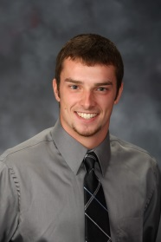
Jordan Bowerman, Seneca East – Jordan is the son of Rick and Sherri Bowerman. His father is an
assistant coach at Seneca East. Jordan served as senior class vice-president, was a member of National
Honor Society, and was selected as a National Machinery Citizenship Award scholarship recipient. He was a four year letter winner in baseball, earning 1st team All-Midland Athletic League honors and All-District honors 3 consecutive years. He lettered 3 years in football and was recognized as 1st team All-League, 2nd team All-District, and a National Football Foundation Scholar Athlete. Jordan also gained Academic All-State honors in football and baseball as a senior. Jordan is currently attending Ashland University with a major in Nursing.

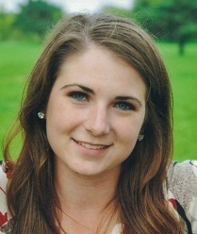
Nora Dorner, St. Henry – Nora is the daughter of John and Brenda Dorner. Her father is the head coach at St. Henry High School. While in high school, Nora earned four varsity letters playing golf, where she was a three-time winner of the Academic All M.A.C. Team. She was an officer of the Science Club and German Club. She was also a member of the Art Club, part of the Yearbook committee and a peer tutor. She attended Girls State at Mount Union College. She graduated tenth in her class with academic honors. She is currently attending Wright State University.

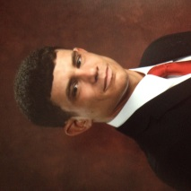
Mason Heatherington, Steubenville – Mason is the son of Fred and Cindy Heatherington. His father is
in his 26th year as the head baseball coach at Steubenville High School and a member of the OHSBCA
Hall of Fame. While at Steubenville, Mason was a two year letter winner in baseball as well as a two year letter winner in golf. Mason was a player on the 2010 Ohio State Babe Ruth 15 year old champion team and had the opportunity to play in the regional tournament. Mason was also an officer of his school’s Key Club. He is currently a freshman at Kent State University studying Sports Administration.

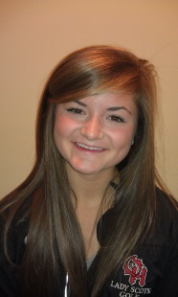
Mackenzie Laumann, Oak Hills – Mackenzie is the daughter of Chuck and Susan Laumann. Her father is the head coach at Oak Hills High School. During high school, Mackenzie played golf (4 years), basketball (4 years), and track (2 years), earning 10 varsity letters. She was 2nd team GMC golf once and first team GMC golf twice. She was a 4 time district qualifier in golf (earning All-District twice) and finished 20th at the state golf tournament her senior year. She was honorable mention All-Southwest District in basketball and as a member of the track team she was a district qualifier in the 100m hurdles and long jump. She was class president for 4 years, member of the National Honor Society, and homecoming queen. Mackenzie is attending Northern Kentucky University and is a member of the women’s golf team while studying business informatics.

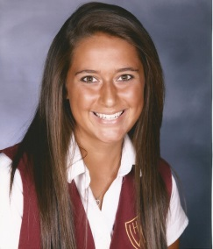
Audrey Manahan, Bishop Watterson – Audrey is the daughter of Scott and Laura Manahan. Her father is a past president and Hall of Fame member of the OHSBCA and the head coach at Bishop Watterson. During high school Audrey played softball four years, basketball two years, and was a member of the WELL Club four years. Audrey lettered in softball all four years while serving as the team captain. She was a selected as All-League both her junior and senior seasons. She earned an athletic scholarship in softball to attend Ashland University and is majoring in nursing.

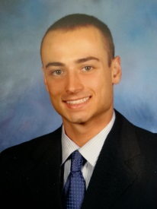
Jim Nagel, Elder – Jim is the son of Andy and Julie Nagel. His father is a varsity assistant coach at Moeller High School. During high school, Jim played football and track all four years. He lettered two years in both football and track and voted Team Captain his senior season for his track team. He was also a member of the Glee Club and Vocal Ensemble for three years. Jim is currently attending the University of Cincinnatiwhere he is majoring in Criminal Justice with a Sports Administration minor. Jim is also receiving an athletic grant from the University of Cincinnati as a member of the Bearcat Football Video Team.

Katelyn Newton, Anderson – Katelyn is the daughter of Chris and Krissy Newton. Her father has been a
head coach for the last 16 years, 10 with Colerain and the last 6 at Anderson. During high school, Katelyn
lettered four years in soccer and one year in basketball. She was a two-time 1st Team All-Conference soccer player and her senior year was 1st team All-City and 1st Team All-District. Katelyn was an honor student and scholar athlete throughout high school, a member of the National Honor Society, and a member of the Student Athletic Leadership Team. Katelyn currently attends Northern Kentucky University studying pre-veterinary medicine and a member of the Soccer Team. This past season, Katelyn was named to the Atlantic Sun Conference All-Freshman Team.

Shelby Saunders, Dublin Coffman – Shelby is the daughter of Tim and Janie Saunders. Her father is a
member of the OHSBCA Hall of Fame and the head coach at Dublin Coffman, a position he’s held for 27
years. During high school, Shelby was a 2-time captain for basketball, and played volleyball, softball and
cross country. She lettered three years in basketball. Shelby was an honors student, an officer in National
Honor Society and the recipient of the OHSAA Award of Excellence for Sportsmanship, Ethics & Integrity. Shelby is currently attending Indiana University majoring in Journalism.

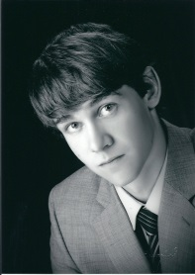
Jacob Sheets, Carroll – Jake is the son of Mike and Vicki Sheets. Mike is the head coach at Carroll High School in Dayton. During high school, Jake played football two years and baseball four years. He earned varsity letters two years in both sports. Jake was awarded the Patriot Award while at Carroll, and was a member of the National Honor Society for three years. Jake is currently attending the University of Dayton, majoring in Mechanical Engineering.

Felicia Smith, Centerburg – Felicia is the daughter of Joe and Anna Smith. Her father is the head coach
at Centerburg. During high school, Felicia was very active in a variety of student groups and organizations. She served as an officer in FFA, FCCLA, National Honor Society, Student Council, and Tri-M MusicHonor Society. She was also involved in Drama Club, Choir, SALT and T2M and competed in the Knox County Distinguished Young Ladies Scholarship Program. Felicia is currently attending The Ohio State University, double majoring in Agricultural Education and Communications.

