* Meeting of the Advisory Committee on Immunization Practices (ACIP)
* Centers for Disease Control and Prevention, Atlanta, Georgia 30329
* Highlights by Stanley Grogg, DO
* No voting today.
* Liaison member representing the American Osteopathic Association (AOA)
* Emergence Virtual Meeting 11/23/2020

**Coronavirus Disease 2019 Vaccines**

**Over 200 COVID-19 vaccines are under development. In the US. 4 vaccines in Phase 3 trials preparing for EUA. Pfizer, Moderna, AstraZeneca and Johnson and Johnson.**

**Presently there are 12,028,081 patients have been diagnosed with COVID-19 infection with > 259,000 deaths in the us.**

**When the vaccine is available, surveys hav indicated onlu 42-86% will initially get vaccination.**



Blacks had lowest response to take COVID-19 vaccination with Asians being the highest acceptance. Many would take vaccine but did not want to be first.

Vaccine is to be provided free of charge, but Health Departments or Healthcare Providers may have administration costs. Hopefully, the administration of the vaccine will be covered by the government.

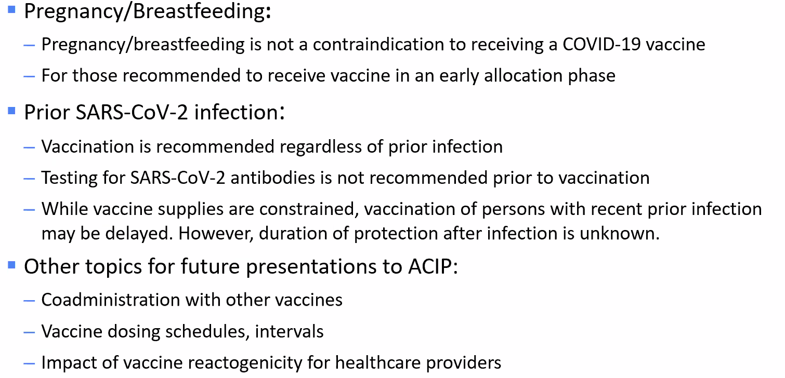

**Prioritization of the Vaccine initially until adequate amounts of vaccine available:**

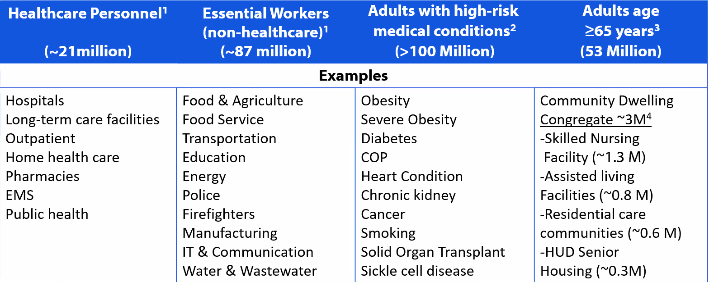

**Death rate of those 80 and above is the highest. Those with co-morbid diagnosis is most important adverse factor for deaths, especially those in long term care facilities.**

**Healthcare Providers MUST emphasis non-pharmaceutical interventions (e.g. wearing a mask and social distancing.**

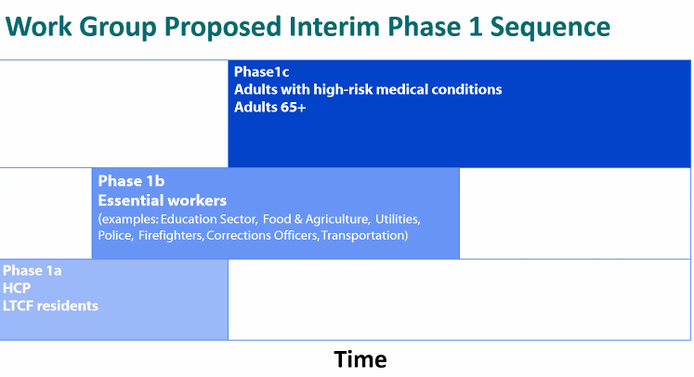

**1a, 1b, 1c Groups listed above.**

**Government has committed to having COVID-19 vaccine available soon for all that want the vaccine.**

**Next emergency ACIP meeting will be after Dec. 10, 2020 depending on FDA’s review and EUA for the applying COVID-19 vaccinations.**