Highlights of the Advisory Committee on Immunization Practices (ACIP)

Centers for Disease Control and Prevention

June 24, 2021

by Stanley Grogg, DO

Liaison Member for American Osteopathic Association

**The ACIP recommend 3 vaccines, Dengue, Influenza and Rabies.** All motions were approved 14/0 and funding for the Vaccine for Children (VFC) was approved for all three motions. The motions were as follows:

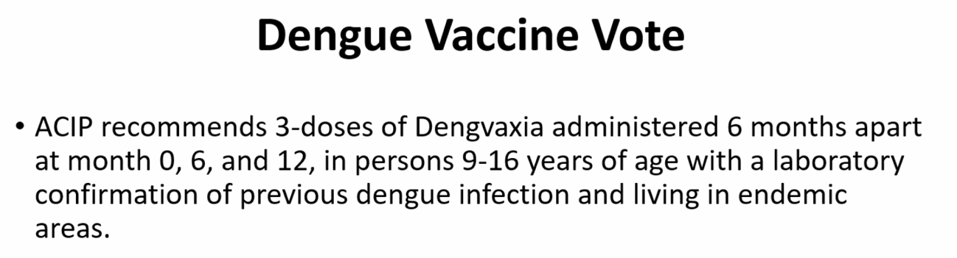

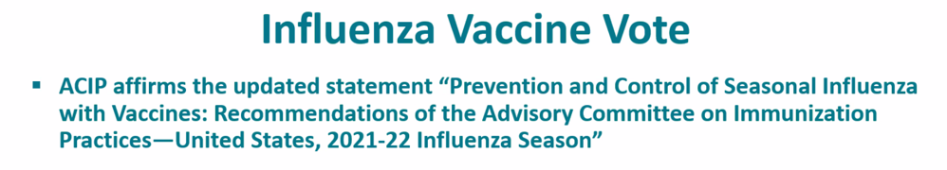

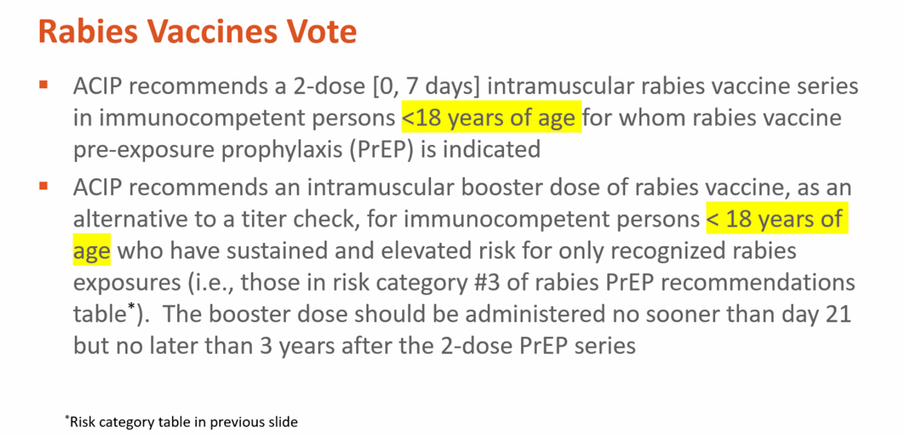

**Dengue Vaccine**

The vaccine is only for 9–16-year-olds with a positive test for previous history of Dengue disease. Surveys were done of the people and physicians in Puerto Rico and most approved of the testing for Dengue and vaccination if laboratory evidence of previous Dengue infections. Cost of Dengue vaccine is about $100 per dose X 3 doses = $300 per Sanofi and will be covered by VFC or private insurance.

**Influenza Vaccines**

**Annual Influenza Vaccine** is recommended for all without contraindications at and beyond 6 months of age. See tables below for expected influenza vaccines and composition of 2021-22 season vaccines. All influenza vaccines are quadrivalent. **Flucelvax Quadrivalent,** cell cultured based injectable vaccine (ccIIV4),was recommended for 6 months of age and older. Influenza vaccine can be given with CoVid-19 vaccines.

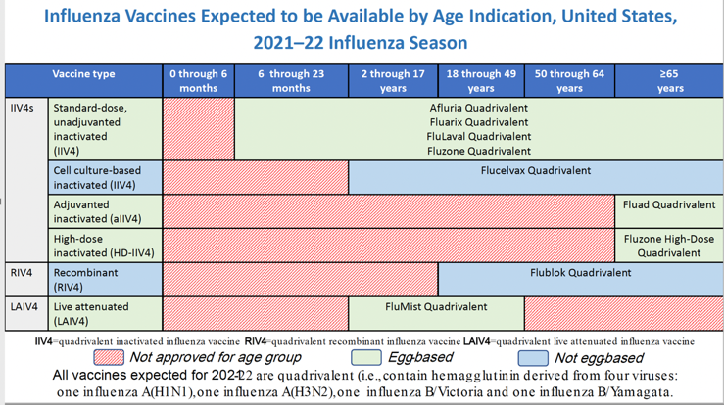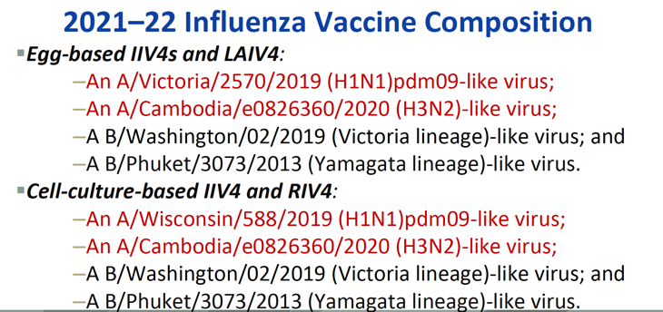

The because of waning protection following vaccination, timing of influenza vaccines are recommended by the end of October and continues as long as influenza viruses are circulating. Other changes:

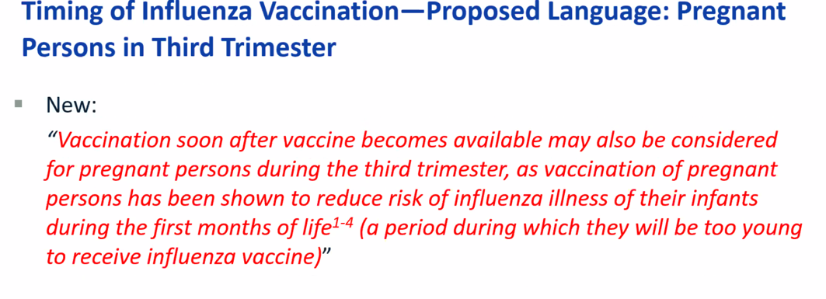

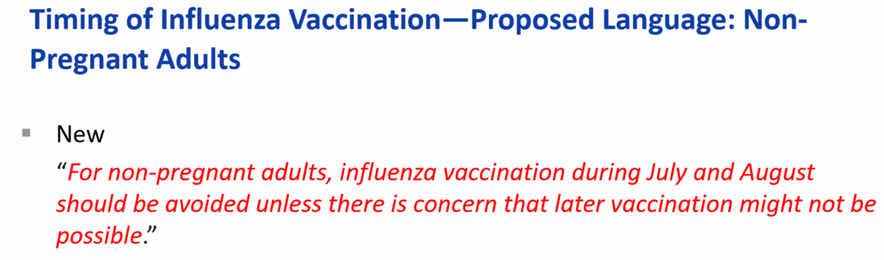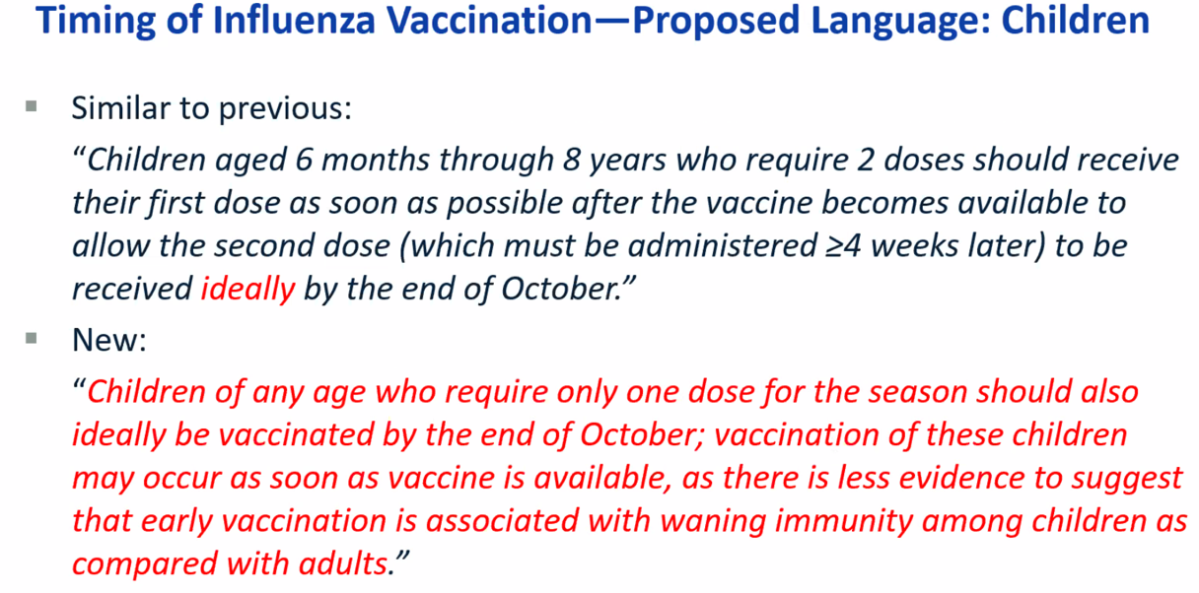

Contrainciations of influenza vaccines changes in red:

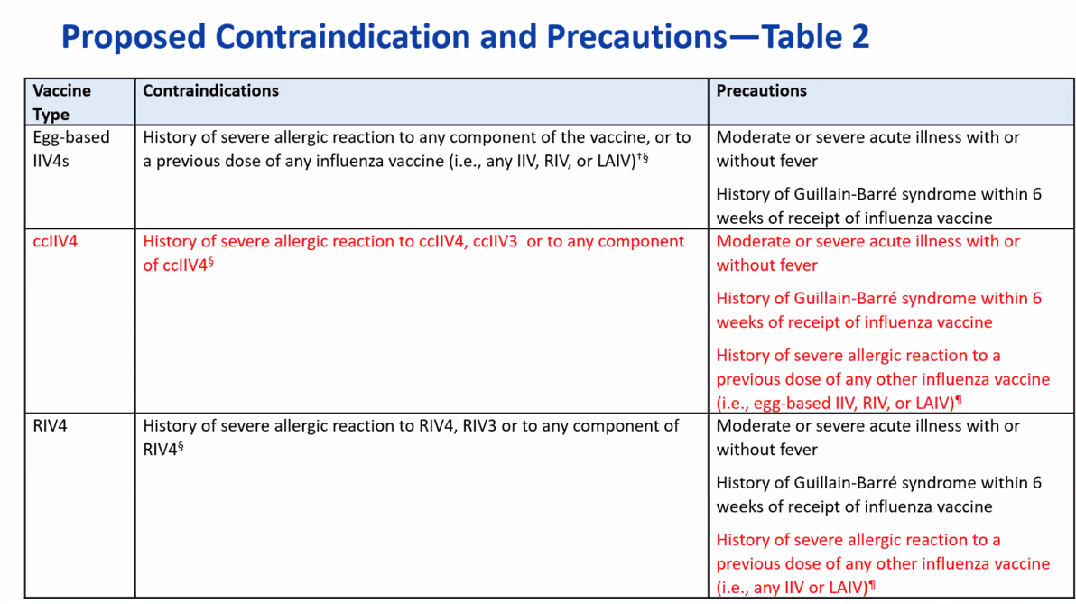

**Rabies Vaccines**

Rabies is caused by a neurotropic virus that enters the peripheral nerves and travels to the central nervous system. Incubation period is usually weeks to months. Death typically within 2 weeks of illness onset. There are 3 licensed rabies vaccines in the US.