Sept. 23, 2021 Meeting of the Advisory Committee on Immunization Practices (ACIP)

Virtual at CDC

Draft/unedited minutes by Stan Grogg, DO

Liaison Member (non-voting) reSARS-CoV-2presenting the

American Osteopathic Association

ACIP slides for Sept. 22 and 23, 2021 can be found at: https://www.cdc.gov/vaccines/acip/meetings/slides-2021-09-22-23.html.

Dr. Fink of the FDA informed the ACIP members that the FDA expanded Pfizer-BioNTech EUA to include a single booster dose, to be administered at least six months after completion of the primary series in:

Note: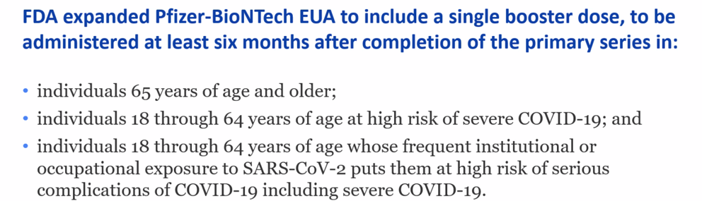

CDC's Director Dr. Walensky 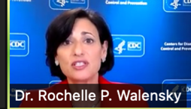 thanked the members of the ACIP for the time committed for the 17 meetings this last year, mostly concerning COVID19. She discussed the deliberations and needed outcomes of the ACIP's decisions.

Three recommendations approved by ACIP 9/23/2021

1.

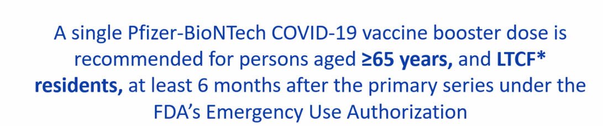

2.

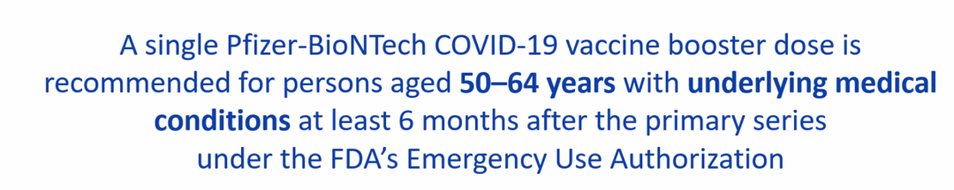

3.

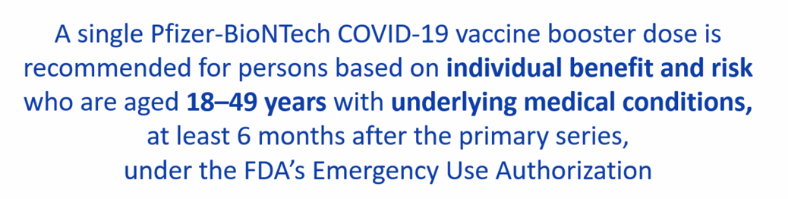

Comments:

1. Current recommendations state that the additional dose should be the same product as the primary series. **BUT:** If the product given for the first 2 doses is NOT available, the other vaccine product may be administered.

2. Axillary Lymphadenopathy was found in 5.2 % after 2nd and 3rd doses. 1 case of myocarditis in 30 plus year old.

3. Most vaccinated adults (76-87% )will get booster if available.

4. It is expected the over 70% of boosters will be given in pharmacies.

**Discussions : pros and cons of boosters discussed below.**

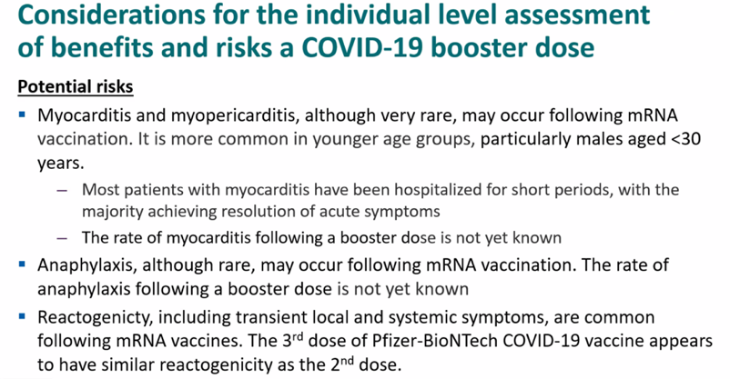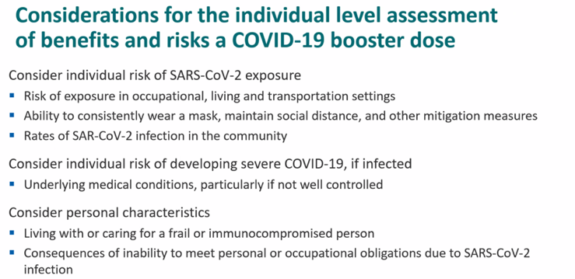

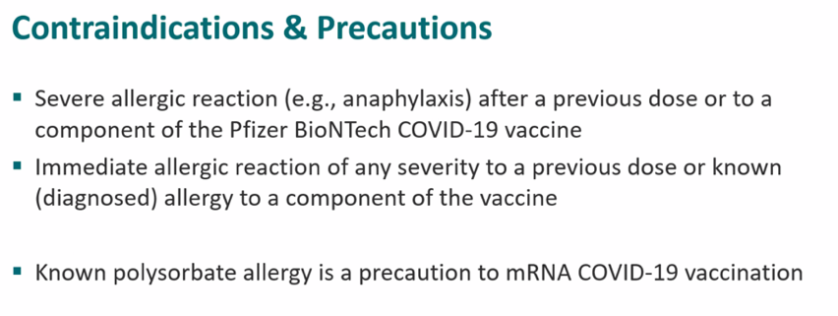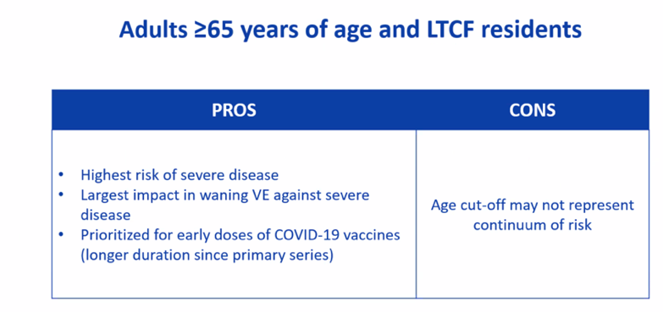

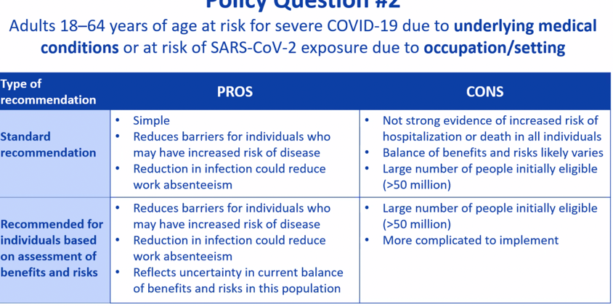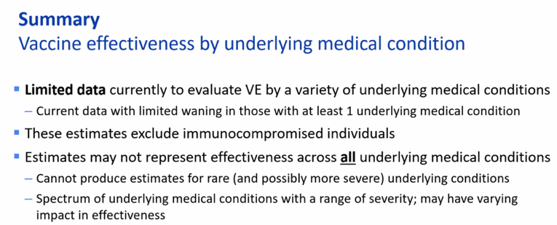

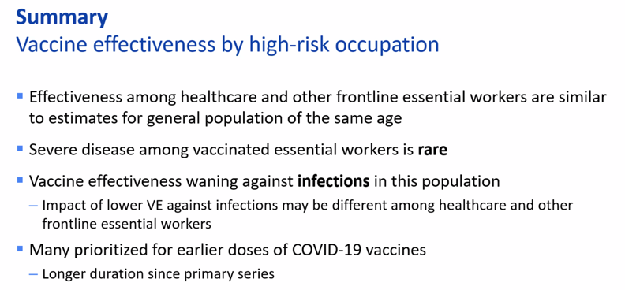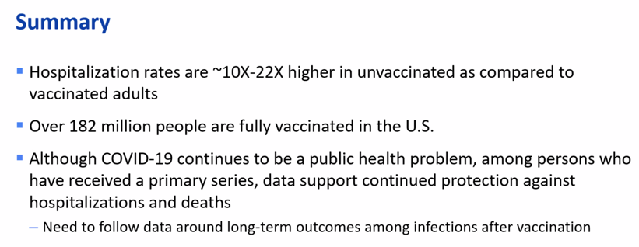

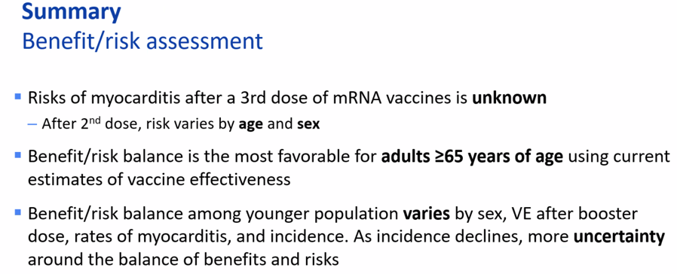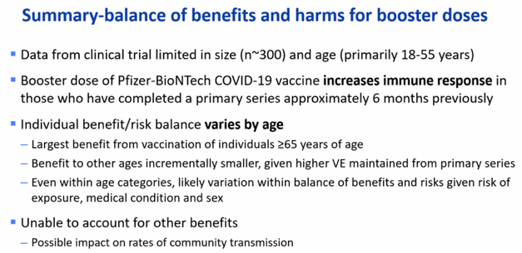

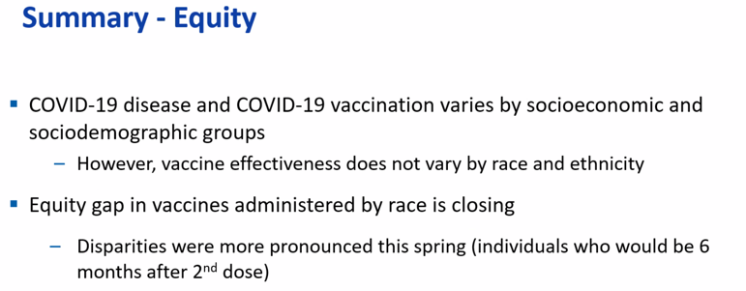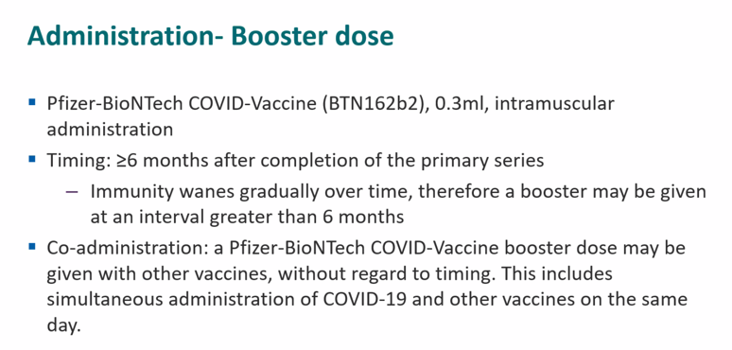

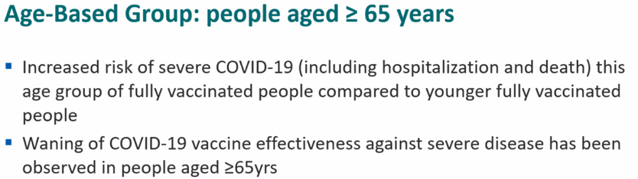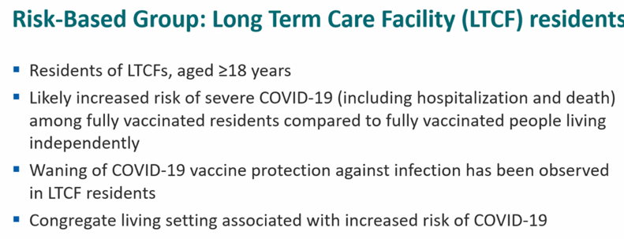

Next scheduled virtual meeting of ACIP Sept. 29, 2021

Questions/Comments Stanley.grogg@okstate.edu.