Organization for Research on Women and Communication
March 5 – 7, 2020

Conference Registration Information

Register for the conference here: Conference Registration

There is no conference registration fee because of generous support from the National Communication Association and the University of Wisconsin-Milwaukee. All conference participants are required to register in advance and be a current member of the Organization for Research on Women and Communication (ORWAC).

Regular ORWAC Membership - $35.00 for one year
Student ORWAC Membership - $15.00 for one year
Lifetime ORWAC Membership - $1,000.00

Become a member of ORWAC here: http://www.orwac.org/aws/ORWAC/pt/sp/member

Conference Locations

UWM, Main Campus UWM, Downtown Campus
Merrill Hall UWM School of Continuing Education
2512 E Hartford Ave 161 W Wisconsin Ave #6000
Milwaukee, WI 53211 Milwaukee, WI 53203

UWM, Main Campus Parking UWM, Downtown Campus Parking
Klotsche Center & Pavilion The Shops of Grand Avenue Structure
3409 N Downer Ave. 275 W. Wisconsin Ave.
Milwaukee, WI 53211 Milwaukee, WI 53203
Cost: $1.00 per hour Validate ticket at 7th Floor Reception Desk - $6.00 a day

Conference Hotel Information

Conference Hotel Address Room Block
Residence Inn by Marriott Milwaukee Downtown Block Available March 4-8, 2020
648 N. Plankinton Ave. Studio Suite: $169.00 a night
Milwaukee, WI 53203 Must book by January 31st
(414) 224-7890

Included with your stay:
Full breakfast buffet, Wi-Fi, The Mix evening social serving complimentary beer, wine, soda, and light far on Monday, Tuesday, and Wednesday evenings from 6pm-7:30pm. In addition to the onsite fitness center, free access to Gold’s Gym adjacent to the hotel.

The Room:
The spacious suites are newly renovated, have fully equipped kitchens, 16-20ft. ceilings and beautiful views with natural lighting. It’s also right on the river walk, walking distance to many restaurants, bars, and entertainment.

Guest Parking:
$24/day per car with in/out access.

Online Reservation Link:
https://www.marriott.com/event-reservations/reservationlink.mi?id=1564604724927&key=GRP&app=resvlink

Directions
Directions from Airport to Conference Hotel
General Mitchell International Airport, 5300 S Howell Ave to Residence Inn by Marriott Milwaukee Downtown, 648 N. Plankinton Ave.
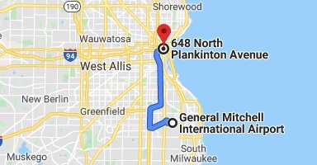

Directions from Conference Hotel to UW-Milwaukee, Main Campus
Residence Inn by Marriott Milwaukee Downtown, 648 N. Plankinton Ave.
to Merrill Hall, 2512 E Hartford Ave.
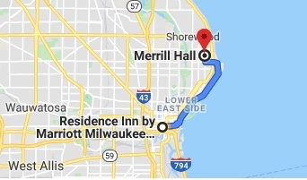

Direction from Conference Hotel to UW-Milwaukee, Downtown Conference Center
Residence Inn by Marriott Milwaukee Downtown, 648 N. Plankinton Ave.
to UWM School of Continuing Education, 161 W Wisconsin Ave #6000

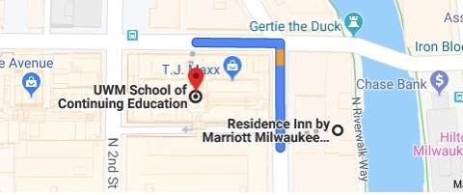
2 min walk (.1 mile) via N Plankinton Ave and W Wisconsin Ave

