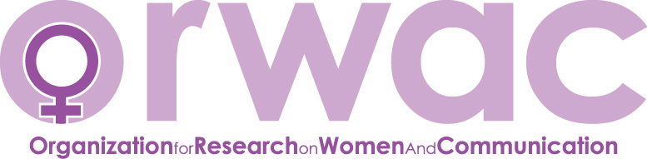2022 Research Development Grant Application

Submitter Name:

Proposal Title:

Membership Status (Check One):
_____ I have verified in advance that my ORWAC membership is current
_____ If not previously a member, I have submitted my membership fee at www.orwac.org

Applicant Category (Check One):
_____ 1. Bachelor’s student
_____ 2. Master’s Student
_____ 3. Ph.D. Student
_____ 4. Contingent Faculty
_____ 5. Tenure-Track / Tenured Faculty

If awarded a grant, I agree to submit, within one year of receipt, a one-page report detailing the status of the submitted project and use of funds to the Immediate Past President of ORWAC, Diane Keeling (keeling@sandiego.edu). _____ Yes _____ No

1. Proposal: Describe the nature and goal of the project. Include content regarding the status of the project such as research questions, theoretical framework, methodology, rationale for project, etc.

2. Timeline: Provide a timeline for each phase and/or activity.

3. Budget: Detailed description of funds needed and their purpose. Please provide an itemized budget.

4. Contribution: Describe the benefit or contribution made to feminist scholarship in the field of Communication.

5. Additional Support: Discuss any other support for this project, including the amount. If not applicable, write “N/A.”

Please be as thorough as possible in responding to the questions above. Completed applications should not exceed three pages, excluding the application form and submitter’s curriculum vitae.

Forward one document that includes the application form, answers, and vitae to Diane Keeling (keeling@sandiego.edu) by April 1, 2022 at noon (PST).

