Youth and Family Director
Implementation Timeline

First Year
Based upon projected spring 2012 hiring

Priority List
- Connect with Downtown Youth Fellowship (DCYF)
- Attend meetings
- Assist with planning
- Connect with learning committee
- Discuss plans for Amazing Grace Day Camp
- Organize volunteers for day camp
- Discuss plans for vacation Sunday school
- Discuss plans for coming year activities
- Connect with church council
- Attend monthly meetings (as needed)
- Discuss plans for outreach before and after day camp
- Obtain bus license
- Create Older Wiser Lutherans (OWLS) association
- Coordinate with pastor to assist with parish outreach
- Capture our Children and Middle School students in meaningful ministry.

Second Year
The on going priority is Amazing Grace Day Camp and vacation Sunday school.

Priority List
- Continue outreach to parish
- Formulate plan for outreach to community
- Coordinate with pastor and church council
- Plan should be one year through five year projection
- Project implementation date within current year
- Plan a series of fund raising events for youth projects
- Coordinate with learning committee and Soulfire
- Coordinate with DCYF to broaden base
- Coordinate with Parish secretary
- Assist with membership records
- Assist with church web site maintenance
- Coordinate volunteers for church functions as needed

Year Three
Continue programs from previous two years.

Priority List
- Formulate projected budget needs for the next 3-5 years
- Coordinate with finance committee and church council
- Plan fund raising efforts to assist in budget needs
- Continue outreach to community
- Explore plan of outreach to local colleges
- Explore outreach to St. Luke’s congregation

Weekly suggested time break down
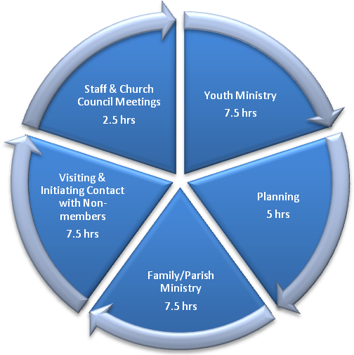
This is only a suggested time break down. During the spring and summer months the focus shifts to Amazing Grace Day Camp and Vacation Sunday School. Both of these activities require much time commitment for set up, coordination and execution.

Youth & Family Ministry Break Down:
Soulfire – high school youth group, currently run by Doug Smith
College Outreach – college campus youth fellowship (in development)
Sunday schools Education – for kindergarten through 8th grade children, currently run by the learning committee
Church for Kids – church service for children during regular service is currently run by Greg Zink
Older Wiser Lutherans (OWLS) association – organize older members of the congregation to be involved with youth (in development)

